Visionary Board Leadership and the Transition to Value Video Series

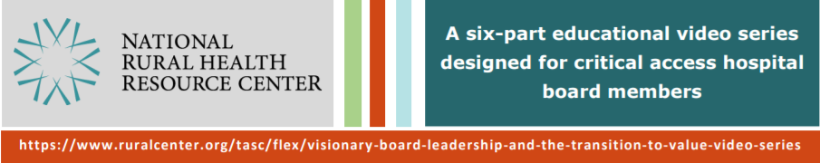

Pre- and Post-Training Evaluation
Boards may choose to have members fill this out individually or together as a group.
Level of Agreement on Likert scale: 1 (Strongly Disagree) to 5 (Strongly Agree)
- I have thought about what our hospital’s vision means to me personally.
5 | 4 | 3 | 2 | 1

- Our board understands what it means to make the transition to value and population health.
5 | 4 | 3 | 2 | 1

- Our board members communicate with others in the community about our hospital’s vision.
5 | 4 | 3 | 2 | 1

- Our board members work to build and strengthen relationships between our hospital and other organizations in our community.
5 | 4 | 3 | 2 | 1

- Our board has had conversations about the qualities we need in our next CEO.
5 | 4 | 3 | 2 | 1

- Our board has effective processes in place for setting expectations for our CEO and providing them with performance feedback.
5 | 4 | 3 | 2 | 1

- What organizations make up the health care system in our community? (short answer)

