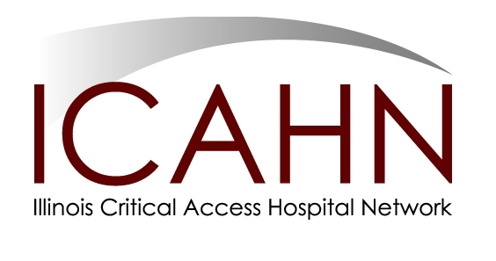

December 11, 2017

TO: Chief Executive Officers
Illinois Small and Rural Hospital
(Under 49 Staffed Beds)

FROM: Pat Schou, Executive Director
Illinois Critical Access Hospital Network

SUBJECT: FY 2018 Small Rural Hospital Improvement Grant Program (SHIP)
Eligibility Information and Grant Application Enclosed
Hospital Applications Due – December 29, 2017

Announcement–Funding Opportunity
The Small Rural Hospital Improvement Grant Program (SHIP) grant application for FY 2018 is now available on the ICAHN website at www.icahn.org and is also attached to this announcement.

SHIP Program and Eligibility
The SHIP grant is a federal grant program designed to assist small, rural hospitals with costs related to one or potentially all three of these areas: 1) Value-Based Purchasing (VBP); 2) Accountable Care Organization (ACO) or Shared Savings; and 3) Payment Bundling (PB) or Prospective Payment System (PPS). Approximately $9,000 will be available for each eligible hospital depending on the number of hospital applications nationwide. To be eligible for the SHIP grant, your hospital must meet the following requirements:
- Defined as small - 49 available acute beds or less, as reported on your most recently filed Medicare Cost Report;
- Located in a rural area or in a Metropolitan Statistical Area or in a Rural Urban Commuting Area called a RUCA or certified as a critical access hospital; and
- Defined as a non-federal short term general acute care facility.

Non-critical access hospitals can check their rural eligibility status by visiting the Office of Rural Health Policy’s web site http://www.hrsa.gov/ruralhealth/grants/index.html. If you have any questions on your hospital’s eligibility for the SHIP grant, please contact the ICAHN office. Hospital may be for-profit or not-for-profit as no matching funds are required.

Application Instructions
Hospitals may select more than one category to participate in if priorities are followed and available funds exist. The priorities for this year’s SHIP grant are as follows:

First Priority: In no particular order, hospitals may select one or both activities; however, both activities must be met in order to go to the 2nd priority. HCAHPS (CAHs only) and ICD-10 (all hospitals) – both of these priorities must be fully implemented and HCAHPS must be publicly reported to Hospital Compare before your hospital can select any other investment options.

Second Priority: If your hospital is already fully participating in HCAHPS and ICD-10, then you may select a different investment listed on the SHIP purchasing menu.

Third Priority: If your hospital has already completed ALL investments listed on the SHIP purchasing menu, then you may identify an alternative piece of equipment and/or service that will optimally affect your hospital’s transformation into an accountable care organization, increase value-based purchasing objectives and/or aid in the adoption of ICD-10. Pre-approval must be given for the project by ICAHN.

Options for Hospitals – Pool Funds for Group Projects (3 or more hospitals)
Hospitals also have the option to pool all, or a portion, of their SHIP funds as a consortium for training assistance. Examples of projects where SHIP funds could be pooled are:
- Your Quality Leader Recharge mini-series
- Billing/Coding Reviews and Training
- Kerry Dunning’s Swing Bed Program
- Access to HTHU School of Compliance, School of Long Term Care, School of Physician Office Education
- Provider Based CQM-Your RHC series
- Care Coordination Training
- Customer Service Programs to improve HCAHPS scores
- Alternative Payment/MIP’s series
- CPOE-HMA's HIT for Value Series
- Pharmacy Services
- Disease Registry Training-HMA's HIT for Value Series
- Project-Telemedicine Project with GPT, NSAT certifications/Also access to HTHU's School of HIT/Transformation
- Systems performance Training-HIT for value series/systems training with EMR vendors, Microsoft training
- Mobile Health-Community Care Telemedicine Series and certification
- Community Paramedicine-Paramedicine series and certification
- HIT for Value-HMA's HIT for Value Series
- ICD-10 training-Do a quarterly coding update, our CDI Series with HCCS, and online support courses
- Project-Project Coding Audit with HCCS, and other CDI related resources; also fit our Medicare Reimbursement monthly series, our Iowa Medicaid series into this category/Access to HTHU's School of Rev Cycle Management, School of Documentation and Coding
- S-10 Cost report-Cost Report training series with Draffin & Tucker
- Pricing Transparency-our PT/Chargemaster Series

Please contact Angie Charlet (acharlet@icahn.org) for information regarding network training opportunities.

ICAHN is responsible for the individual hospital application process and the submission of the state application for all Illinois hospitals collectively. A copy of the application can be found on the ICAHN website at www.icahn.org.

The attached FY 2018 (June 1, 2018-May 31, 2019) SHIP Grant Application must be completed and returned to the ICAHN office to ltoth@icahn.org no later than Friday, December 29th. Please do not hesitate to contact Lindsey Toth at the ICAHN office (815-875-2999) for assistance with the application.

A progress report is required on the outcomes of the grant program and how the funding was spent. The ICAHN office will remind and issue the grant progress reporting form approximately three months after the funding has been received by the hospital. If your hospital fails to submit the progress report by the deadline, your eligibility to receive next year’s funds will be subjected to a compliance review and your hospital may be excluded from future participation.

