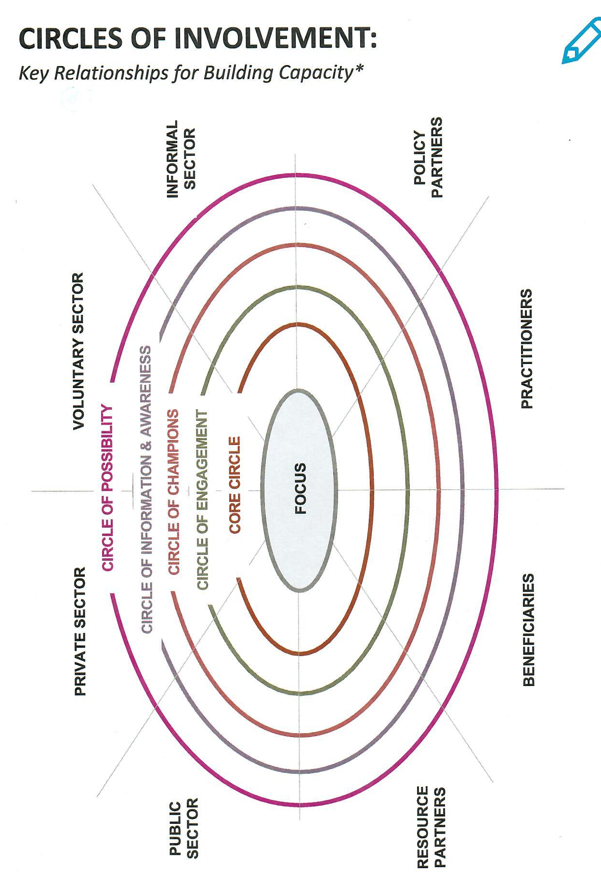
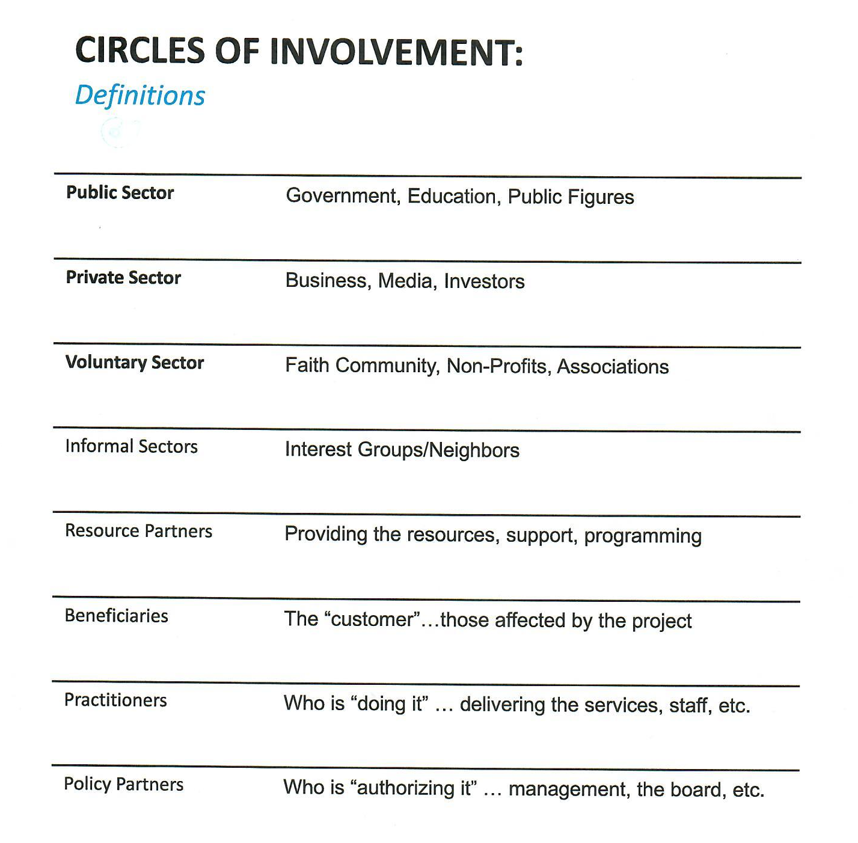
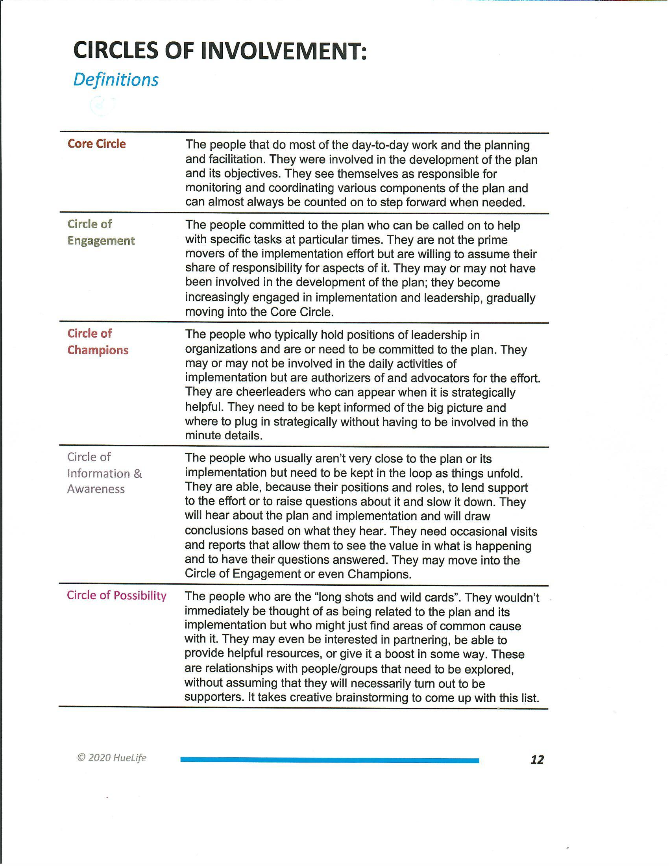

Circle of Involvement Worksheet
Potential Community Partner Organization | Organization Representative | Potential Role in Partnership | Potential Contribution to Partnership | Message to Engage Partner | Method of Communicating Message | Person Delivering Message
Long Term Care Provider | Administrator Dan | - Care Team Member  - Advisory  - Taskforce | - Referrals  - Care plan development | - Decrease resident stress  - Decrease behavior issues  - Decrease staff time coordinating transportation  - Increase resident/care giver satisfaction | - Email  - Phone  - Care team meeting | Janice

A Checklist for Organizing Partnership Engagement
- Ask partners to describe what they can bring to the partnership: this is also a way to assess their level of commitment
- Craft a compelling message based on your assessment of the community’s need for addressing health needs
- Identify how each partner will benefit from the partnership and how the partnership will benefit from the partner’s participation. Discuss the consequences and next steps in the event that particular partners do not want to engage in the partnership.
- Identify how the message should be delivered. You can engage partners through large events, meetings, 1:1 conversations.
- Review the role each organization will play in your partnership.
- Use relevant data to support your partnership and goal and solicit partner engagement. Sharing data that highlights your organizations priorities can effectively mobilize support for this initiative.

Understanding Who Should Attend the Community Connect Event and Why Should They Stay for the Event

PREFACE: The table below captures who should be invited to the Community Connect event and why they should stay. Please note this is a general list and is not inclusive of other attendees. Use this as a guide for creating the invite list and talking points when speaking with prospective attendees.

Event Attendees | Why Invite | Why Stay
Hospital Staff (Frontline, Management and Leadership) | Need to hear input from all community joint partners, leaders and residents to understand community health goals. | It shows the community you are committed to the community’s health and your words hold weight. Decision makers need to ensure work supports their mission and goals and is worth their time and energy as project leads.
Community Residents | Residents are the voice of the community. | To learn about the health outcomes. To use their voice to share their health goals and how the hospital and its joint partners can help achieve those goals.
Health Department | Already speak population health and have a pulse on MANY aspects of community health needs and resources. Strong partners in population health. | To act as a voice for community residents. that may not be attending the event or comfortable expressing themselves. To offer diverse opinions and insight to community residents’ health goals and the barriers to those goals. To also share how they can connect with hospital and its joint partners to support goal attainment and create a culture of health for the community.
Social Services | Aware of community assistance services for all ages and social/economic needs. Can speak on behalf of clients. | To act as a voice for community residents. that may not be attending the event or comfortable expressing themselves. To offer diverse opinions and insight to community residents’ health goals and the barriers to those goals. To also share how they can connect with hospital and its joint partners to support goal attainment and create a culture of health for the community.
Mental Health  Rep | Aware of resources for mental health patients or the lack of. Mental/Behavioral Health/ Substance Abuse patients contribute greatly to ED visits. | To act as a voice for community residents. that may not be attending the event or comfortable expressing themselves. To offer diverse opinions and insight to community residents’ health goals and the barriers to those goals. To also share how they can connect with hospital and its joint partners to support goal attainment and create a culture of health for the community.
Library Staff | Non-intimidating. They interact with people of all income levels. They are knowledgeable resources connecting people to services. | To act as a voice for community residents. that may not be attending the event or comfortable expressing themselves. To offer diverse opinions and insight to community residents’ health goals and the barriers to those goals. To also share how they can connect with hospital and its joint partners to support goal attainment and create a culture of health for the community.
Local large business managers | Have a pulse on the community economic situation. Understand the job needs and forecast. | To act as a voice for community residents. that may not be attending the event or comfortable expressing themselves. To offer diverse opinions and insight to community residents’ health goals and the barriers to those goals. To also share how they can connect with hospital and its joint partners to support goal attainment and create a culture of health for the community.
Mayor/Chamber | Represents the community. They have knowledge of many services and a vested interest in improving the health of the area. | To act as a voice for community residents. that may not be attending the event or comfortable expressing themselves. To offer diverse opinions and insight to community residents’ health goals and the barriers to those goals. To also share how they can connect with hospital and its joint partners to support goal attainment and create a culture of health for the community.
Law Enforcement | Interact with people who have mental, behavioral, and substance abuse health needs. Can speak to safety concerns that frequently impact health choices in the community. Work with individuals of all income levels and see what is not always spoken about. | To act as a voice for community residents. that may not be attending the event or comfortable expressing themselves. To offer diverse opinions and insight to community residents’ health goals and the barriers to those goals. To also share how they can connect with hospital and its joint partners to support goal attainment and create a culture of health for the community.
School Administration | Interact with school age children and their parents from all economic backgrounds, different languages, and abilities. They understand the barriers for their students and are essential to developing action items to pertaining to youth. | To act as a voice for community residents. that may not be attending the event or comfortable expressing themselves. To offer diverse opinions and insight to community residents’ health goals and the barriers to those goals. To also share how they can connect with hospital and its joint partners to support goal attainment and create a culture of health for the community.
Emergency Medical Services | Trusted community health resource. Available 24/7. See people where they live, learn, work, and grow. | To act as a voice for community residents. that may not be attending the event or comfortable expressing themselves. To offer diverse opinions and insight to community residents’ health goals and the barriers to those goals. To also share how they can connect with hospital and its joint partners to support goal attainment and create a culture of health for the community.
Faith Based Community | Churches are a support network and aid for community members. Frequently aware of community resources and services. Trusted leaders in the community. | To act as a voice for community residents. that may not be attending the event or comfortable expressing themselves. To offer diverse opinions and insight to community residents’ health goals and the barriers to those goals. To also share how they can connect with hospital and its joint partners to support goal attainment and create a culture of health for the community.
Housing Representative | Can speak to HUD/low income/elderly housing needs in the community. Know available housing resources and needs. | To act as a voice for community residents. that may not be attending the event or comfortable expressing themselves. To offer diverse opinions and insight to community residents’ health goals and the barriers to those goals. To also share how they can connect with hospital and its joint partners to support goal attainment and create a culture of health for the community.
Local Reporter | Can partner with for public exposure of the hospital’s activities. | To capture firsthand the outcomes of the event and share the experience through the local newspaper.
Senior Population  Representative | Assisted living, home health, nursing homes staff can speak on behalf of patients with multiple chronic conditions and health needs. | To act as a voice for community residents. that may not be attending the event or comfortable expressing themselves. To offer diverse opinions and insight to community residents’ health goals and the barriers to those goals. To also share how they can connect with hospital and its joint partners to support goal attainment and create a culture of health for the community.

