Stay the Course Community Champion Responsibilities - 2023

Table of Contents

Overview 2

Stay the Course Community Champion Responsibility Overview 3

Setting the Stage Presentation 6

Agenda Format 6

Stay the Course Options 8

STC Room Prep 9

Participant Tables (DRCHSD staff provides) 9

Walls (DRCHSD staff provides) 9

Other 9

In-Person Room Requirements 10

## Overview

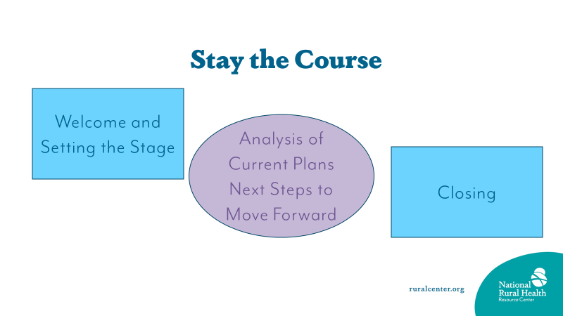

## Stay the Course Community Champion Responsibility Overview

|  |  |  |  |
| --- | --- | --- | --- |
| **Step** | **Responsibilities** | | **Completed?** |
| **Step 1: Pre–Work** | * Complete two 90-minute prep calls with DRCHSD staff * Issue Invitation to Community Partners and health care organization staff a month in advance * Complete visuals for Analysis of Plans (See Step 4 below for details) * Complete Welcome Design * Complete Setting the Stage Presentation * Complete Closing (see step 6 below for details) | |  |
| **Step 2:** **Welcome** (20 Minutes) | * + Welcome   + Introductions   + Big Question   + Agenda/process for day | |  |
| **Step 3:** **Setting the Stage Presentation** (20 -minute PowerPoint) | * Highlights of your work:   + - History of program     - Priority areas     - Community Partners through time     - Community Events     - Highlights of activities     - Other happenings with program * CEO – talk about vision for community care coordination in the future | |  |
| **Step 4: Analysis of Current Plans**  **(10 minutes to go over visuals)** | * We will use the sticky wall for this. * Priority Areas * Use 8.5 x 11 sheets of paper color of your choice – but use the same color for all priority areas * One Priority Area per sheet * Write Big * Actions for each area * Use ½ sheets of 8.5 x 11 paper. Color of your choice – but use the same color for all priority action ideas. * One action item per ½ sheet * Use your previous reports for this information | * A picture containing chart    Description automatically generatedPriority Area Diagram |  |
| **Step 5: Solutions Workshop (2.5 hours)** | * Prepare for leading one of the breakout sessions   + We will discuss this in detail in one of the 90-minute individual sessions | |  |
| **Step 6: Closing – Focus Conversation (15 minutes)** | * Prepare Closing   + Reflection on work done today through a Focus Conversation   + Next Steps   + Thank you / Farwell | |  |
| **Step 6: Prepare Report** | * Prepare report of visit. * Due to DRCHSD staff 2 weeks after the site visit. | |  |

## Setting the Stage Presentation

The ‘Setting the Stage’ presentation is yours to design. In previous events, you have done different versions. Most often DRCHSD staff have provided templates. This time we are providing an outline of what should be included – but you choose your own design. This is a time for you to use the training you have had in preparing PowerPoint presentations. You should aim for 20 minutes. As mentioned in the Learning Collaborative, you are challenged to frame your setting the stage presentation around; what was present when you started community care coordination work and is no longer there, what things are now status quo that community care coordination has developed, what are the things that are just ready to be implemented, and finally what are your dreams, what is out on the horizon.

Your draft presentation will be shared at one of the upcoming Q&A times.

Your CEO will have at least 5 minutes to share his/her vision for community care coordination along with how the health care organization is going to support the efforts. This can be part of your presentation or right after it.

## Agenda Format

Delta Region Community Health System Development (DRCHSD) Program

**Health care organization Full Name – Stay the Course**

**Purpose:** 1) To review priority areas and work done in each, and 2) To determine how we are going to stay the course and confirm partner involvement.

**Audience:** Community Champion, community partners (current and prospective), health care organization leadership, management, and frontline staff.

**Date and Time (5 hours)**

|  |  |  |
| --- | --- | --- |
| 25 minutes | **Welcome and Introductions**   * Provide welcome | CEO, Community Champion |
| 25 minutes | **Setting the Stage - Looking back and looking forward** | CEO, Community Champion |
| 20 minutes | **Analysis of Current Plans** | Community Champion, Priority Leads, and DRCHSD staff |
| 10 minutes | **Moving Forward** | DRCHSD staff |
| 2.5 hours | **Priority Area Next Steps - Small Groups**  **Break** | DRCHSD staff, Community Champion |
| 30 minutes | **Report Out from Small Group Work** | DRCHSD staff |
| 15 minutes | **Closing**   * Capture group photo * Debrief the workshop and discuss next steps | DRCHSD staff, Community Champion |

## STC Room Prep

### Participant Tables (DRCHSD staff provides)

* 4 - 6 participants per table
* Decorative paper
* Markers
* ½ sheets of paper
* Fidget toys
* Stickers / stars
* Pens

### Walls (DRCHSD staff provides)

* 2 Sticky walls
* Agenda
* Victory
* Shifts

### Other

* Staff Supply Table
* Registration Table

### 

### In-Person Room Requirements

* **Mandatory Requirements!!**
  + Wall Space for **1 main** sticky wall that is 5’ high and 12’ wide
  + Wall space for 2 sticky walls for break out session planning 4’ high and 6’ wide
  + Tables for 4 or 6 participants with 6’ between tables. These can be round or two rectangular tables together.
* Needed
  + One 4- or 6-foot table for Center staff to use for supplies
  + One 4- or 6-foot table to use for participant registration (Community Champion set up)
* Optional
  + A table for refreshments

On the next page, you will find a diagram of the requirements above.

Center Supply Table

Sticky Wall 1

3 Chairs

3 Chairs

6’

Sticky Wall 3

Registration Table



Sticky Wall 2

This is not to scale. You will need enough tables for the number of participants.