Delta Region Community Health Systems Development (DRCHSD) Program

2024 Community Health Status Report

Health Care Organization Name

The below tables and graphs provide information from a variety of secondary data sources about demographics, social and economic factors, and quality indicators. Please note, the data collected for this report is the most current information as of May 2024. Where available, comparative data is provided for the average of the state and US or the United States. Please refer to Appendix A for a description of the secondary data indicators and sources. Refer to Appendix B to learn how to look up the secondary data for yourself.

Health Care Organization Overview (AHA)
Name
Address
CEO

What’s possible in your community?
Being healthy means more than just not being sick; health is impacted by a wide range of causes. Although clinical care is a contributing aspect to health outcomes, it’s important to emphasize the community conditions in which people are born, grow, live, work, and age – also known as the social drivers of health (SDOH). Examples of SDOH include factors such as education, food access, poverty, mental health assistance, neighborhood environment, employment, and family and social support.
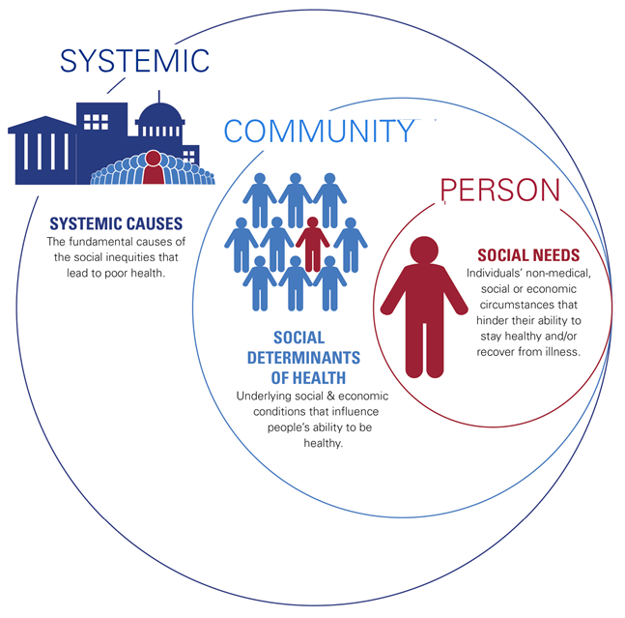
Figure 1: County Health Rankings Model Figure 2: Societal Factors that Influence Health: A Framework for Hospitals

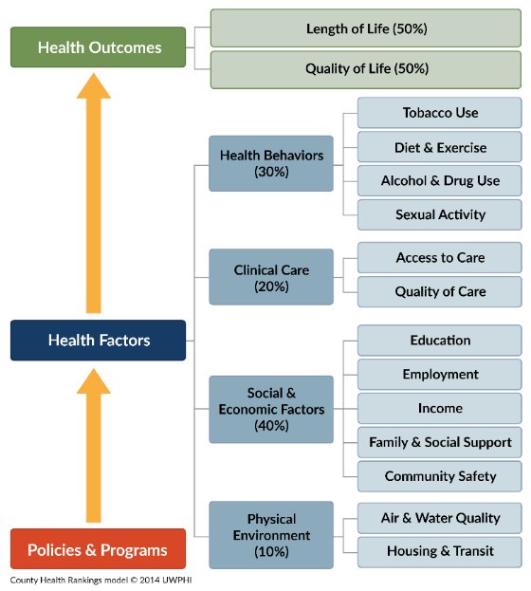

The measures listed in this report will challenge communities to consider the social drivers of health and how these hinder an individual, population group, or community’s ability to be healthy, stay healthy, or recover from an illness. Through community care coordination, health and social service providers can collaborate to support areas such as food access, employment aid, transportation, and housing. These positively impact a person’s long-term health and well-being, while also improving community health outcomes. These relationships and collaboration will open doors that allow communities to 1) work together to identify and prioritize key health needs, 2) coordinate existing strengths to innovate solutions, and 3) plan projects that continue to ensure everyone has a fair opportunity to be their healthiest selves. Collaborating with partners could develop an education program, open a new clinic, or address transportation needs and much more.
Figure 3: Uncovering Root Causes
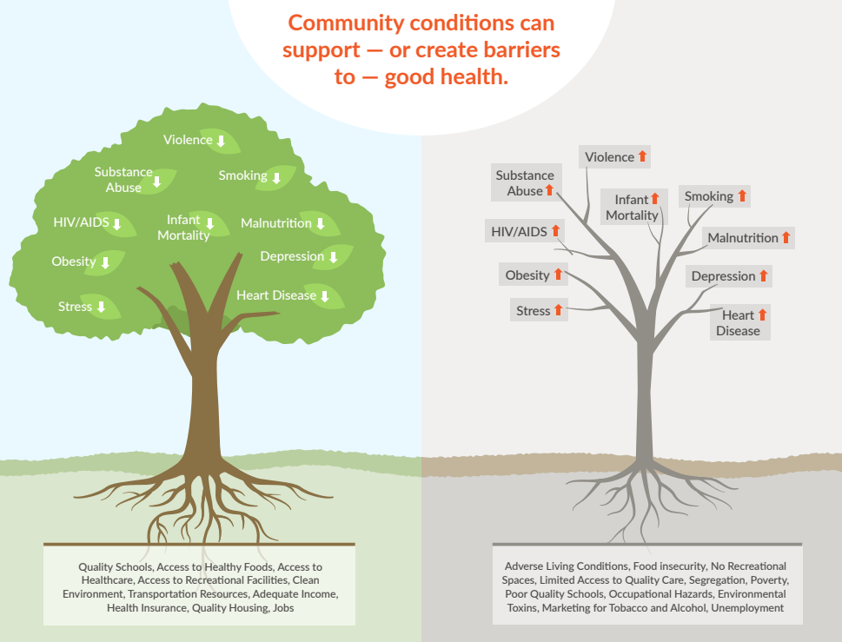
This document compiles secondary data (obtained from state and federal sources) about your local county/parish and state. This is not all the data available for your location, but merely a snapshot. These measures highlight areas where potentially not everyone has the same opportunity to be healthy. This should be the start of a conversation about the needs of your individual community. This data should be used to brainstorm partners (leaders, organizations, those with lived experience) for collaboration. Their voices are essential to informing this work – everyone plays a crucial role in changing the health of the community!

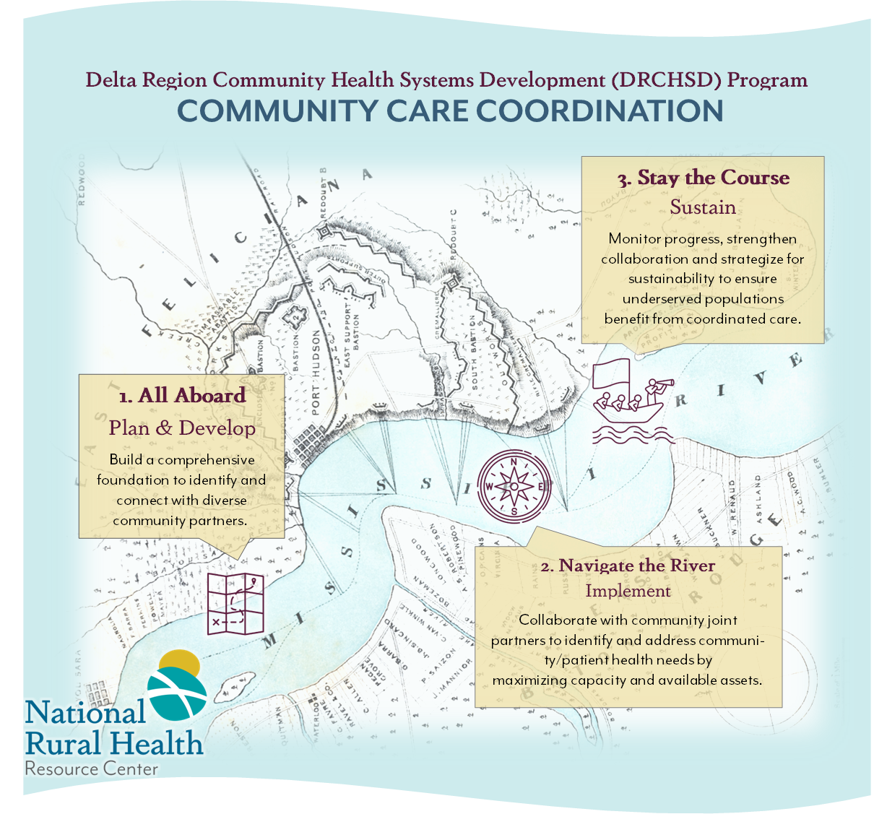
In the future, these specific measures can be tracked by referring to the websites cited for more current information. A “How to” is included in Appendix B, Secondary Data Search Steps to do Yourself.

Organization Background and Mission/Vision
Facility Name is located in City, State, County. It is in which part of the state.
Insert facility history information
Insert Facility Mission and Vision

Demographics

This county/parish has a higher or lower percentage of persons with a disability compared to the state and national averages (% compared to % and %). A high percentage of the population of this county/parish live in an area designated as ‘rural’, _% compared to state, _% and national averages, _%. Additionally, it has a higher percentage of persons aged 65 years and over % compared to the state of XXX, _% and the Nation, _%. It is common to see a higher proportion of seniors in rural areas compared to state and national averages. XXX County/Parish has an average high school completion (_% vs. _% and _%).
 | County/Parish | State | United States
Population Estimates, July 1, 2023 | x | x | 334,914,895
% Rural | x | x | 20.0%
Persons 65 years and over, Percent5 | x | x | 17.3%
Persons under 18 years, Percent5 | x | x | 21.7%
Percent Change in Population (2010- 2020) | x | x | 7.4%
Veteran Population, 2018-20225 | x | x | 17,038,807
With a disability, under age 65 years, percent, 2018-20225 | x | x | 8.9%
High School Graduate or Higher, percent of persons age 25 years+, 2018-20225 | x | x | 89.1%
Bachelor’s degree or higher, percent of persons age 25+, 2018-20225 | x | x | 34.3%

Value of Health Factors & Health Outcomes Data
Health factors represent those things we can improve, like health behaviors, clinical care, social & economic factors, and physical environment, to live longer and healthier lives. These can help identify whether a county/parish is moving in a positive or negative health direction and are indicators of a community’s future health. Health outcomes include length and quality of life and point to how a community experiences health while they are alive.
XXXX county/parish is faring better/worse/the same as the average county/parish in [STATE] for health outcomes, and better/worse than the average county/parish in the nation. XXXX county/parish is faring worse/better/the same than the average county/parish in [STATE] for health factors and better/worse than the average county/parish in the nation.

Social & Economic Factors
XXX County/Parish’s per capita income is lower than the state and United States ($__ vs $__ and $__). Additionally, XXX County/Parish has a higher percentage of uninsured adults (_%), children in single-parent households (_%), and higher unemployment rates (_%) than the state and national averages. The persons in poverty level measures annual cash income for an individual or family. These numbers show the people eligible for programs, subsidies, and benefits like SNAP, Head Start, Children’s Health Insurance Program, and the National School Lunch Program. Child care Centers and Child care Cost Burden are highlighted because affordable childcare options enhance a parent’s or guardians’ opportunity to further their education or participate in paid work, potentially gaining healthcare and retirement benefits. When costs are burdensome or care is unavailable, residents may face difficult decisions related to paying rent/mortgage, affording health care, paying bills, and affording reliable transportation. Adults at or below Level 1 Literacy Level refers to the percentage of the population in each area that may only be able to understand very basic vocabulary or struggle with being illiterate. Adults at or below Level 1 Numeracy may only be able to count, sort, and do basic arithmetic operations with whole number and be functionally innumerate. These levels are important to consider when sharing health information with the general population.

 | County/Parish | State | United States
School Funding Adequacy | x | x | $634
Unemployment8 | x | x | 3.7%
Children in single-parent households8 | x | x | 25%
Living Wage8 | x | x | N/A
Children eligible for free or reduced lunch8 | x | x | 51%
Child care Cost Burden8 | x | x | 27%
Child care Centers8 | x | x | 7
Uninsured Adults | x | x | 12%
Uninsured Children9 | x | x | 5%
Per Capita income in last 12 months, (in 2022 dollars), 2018-2022 5 | x | x | $41,261
Median Household Income, 20225 | x | x | $75,149
Persons in Poverty Percent5 | x | x | 11.5%
Adults at or below Level 1 Literacy Level | x | x | 22%
Adults at or below Level 1 Numeracy Level10 | x | x | 32%

Health Behavior and Outcomes
Health behaviors, such as physical activity and eating healthy foods, can lead to positive health outcomes such as longer life, mobility, mental wellness, healthy pregnancies and births, prevention of chronic and acute disease, and management of chronic disease. Socially isolated individuals have an increased risk for poor health outcomes, including chronic disease, unhealthy behaviors, and obesity. XXX County/Parish has a higher percentage of people citing adult smoking (_%), physical inactivity (_%), alcohol impaired driving deaths (_%), and poor mental health days (__) than United States. The use of cigarettes, lack of physical activity, dietary choices, and other elements can lead to numerous chronic diseases and comorbidities including cardiovascular disease, diabetes, and cancer. Alcohol impaired driving results in more unintentional injuries and higher mortality rates. Additionally, the rates of people who regard themselves as having poor or fair health is _% County/Parish, _% State, and __% United States. This measure relates to quality of life and describes how healthy people are while alive. People who rate themselves as “poor or fair health” have a twofold higher mortality risk than persons with “excellent” health. Teen birth rates are also higher in XXX County/Parish, __/1,000 compared to State, __/1,000 and United States, __/1,000. Teen births can tie to social disadvantages like decreased educational attainment, increased physical and mental stress, lack of community support and child care options, and employment challenges.

 | County/Parish | State | United States
Adult Smoking | x | x | 15%
Physical Inactivity12 | x | x | 23%
Adult Obesity12 | x | x | 34%
Excessive Drinking12 | x | x | 18%
Alcohol Impaired Driving Deaths12 | x | x | 26%
Drug Overdose Deaths12 | x | x | 27
Poor or Fair Health | x | x | 14%
Teen Births 12 | x | x | 17
Poor Mental Health Days reported in the last 30 days13 | x | x | 4.8

Physical Environment
XXX County/Parish has a Food Environment Index slightly higher than the state of XXX (__ vs __). This measure rates proximity to healthy foods and cost on a 0 (worst) to 10 (best) scale. Lower scores correlate with higher prevalence of persons being overweight, obese, and premature death. Severe housing problems are also seen in XXX County/Parish, _%, compared to _% in the United States. However, this is the same as the state of State at _%. This relates to high housing costs, overcrowding, and lack of plumbing facilities. Lastly, _% of people in XXX County/Parish report a long commute, which is less than the state of State at _%, but almost twice the rate of United States at _%. This implies good jobs are not located close to home. Long commuters typically have higher blood pressure and body mass index contributing to obesity than those who work close to home. Broadband Access in this measure reflects any access to the internet, however many areas may not have internet capabilities/strength to connect to all telehealth capabilities.

 | County/Parish | State | United States
Food Environment Index12 | x | x | 7.7
Severe Housing Problems | x | x | 17%
Air pollution-particulate matter (av daily density of particulate matter in µg/m314 | x | x | 7.4
Long Commute-driving alone (>30 minutes)14 | x | x | 36%
Broadband Access14 |  |  | 88%

Clinical Care
Residents in XXX County/Parish have a fewer number of mental health providers, primary care physicians, and dentists compared to the state of XXX and United States. They also have a higher rate of preventable hospital stays per 100,000 Medicare enrollees related to ambulatory care, ____ compared to United States, ____. The preventable hospital stays measure, rates the hospital stays pertaining to ambulatory-care sensitive (relating to the ability to walk) conditions. These patients are suggested to have received less than ideal outpatient care that resulted in a hospital stay. This measure is classified as a quality and access measure. Lastly, XXX County/Parish has a smaller percentage of residents receiving flu vaccinations, __% compared to State, __%, and United States, ____%. Unfortunately, this measure only takes into account Medicare fee-for-service enrollees and may miss trends pertaining to young and people not enrolled in Medicare.

 | County/Parish | State | United States
Primary Care Physicians9 | x | x | 1,330:1
Mental Health Providers9 | x | x | 320:1
Dentists9 | x | x | 1,360:1
Preventable Hospital Stays Related to Ambulatory-Care per 100,000 Medicare Enrollees9 | x | x | 2,681
Flu Vaccinations9 | x | x | 46%
Mammography screening9 | x | x | 43%

The graph below shows in another way, that XXX County/Parish has had a shortage of primary care physicians compared to the state of XXX going back to at least 2010. Availability of primary care physicians and dentists is essential for individuals to receive preventative care and referrals to appropriate specialty care.

Figure 4. Primary care physicians in Hardin County, TN County, State, and National Trends, 2010-2021. Graph from County Health Rankings, Hardin County, TN. Retrieved from
https://www.countyhealthrankings.org/health-data/tennessee/hardin?year=2024

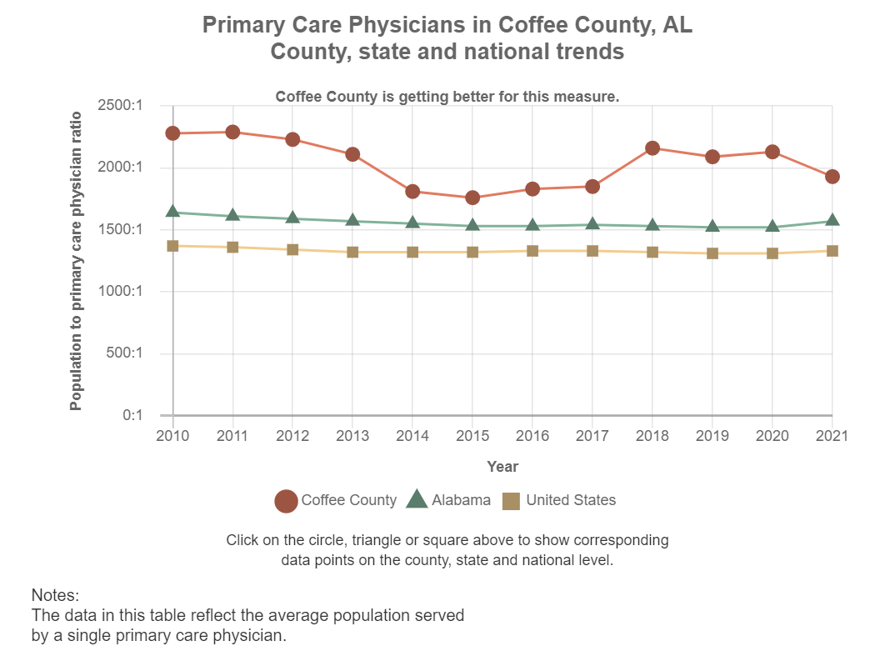

Health Outcomes
Life expectancy in XXX County/Parish is __ years, which is below __ years for State and the United States, ____ years. This measure is easier to understand than years of potential life lost and is an important population health outcome measure. Injury deaths are an important measure because injuries are one of the leading causes of death of those under 45 years old. Poisoning, motor vehicle deaths, and falls are included under unintentional injuries and suicides and homicides fall under intentional injuries. Injuries are also a significant portion of emergency department visits. The injury death rate in XXX County/Parish, __/100,000 is higher than the state of XXX, __/100,000 and United States, ____/100,000. Low birth weight and infant mortality are important public health metrics because they can gauge maternal health, nutrition, health care delivery, poverty, and can be tied to health disparities between groups. Diabetes is persistent condition highlighted in health outcomes because of its impact on physical, social, and mental health and causes significant suffering and death. Diabetes prevalence in XXX County/Parish is ________, which is below __ for State and the United States, ____.

 | County/Parish | State | United States
Life Expectancy13 | x | x | 77.6
Premature Age-Adjusted Mortality (YPLL) 13 | x | x | 390
Low Birth Weight13 |  |  | 8%
Infant Mortality13 | x | x | 6
Diabetes Prevalence13 | x | x | 10%
Injury Deaths8 | x | x | 80

Patient Survey Rating
Survey of patients' experiences: HCAHPS (Hospital Consumer Assessment of Healthcare Providers and Systems) is a national survey that asks patients about their experiences during a recent hospital stay. These scores are important because they provide comparable data from a patient’s perspective between hospitals. They consider patient satisfaction and perception of care and not just the outcome of the patient. Reimbursements are also linked to HCAHPS scores and organizations need to take the results seriously to maximize reimbursements. Use the below scores with caution, as the number of surveys may be too low to reliably assess hospital performance in rural areas. Data not available for medical centers or clinics.
Patients who reported:
 | Organization | State | Nation
Nurses “always” communicated well |  |  | 79%
Doctors “always” communicated well |  |  | 79%
“Always” received help as soon as they wanted |  |  | 66%
Staff “always” explained about medicines before giving it to them |  |  | 62%
Their room and bathroom were “always” clean |  |  | 72%
Area around their room was “always” quiet at night |  |  | 62%
YES, they were given information about what to do during their recovery time |  |  | 86%
“Strongly Agree” they understood their care when they left the hospital |  |  | 52%
Gave their hospital a rating of 9 or 10 on a scale from 0 (lowest) to 10 (highest) |  |  | 71%
YES, they would definitely recommend the hospital |  |  | 69%

Appendix A

Description of Secondary Data Indicators
Data Areas | Description | Source and Dates
Population Estimates, July 1, 2023 | Resident Population | US Census Bureau, Quick Facts: County, State, and United States. 2023 data.
% Rural | Percentage of population living in census-defined rural areas. Rural areas are identified using population density, count, and size thresholds. | County Health Rankings data from US Census Bureau Decennial Census Demographic and Housing Characteristics File, 2020 data.
Persons 65 years and over, percent | Estimated percentage of the population in the report area age 65 or older. | US Census Bureau, Quick Facts: County, State, and United States. 2023 data.
Persons under 18 years, percent | Estimated percentage of the population in the report area under 18 years of age. | US Census Bureau, Quick Facts: County, State, and United States. 2023 data.
Percent Change in Population (2010- 2020) | Population changes between 2010 and 2020 Census | U.S Census Bureau, State Visualizations of Key Demographic Trends from the 2020 Census, 2020 data.
Veteran Population, 2018-2022 | Percentage of the population age 18 and older that served (even for a short time), but are not currently serving, on active duty in the U.S. Army, Navy, Air Force, Marine Corps, or the Coast Guard, or that served in the U.S. Merchant Marines during World War II. National Guard or Reserves are classified as veterans only if they were ordered to active duty, not including initial training or yearly summer training. | US Census Bureau, Quick Facts: County, State, and United States. 2018-2022 data.
With a disability, under and 65 years, percent, 2018-2022 | Percentage of those who report serious difficulty with specific functions related to hearing, vision, cognition, ambulatory, self-care, and independent living as reported to the American Community Survey. | US Census Bureau, Quick Facts: County, State, and United States. American Community Survey, 2018-2022 data.
High School Graduate or Higher, percent of persons age 25 years+, 2018-2022 | Percentage of persons ages 25 and older with a high school diploma or equivalent | US Census Bureau, Quick Facts: County, State, and United States. 2018-2022 data.
Bachelor’s degree or higher, percent of persons age 25+, 2018-2022 | Percentage of persons ages 25 of older with bachelor’s degree or higher | US Census Bureau, Quick Facts: County, State, and United States. 2018-2022 data.
School Funding Adequacy | The average gap in dollars between actual and required spending per pupil among public school districts. | County Health Rankings data from the School Finance Indicators Database, 2021 data.
Unemployment | Percentage of the county’s population ages 16 and older that are unemployed but seeking work. | County Health Rankings data from the Bureau of Labor Statistics- Local Area Unemployment Statistics program, 2022 data.
Children in Single-Parent Households | Percentage of county’s children that live in a household headed by a single parent. 5-year estimates | County Health Rankings data from the American Community Survey, 2018-2022 data.
Living Wage | The hourly wage needed to cover basic household expenses plus relevant taxes for a household of one adult and two children. | County Health Rankings data estimated using the Living Wage Calculator developed by MIT which estimates the cost of living in a region based on typical expenses, 2023 data.
Children Eligible for Free or Reduced-Price Lunch | Percentage of children enrolled in public schools that are eligible for free or reduced lunch | County Health Rankings data from National Center for Education Statistics, 2021-2022 data.
Child Care Cost Burden | Child care costs for household with two children as a percent of median household income. | County Health Rankings data from The Living Wage Calculator and U.S. Census Bureau’s Small Area Incomes and Poverty Estimates, 2022 & 2023 data.
Child Care Centers | Number of child care centers per 1,000 population under 5 years old. | County Health Rankings data from Homeland Infrastructure Foundation-Level Data (HIFLD), 2010-2022 data.
Uninsured Adults | Percentage of adults under age 65 without health insurance. | County Health Rankings data from US Census Bureau, Small Area Health Insurance Estimates, 2021 data.
Uninsured Children | Percentage of children under age 19 without health insurance. | County Health Rankings data from US Census Bureau, Small Area Health Insurance Estimates, 2021 data.
Per Capita income in last 12 months (in 2022 dollars), 2018-2022 | Mean income computed for every man, woman, and child in a particular group, including those living in group quarters. Dividing the aggregate income of a particular group by the total population of the group. | US Census Bureau, Quick Facts: County, State, and United States. 2018-2022 data.
Median Household Income, 2018-2022 | Income where half of households in a county earn more and half of households earn less. | US Census Bureau, Quick Facts: County, State, and United States. 2018-2022 data.
Persons in poverty, percent | An income measure used by the federal government to determine who is eligible for subsidies, programs, and benefits. Using a set of money income thresholds that vary by family size and composition. If a family’s total income is less than the family’s threshold, then that family and every individual in it is considered in poverty. | US Census Bureau, Quick Facts: County, State, and United States. National level data from Current Population Survey, Annual Social and Economic Supplement. State level data from American Community Survey, 1-year estimates. County level data from Small Area Income and Poverty Estimates, 1-year estimates. 2022 data.
Adults at or below Level 1 Literacy Level | Adults at this level can be considered at risk for difficulties using or comprehending print materials. Adults at the upper end of this level can read short texts in print or online and understand the meaning well enough to preform simple tasks, such as filling out a short form, but drawing inferences or combining multiple sources of texts may be difficult. Adults who are below level 1 may only be able to understand very basic vocabulary or find very specific information on a familiar topic. Some adults below level 1 may struggle even to do this and may be functionally illiterate. | U.S. Department of Education, National Center for Education Statistics. U.S. Program for the International Assessment of Adult Competencies (PIAAC) U.S. Skills Map: State and County Indicators of Adult Literacy and Numeracy. 2012/2014/2017 data from https://nces.ed.gov/surveys/piaac/skillsmap/
Adults at or below Level 1 Numeracy Level | Adults at this level can be considered at risk for difficulties with numeracy. Adults at the upper end of this level can understand how to add, subtract, multiply, and divide and can perform one-step mathematical operations with given values or common spatial representations. Adults who are below level 1 may only be able to count, sort, and do basic arithmetic operations with simple whole numbers and may be functionally innumerate. | U.S. Department of Education, National Center for Education Statistics. U.S. Program for the International Assessment of Adult Competencies (PIAAC) U.S. Skills Map: State and County Indicators of Adult Literacy and Numeracy. 2012/2014/2017 data from https://nces.ed.gov/surveys/piaac/skillsmap/
Adult Smoking | Percentage of adults who are current smokers (age-adjusted). | County Health Rankings data from the Behavioral Risk Factor Surveillance System from 2021 data
Physical Inactivity | Percentage of adults aged 18 and older self-report no leisure time for physical activity, based on the question: "During the past month, other than your regular job, did you participate in any physical activities or exercises such as running, calisthenics, golf, gardening, or walking for exercise?". | County Health Rankings data from Behavioral Risk Factor Surveillance System from 2021 data.
Adult Obesity | Percentage of the adult population, aged 18 and older, that self-report they have a Body Mass Index (BMI) greater than 30.0kg/m² (obese)- age-adjusted. | County Health Rankings data from Behavioral Risk Factor Surveillance System, 2021.
Excessive Drinking | Percentage of adults reporting binge or heavy drinking (age- adjusted). | County Health Rankings data from the Behavioral Risk Factor Surveillance System. 2021 data
Alcohol Impaired Driving Deaths | Percentage of driving deaths with alcohol involvement | County Health Rankings data from the Fatality Analysis Reporting System. 2017-2021 data.
Drug Overdose Deaths for 100,000 | Number of drug poisoning deaths per 100,000 population | County Health Rankings data from the National Center for Health Statistics- Mortality Files; Census Population Estimates Program. 2019-2021
Poor or Fair Health | Percentage of adults self-reporting fair or poor health (age-adjusted). | County Health Rankings from Behavioral Risk Factor Surveillance System, 2021 data
Teen Births | Number of births to female population, ages 15 – 19, per 1,000 | County Health Rankings data from National Center for Health Statistics-Natality Files and drawn from National Vital Statistics System; Census Population Estimates Program. 2016-2022.
Poor Mental Health Days | Average number of self-reported mentally unhealthy days reported in the last 30 days (age adjusted). | County Health Rankings data from Behavioral Risk Factor Surveillance System, 2021.
Food Environment Index | Index of factors that contribute to a healthy food environment (0-worst to 10-best). This index considers income, recreation opportunities, food expenditure(s), and the distance of stores and restaurants. | County Health Rankings data from the U.S. Department of Agriculture Food Environment Atlas and Map the Meal Gap from Feeding America, 2019 and 2021 data.
Severe Housing Problems | Percentage of households with at least 1 of 4 housing problems: overcrowding, high housing costs, lack of kitchen facilities, or lack of plumbing facilities. | County Health Rankings data from the U.S. Department of Housing and Urban Development (HUD)’s Comprehensive Housing Affordability Strategy, 2016-2020 data.
Air Pollution- Particulate Matter | Average daily density of fine particulate matter in micrograms per cubic meter. | County Health Rankings data from the Center for Disease Control and Prevention’s Environmental Public Health Tracking Network, 2019 data.
Long Commute – Driving Alone | Among workers who commute in their car alone, the percentage that commute more than 30 minutes. 5-year estimates. | County Health Rankings data from the American Community Survey 5-Year Estimates, 2018-2022 data.
Broadband Access | Percentage of households with broadband internet connect. The measure counts speed at any level of access, which may not be adequate for all household needs. | County Health Rankings data from the American Community Survey 5-Year Estimates, 2018-2022 data.
Primary Care Physicians per 100,000 | Ratio of population to primary care physicians. Doctors classified as "primary care physicians" by the AMA include: General Family Medicine MDs and DOs, General Practice MDs and DOs, General Internal Medicine MDs, and General Pediatrics MDs. Physicians age 75 and over and physicians practicing sub-specialties within the listed specialties are excluded. | County Health Rankings data from the Area Health Resource File compiled by more than 50 sources including the American Medical Association, American Hospital Association, US Census Bureau, Centers for Medicare & Medicaid Services, and National Center for Health Statistics, 2021 data.
Mental Health Providers per 100,000 | Ratio of population to the number of mental health providers including psychiatrists, psychologists, clinical social workers, and counsellors that specialize in mental health care. | County Health Rankings data from the CMS, National Provider Identification Registry and the National Plan and Provider Enumeration System, 2023.
Dentists per 100,000 | Ratio of population to dentists. This indicator includes all dentists - qualified as having a doctorate in dental surgery (D.D.S.) or dental medicine (D.M.D.), who are licensed by the state to practice dentistry and who are practicing within the scope of that license. | County Health Rankings data from the Area Health Resource File/National Provider Identification file maintained by the Centers for Medicare and Medicaid Services, 2022 data.
Preventable Hospital Stays | Rate of hospital stays for conditions that are ambulatory care sensitive (ACS) conditions per 100,000 Medicare enrollees. ACS conditions include pneumonia, dehydration, asthma, diabetes, and other conditions which could have been prevented if adequate primary care resources were available and accessed by those patients. | County Health Rankings data from the Centers for Medicare and Medicaid Services Office of Minority Health’s Mapping Medicare Disparities Tool, 2021 data.
Flu Vaccinations | Percentage of fee-for-service Medicare enrollees that had an annual flu vaccination. | County Health Rankings data from the Centers for Medicare and Medicaid Services Office of Minority Health’s Mapping Medicare Disparities Tool, 2021 data.
Mammography Screening | Percentage of female Medicare enrollees, ages 65-74, that have received an annual mammography screening | County Health Rankings data from the Center for Medicare and Medicaid Services Office of Minority Health’s Mapping Medicare Disparities Tool, 2021 data.
Life Expectancy, Age-Adjusted | Average number of years a person can expect to live, according to the current mortality experience of the population. This measure allows comparisons between counties with differing age structures and population sizes. | County Health Rankings data from the National Center for Health Statistics – Mortality Files, 2019-2021 data.
Premature Age – Adjusted Mortality | Number of deaths among residents under age 75 per 100,000 population (age-adjusted). Rates measure the number of events (ie: births and deaths) in a given time period divided by average number of people at risk during the period. This measure allows comparisons between counties with differing age structures and population sizes. | County Health Rankings data from the National Center for Health Statistics -Mortality Files, 2019-2021 data.
Low Birthweight | Percentage of live births with low birthweight (<2,500 grams or 5.5 pounds). | County Health Rankings data from the National Center for Health Statistics -Natality Files, 2016-2022 data.
Infant Mortality | Number of all infant deaths (within 1 year), per 1,000 live births. This measure represents the health of the most vulnerable age group and is commonly used to examine global health differences and historic racial inequalities in the US. | County Health Rankings data from National Center for Health Statistics, Mortality Files, 2015-2021 data.
Diabetes Prevalence | Percentage of adults aged 20 and older who have ever been told by a doctor that they have diabetes (age-adjusted). | County Health Rankings data from Behavioral Risk Factor Surveillance System, 2021 data.
Injury Deaths | Number of deaths due to injury per 100,000 population. Intentional injuries are generally related to violence and unintentional injuries are accidental. | County Health Rankings data from the National Center for Health Statistics- Mortality Files; Census Population Estimates Program, 2017-2021 data.

Appendix B

Secondary Data Search Steps to do Yourself

County Health Rankings
- Go to https://www.countyhealthrankings.org
- Scroll down to “How healthy is your community” and type in your county or parish in the search. Your state should come up with it.
- Scroll through measures
- You can click on any measures, such a “Premature Death”, and scroll through disaggregated data by racialized group, look for trends, and view map.
- While you have a measure selected, you can learn more about the measure by selecting “methods and limitations” highlighted in blue or “find strategies” to address each measure. Data shows you the actual numbers/data the graphs and rankings are based off. About describes what was measured in greater detail. Source tells you where the data originally came from (CDC, Census Data, etc).

United States Census Bureau - QuickFacts
- Go to https://www.census.gov/quickfacts/
- Enter your state in the search field and hit enter. Enter your county/parish in the search field and hit enter.
- You can now see a table with your census data.
- Scroll down to look at the data tables, maps, and pages related to that location.

US Skills Map
- Follow the link to https://nces.ed.gov/surveys/piaac/skillsmap/ to locate your counties literacy and numeracy rates.
- You will notice there is an area to search for both literacy and numeracy beneath the search bar. You can also switch between the county and state tabs above the search bar.
- Search for your county/parish and state literacy and numeracy rates for “At or Below Level 1”. This selection should be defaulted upon opening the website.
- “At or Below Level 1” literacy is defined as, “adults at risk for difficulties using or comprehending print material. Adults at the upper end of this level can read short texts, in print or online, and understand the meaning well enough to perform simple tasks, such as filling out a short form, but drawing inferences or combining multiple sources of text may be too difficult. Adults who are below Lebel 1 may only be able to understand very basic vocabulary or find very specific information on a familiar topic. Some adults below Level 1 struggle even to do this and may be functionally illiterate.”
- “At or Below Level 1” numeracy is defined as, “adults at risk for difficulties with numeracy. Adults at the upper end of this level can understand how to add, subtract, multiply, and divide and can perform basic one-step mathematical operations with given values or common spatial representations (e.g., calculate how may bottles of soda are in a full box with two levels when only the top level can be seen). Adults who are below Level 1 may only be able to count, sort, and do basic arithmetic operations with simple whole numbers and may be functionally innumerate.”

Medicare.gov – Hospital Compare
- Go to https://www.medicare.gov/care-compare/ and select “Hospitals” on the left ribbon.
- Enter the field for your location/city and select “Search”.
- Select the organization by clicking on its name and scroll down to the “Patient survey rating” and click “View Survey Details”.
- Please note that not all hospitals have enough completed surveys to list data, so some results may come back as “Not available”.

US Census Bureau – State Visualization
- Go to https://www.census.gov/library/stories/state-by-state.html and select your state.
- Scroll down the page until you find Population and Housing
- Find the “Percent change in Population” on the bottom left of the table for the state
- Scroll down the page a little more to find your county/parish
- Hover over the map where your county is located to find the “Percent change in Population”
- OR
- Scroll the table to find your county/parish specifically and hover over the total population on the right to find the “Percent change in Population”

County Health Rankings & Roadmaps. (2023) County Health Rankings Model. https://www.countyhealthrankings.org/explore-health-rankings/county-health-rankings-model
Bathija, P. and Resnick, J. (2020). Addressing Societal Factors to Improve Health Equity | AHA News. [online] American Hospital Association | AHA News. Available at: https://www.aha.org/news/blog/2020-12-07-addressing-societal-factors-improve-health-equity
County Health Rankings & Roadmaps. (2019, October 4). Understand and Identify Root Causes of Inequities. https://www.countyhealthrankings.org/sites/default/files/UnderstandandIdentifyRootCauses_Worksheet.pdf
Insert Healthcare Organization Website Link Here
U.S. Census Bureau demographics data from QuickFacts
County Demographics data from County Health Rankings & Roadmaps.
Percent Change in Population (2010 to 2020) data from U.S Census Bureau, State Visualizations of Key Demographic Trends from the 2020 Census
Social & Economic data from County Health Rankings & Roadmaps.
Clinical Care data from County Health Rankings & Roadmaps.
National Center for Education Statistics. (2022). U.S. Skills Map: State and County Indicators of Adult Literacy and Numeracy. https://nces.ed.gov/surveys/piaac/skillsmap/
DeSalvo K, Bloser N, Reynolds K, He J, Muntner P. Mortality prediction with a single general self-rated health question. A meta-analysis. Journal of General Internal Medicine. 2006; 21:267-275
Health Behaviors data from County Health Rankings & Roadmaps.
Health Outcomes data from County Health Rankings & Roadmaps.
Physical Environment data from County Health Rankings & Roadmaps.
U.S. Centers for Medicare and Medicaid Service. Care Compare - Hospitals. Medicare.gov. (n.d.). https://www.medicare.gov/care-compare/?providerType=Hospital

