How to Perform Secondary Data Search

County Health Rankings
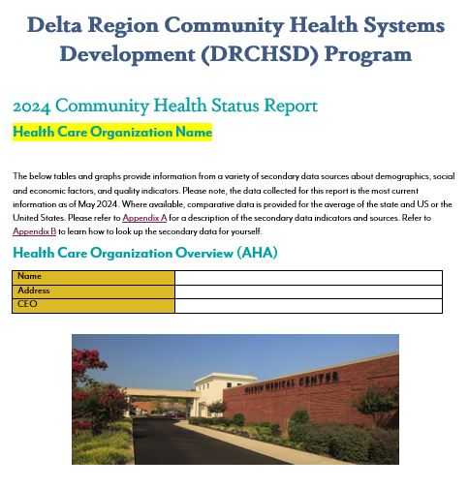
- Go to https://www.countyhealthrankings.org
- Scroll down to “How healthy is your community” and type in your county in the search. Your state should come up with it.
- Scroll through measures
- You can click on any blue measures, such a “Premature Death”, to compare to all other counties in your state on a specific measure.
- While you have a measure selected, notice “Map, Data, Description, and Data Source” highlighted in blue. Each of these can also be clicked on to provide a better understanding of the data. Data shows you the actual numbers/data the graphs and rankings are based off. Description describes what was measured in greater detail. Data source tells you where the data originally came from (CDC, Census Data, etc).

United States Census Bureau
- Go to https://data.census.gov/cedsci
- Type in your county, state in the search box.
- Scroll down to look at the data tables, maps, and pages related to that location.
OR
- Go to https://www.census.gov/
- Scroll down until you see a section titled “Access Local Data/QuickFacts” and click it.
- Enter your state and hit enter. Enter your county and hit enter.
- You can now see a table with your census data.

US Skills Map
- Follow the link to https://nces.ed.gov/surveys/piaac/skillsmap/ to locate your counties literacy and numeracy rates.
- You will notice there is an area to search for both literacy and numeracy beneath the search bar. You can also switch between the county and state tabs above the search bar.
- Search for your county and state literacy and numeracy rates for “At or Below Level 1”. This selection should be defaulted upon opening the website.
- “At or Below Level 1” literacy is defined as, “adults at risk for difficulties using or comprehending print material. Adults at the upper end of this level can read short texts, in print or online, and understand the meaning well enough to perform simple tasks, such as filling out a short form, but drawing inferences or combining multiple sources of text may be too difficult. Adults who are below Lebel 1 may only be able to understand very basic vocabulary or find very specific information on a familiar topic. Some adults below Level 1 struggle even to do this and may be functionally illiterate.”
- “At or Below Level 1” numeracy is defined as, “adults at risk for difficulties with numeracy. Adults at the upper end of this level can understand how to add, subtract, multiply, and divide and can perform basic one-step mathematical operations with given values or common spatial representations (e.g., calculate how may bottles of soda are in a full box with two levels when only the top level can be seen). Adults who are below Level 1 may only be able to count, sort, and do basic arithmetic operations with simple whole numbers and may be functionally innumerate.”

Medicare.gov
- Please reference “Hospital Compare” of the CHSR Template and follow the Patient Survey Rating link (https://www.medicare.gov/care-compare/)
- Enter the fields of your location/city, provider type – “HOSPITALS” and name of your facility in the search field (For example: Chicot, Arkansas – Drew Memorial Hospital) and select “Search”
US Census Bureau – State Visualization
1. Go to https://www.census.gov/library/stories/state-by-state.html and select your state.
2. Scroll down the page until you find Population and Housing
3. Find the “Percent change in Population” on the bottom left of the table for the state
4. Scroll down the page a little more to find your county/parish
5. Hover over the map where your county is located to find the “Percent change in Population”
6. OR
7. Scroll the table to find your county/parish specifically and hover over the total population on the right to find the “Percent change in Population”

