Strategic Plan Sample

Rural Allied Health Training Networks Program Technical Assistance

June, 2016

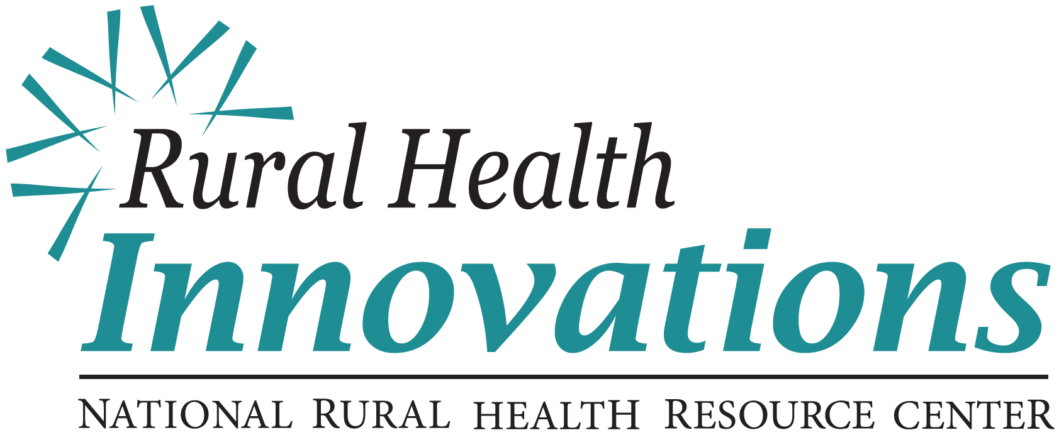

525 South Lake Avenue, Suite 320 │ Duluth, Minnesota 55802   
(218) 727-9390 │ info@ruralcenter.org  
Get to know us better: www.ruralcenter.org/rhi

Facebook iconcid:image002.png@01CF4CF0.D46F4E00Blog iconcid:image002.png@01CF4CF0.D46F4E00Twitter iconcid:image002.png@01CF4CF0.D46F4E00LinkedIn Icon

This is a publication of Rural Health Innovations, LLC, (RHI), a subsidiary of the National Rural Health Resource Center. The Technical Assistance for Network Grantees Project is supported by Contract Number HHSH250201400024C from the U.S. Department of Health and Human Services, Health Resources and Services Administration, Federal Office of Rural Health Policy.

Table of Contents

Network Purpose and Shared Vision 2

Environmental Scan and Analysis 4

Strategic Objectives 5

Communication Plan 6

Operationalizing the Objectives and Key Initiatives 7

Monitoring and Adjusting 8

## Network Purpose and Shared Vision

* **Network History**

WHP network, established in 2012, aligns seven separate entities in all aspects of health care for a six county region in rural northern Iowa. Services provided include ambulance and emergency care, primary and specialty care, surgical care and community health and wellness. A core focus of WHP is offering comprehensive healthcare to improve health for rural residents. The network was founded to increase access to high quality health care and to ensure that all rural residents in the area are able to receive the care needed.

* **Network Members**

WHP network is governed by a board consisting of the CEO’s from Iowa Specialty Hospital Clarion, Iowa Specialty Hospital Belmond, along with the founding physicians of Orthopedic Specialists and Gabrielson Clinic for Women. Other key leaders are on the board, including North Iowa Area Community College (NIACC) outreach director, Belmond-Klemme High School superintendent, ABCM Corporation marketing coordinator, and the chief quality officer and physician representation from all the sites across the network. This board was selected based on the network structure and the mission of the network to ensure each member had representation as well as those directly serving the patients. The board is charged with making financial, personnel, and strategic planning for the entire network.

* **Network Mission**

The WHP Health Careers Academy will effectively train and retain highly skilled personnel across the six entities in northern Iowa.

* **Network Shared Vision**

“Excellence in Healthcare”, encompassing integrity and compassion driven by accountability and sustained results.

One of the first things done at the network strategic planning retreat was to develop the networks vision. We used the 90 minute vison workshop provided in the strategic planning guide. By the end of our time we were in unanimous agreement on the networks vision.

* **Goals**

1. To provide safe, effective, and timely access to high quality rural health care.
2. Wright Health Partners within three years will develop a sustainable community-based job-driven program for health professionals in North Central Iowa.
3. Wright Health Partners will develop a sustainable training and certification program for Health Professionals in North Central Iowa.

## Environmental Scan and Analysis

























Strengths

**Strong provider support and relationships Growing network and recognition of the network Well deployed quality and service standards**

**Repeated and innovative organizational assessment and auditing**

Weaknesses

**Limited to no Electronic Medical Record interoperability and efficiencies**

**Agility and communication between entities for service, finance and quality**

**Continued efficiencies and efforts for waste (reduction) with Lean (improvement models)**

**Wright Health**

**Partners**

Opportunities

**Fully integrate EMR system Integration and adoption of technology and**

**innovation**

**New partnership to stabilize the workforce and community services**

**Agility to react to changing environmental demands and requirements**

Threats

**Workforce shortages**

**Changing reimbursement models and payer reductions**

**Lack of coordination between community-based services**

**Maintaining competitive advantage**

## Strategic Objectives

**Goal #1:** To provide safe, effective, and timely access to high quality rural health care.

**A:** WHP will have 80% of EMS positions filled by WHP career Academy.

**B:** WHP will have 80% of C.N.A positions filled by WHP career Academy.

**Goal #2:** Wright Health Partners within three years will develop a sustainable community-based job-driven program for health professionals in North Central Iowa.

**C:** By end of year one, Wright Health Partners will have a completed strategic plan including expansion of this program.

**D:** By the end of year three, Wright Heath Partners will have a complete sustainability and recruitment plan in place.

**Goal #3:** Wright Health Partners will develop a sustainable training and certification program for Health Professionals in North Central Iowa.

**E:** By the end of year two, the second cohort of twenty-five students will have successfully completed the training program (EMT and CNA).

**F:** By the end of year three, the third cohort of thirty students will have successfully completed the training program (EMT, CNA, or Paramedic).

## Communication Plan

|  |  |  |  |  |
| --- | --- | --- | --- | --- |
| **What is being**  **Communicated?** | **Audience of Communication** | **Mode of Delivering Information** | **Frequency of Delivering Information** | **Person**  **Responsible for**  **Communication** |
| Mission / Vision | * Program Staff * Board Members * Potential Partners * Senior Leadership * Community Members | * Network Board Meetings * Email * Planning Meetings * Website | * Ongoing | * Network Director * Program Director * Board Members |
| Strategic Objectives | * Program Staff * Board Members * Potential Partners * Senior Leadership * Community Members | * Network Board Meetings * Email * Planning Meetings * Website | * Ongoing | * Network Director * Program Director * Board Members |
| Key Initiatives | * Program Staff * Board Members * Potential Partners * Senior Leadership * Community Members | * Network Board Meetings * Email * Planning Meetings * Website | * Ongoing | * Network Director * Program Director * Board Members |
| Key Measures | * Program Staff * Board Members * Community Members | * Network Board * Meetings * Email * Website * Planning Meetings | * Annually * Quarterly | * Network Director * Program Director |
| Strategic Plan Completion including expansion of program. | * Program Staff * Board Members * Potential Partners * Senior Leadership * Community Members | * Network Board Meetings * Email * Planning Meetings * Website | * Annually | * Network Director * Program Director |
| Deep Dive Review with Program Evaluation Plan review to create sustainability Plan | * Program Staff * Board Members * Potential Partners * Senior Leadership | * Meetings * Email * Planning Meetings | * Near End of Year 3 | * Network Director * Program Director |

## 

Operationalizing the Objectives and Key Initiatives

|  |  |  |
| --- | --- | --- |
| **Goal #1:** Wright Health Partners will provide safe, effective, and timely access to high quality rural health care. | | |
| **Strategic Objective** | **Output/Outcome Measures (Top 2)** | **Key Initiatives** |
| 1. 80% of EMS positions filled by WHP career Academy. | 1. To have a full weekly EMS schedule. | * Recruit students * Develop recruitment literature * Attend career fairs * Hire tutors * Scholarships |
| 1. 100% of students are EMT certified. |
| 1. 80% of C.N.A. positions filled by WHP career Academy. | 1. To have a full weekly CNA schedule. | * Recruit students * Develop recruitment literature * Attend career fairs * Hire tutors * Scholarships |
| 1. 100% of students are C.N.A. certified. |
| **Goal #2:** Wright Health Partners within three years will develop a sustainable, community-based job-driven program for health professionals in North Central Iowa. | | |
| 1. Wright Health Partners will have completed a strategic plan including expansion of program. | 1. Complete Network Strategic Plan utilizing the Community Needs Assessment. | * Gather background materials for planning meeting. * Hold a strategic planning retreat. * Communicate planning meeting outcomes to partners/community. * Sync evaluation plan with strategic plan. |
| 1. By March 1st 2016 the final Program Evaluation Plan will be completed and submitted. |
| 1. Wright Health Partners will have a complete sustainability and recruitment plan in place. | 1. Retention and job placement measured at 3, 5 & 10 years. | * Thorough members needs assessment. * Determine appropriate data to collect. * Determine value propositions. * Create an ongoing monitoring and adjusting process. |
| 1. Conduct a deep dive and review program evaluation plan to create sustainability plan. |
| **Goal #3:** Wright Health Partners limited network partners will develop a sustainable training and certification program for health professionals in North Central Iowa. | | |
| 1. By the end of year two, the second cohort of twenty-five students will have successfully completed the Training Program. | 1. Students have completed the training program. | * Ongoing monitoring of student progress. * Design intervention programs if needed. * Determine data needed for student needs assessment. * Develop assessment tool. * Implement assessment tool. |
| 1. One on One student-instructor meetings to understand student and program needs. |
| 1. By the end of year three, the third cohort of thirty students will have successfully completed the Training Program. | 1. Students have completed the training program. | * Ongoing monitoring of student progress. * Design intervention programs if needed. * Determine data needed for student needs assessment. * Develop assessment tool. * Implement assessment tool. |
| 1. One on One student-instructor meetings to understand student and program needs. |

## Monitoring and Adjusting

The cycle of ongoing evaluation, in the diagram below, demonstrates the process in which the strategic plan and action plans are continuously monitored and adjusted. Stages of the cycle include reviewing and updating the current plan, establishing new sets of issues or potential conflicts, followed by an evaluation of how those conflicts impacts the current strategic plan and tactics. After this evaluation, changes are to the plan are completed and communicated to the stakeholders and other beneficiaries in the communities. Finally, leadership will continue to building a new set of workforce competencies or resources in order to implement the future plan.

The leadership of the Wright Health Partners network prides itself on being able to assess the needs of the organization on an ongoing basis and adjust such plans and actions according to the changing internal and external environments. This requires a systematic ongoing review of the current plan and determining if the current goals and action statements meet the needs of the network and the community in which it serves. During the use of this strategic planning cycle dashboards including key measurements, targets, and results are used as data for decision-making. This allows for data to drive ongoing evaluation of past performance and predictive futures.