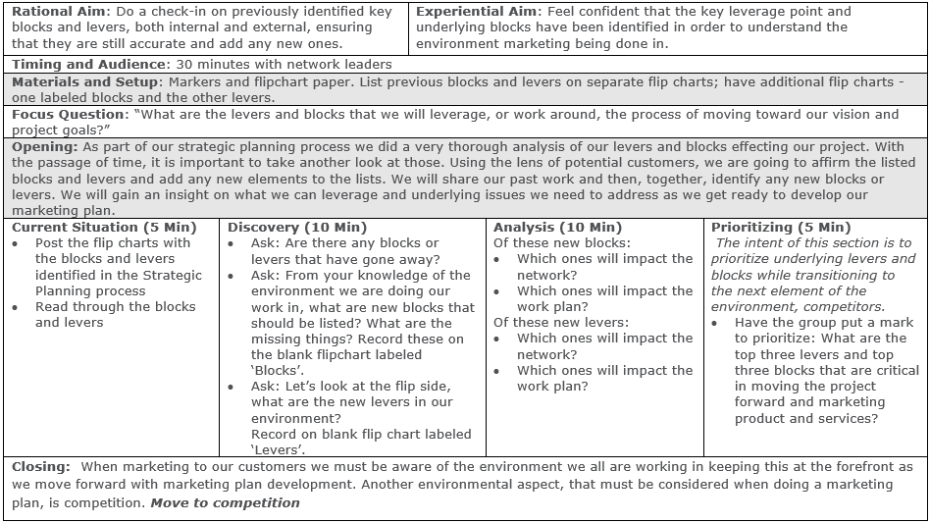
Facilitation Guide: Environmental Scan and Analysis Check-In

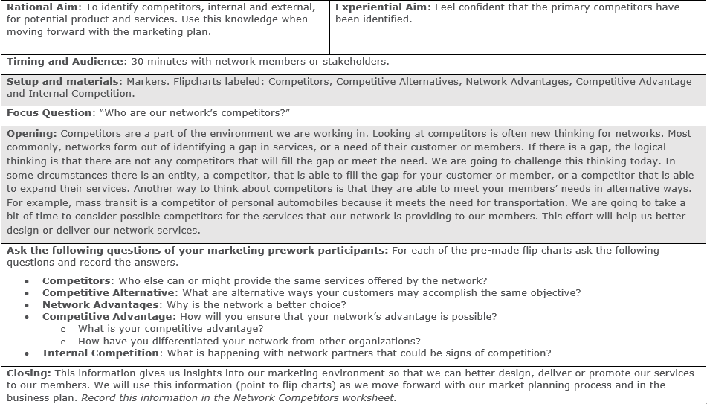
Facilitation Guide: Identifying Competitors

Competitors Worksheet
Transfer the information from flip charts filled out during the Competitor Identification Facilitation. Add additional bullets as necessary. This information is part of the overall environment your network is doing its work in. Make sure to keep this worksheet, as you will need it for part of your business planning efforts in six months.

Network Competitor Analysis

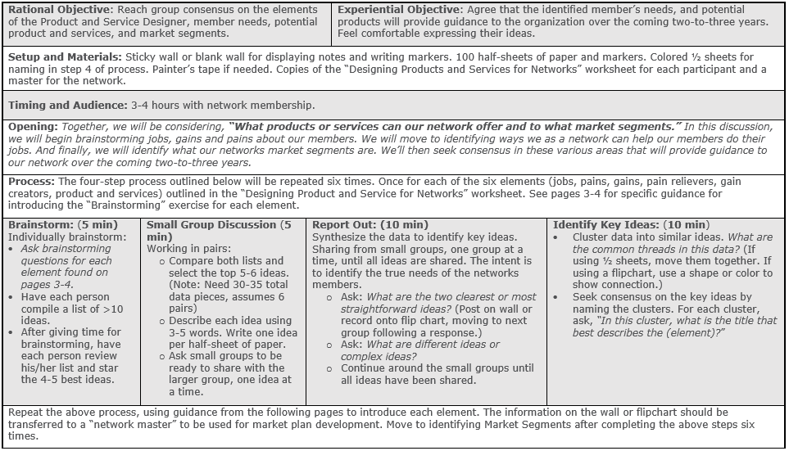
Facilitation for Designing Products and Services
