Business Canvas Worksheet
Network Business Planning
Partnership Meeting
Rural Health Network Development Grantees
October, 2016

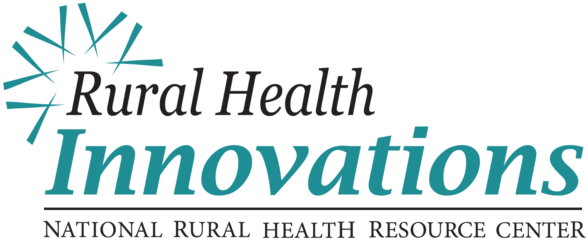
600 East Superior Street, Suite 404 │ Duluth, Minnesota 55802
218-727-9390 │ www.ruralcenter.org/rhi/network-ta

Based on Business Model Generation: Business Model Canvas and Value Proposition Designer and designed by RURAL HEALTH INNOVATIONS, a subsidiary of the National Rural Health Resource Center

Organization :

- Mission- why we exist?

- Vision – what do we want to be?

- Strategic Objectives – what is our game plan?

1. Product and Service Description:
What is the business product or service that will meet your members’ needs assessment AND is aligned with the network’s mission, vision, and strategic objective?
2. Value Statements: Discription of Business Product or Service
What alleviates pains and create gains for the members?

Double-Check: Is this product and service aligned with our mission, vision, strategy?

3. Desired End-User Experience & Relationship:
- What experience do you want your members to have while they are receiving or using your product or service? ( i.e. personal, interactive, remote, etc.)
- What relationship do your members expect you to establish and maintain with them when they receive or use your product or service? (i.e. personal assistance, self-service, automated, communities, co-creation, etc.)

4. Product or Service Communication & Delivery:
- What communication methods will you use with your members as they learn about, receive and use your product or service?
- What are the methods you can use to deliver your product or service?

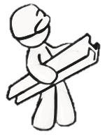
5. Key Initiatives:
- What are the key initiatives (actions) needed to develop, implement, support and/or provide this product or service?

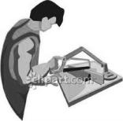
6. Key Resources/Infrastructure:
- What are the most important tools, technology, expertise, staffing, materials, and/or financial resources needed to develop, implement, support and/or provide this product or service?

7. Key Partners:
- Who are the key partners that are needed to develop, implement, support and/or provide this product or service?

8. Development & On-going Costs:  Describes and estimates costs related to the product or service.  - Look to key initiatives, infrastructure and resources for identifying costs.  - Estimate one-time purchases.  - Estimate on-going costs related to recurring fees and purchases, and human resources.  Forecast Assumptions:  Development/Start-up one-time cost components:  Ongoing costs components:  Annual Cost = one-time cost + on-going costs per year | 9. Expected Income:  - Identify a payment type for your product or service.  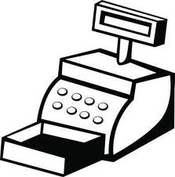  - Estimate price and frequency of member’s payment.  Examples of payment types include: selling a physical product, charging on a per use basis (fee for service), subscription fee based on a time period, rent or lease a physical product, and licensing an intellectual property (shared staffing).  Forecast Assumptions:  Identify type of payment:  Estimate how much (price) and how often (frequency) your members are willing to pay:  Annual Income = Price per Unit x Frequency per year x Number of Members
Forecasted Income = Expected Income – (Development + On-Going Costs)

