Network Board Development Samples

Rural Health Network Technical Assistance

September 2016



525 South Lake Avenue, Suite 320 │ Duluth, Minnesota 55802   
(218) 727-9390 │ info@ruralcenter.org  
Get to know us better: www.ruralcenter.org/rhi

Facebook iconcid:image002.png@01CF4CF0.D46F4E00Blog iconcid:image002.png@01CF4CF0.D46F4E00Twitter iconcid:image002.png@01CF4CF0.D46F4E00LinkedIn Icon

This is a publication of [Rural Health Innovations, LLC](https://www.ruralcenter.org/rhi) (RHI), a subsidiary of the [National Rural Health Resource Center](http://www.ruralcenter.org/). The Technical Assistance for Network Grantees Project is supported by Contract Number **HHSH250201400024C** from the U.S. Department of Health and Human Services, Health Resources and Services Administration, Federal Office of Rural Health Policy.

Table of Contents

Background and Purpose 3

Getting Started 3

High-Level Organization 4

Network Board Development Bylaws Checklist 4

Organization Chart 8

OPEN Narrative: Network Description 9

OPEN CTM Financial Workbook 11

OPEN Meeting Agenda 12

Job Descriptions 14

Board Member Job Description 14

President Job Description 16

Secretary/Treasurer Job Description 18

Past President Job Description 20

# Background and Purpose

Rural Health Innovations (RHI), LLC, is a subsidiary of the National Rural Health Resource Center (The Center), a non-profit organization. Together, RHI and The Center are the nation’s leading technical assistance and knowledge centers in rural health. The National Cooperative of Health Networks Association Inc. (NCHN) is the only national organization whose sole focus is on health networks. NCHN’s mission is to support and strengthen health networks.

The main purpose of any nonprofit board of directors is to guide the direction of the organization in a fiduciary manner to ensure the staff are able to carry out the organization’s mission. RHI and NCHN have developed this *Network Board Development Samples* document as a supplement to the *Network Board Development Guide*. These two publications are designed to support rural health networks in their efforts to establish, maintain, and improve the effectiveness of their boards. The benefits of using these materials include an improved understanding of how to identify and recruit board members, the roles and responsibilities of board members, how to manage effective board meetings, and quick access to resources on board development. The intended audience for this document includes network leaders and boards of directors of rural health networks.

# Getting Started

There are a number of places in the accompanying *Network Board Development Guide* that refer to samples within this document.

These samples are meant for you, as network leaders, to use as guides when developing your own. Please feel free to use and adapt them as you see fit. The samples include meeting agendas, organizational charts, job descriptions, and a checklist for developing bylaws.

As RHI receives more samples, this document will be updated. Please check the version date on the cover page to make sure you have the most up-to-date samples.

# High-Level Organization

## Network Board Development Bylaws Checklist

When forming your rural health network governance structure, one step in the process is developing bylaws for the organization. The bylaws document is a building block in the legal steps of establishing a formalized, legal structure and expands on the information covered in the network’s Articles of Incorporation, if establishing a legal entity. The bylaws are the written rules established to direct the ways in which the network board functions, as well as providing directions on how the internal operations of the network will be governed. Bylaws serve as an operating manual for the organization.

Because regulations about nonprofit bylaws are by individual states and not federal regulations, there can be quite a bit of variation in what may be required in bylaws from state to state. For instance, some states require a minimum of one board member, while others require a minimum of three. So, as you begin to develop your network’s bylaws, it is important to obtain the most current state laws and regulations for the state in which you plan to incorporate and register your network. Also, some city or local governments may have regulations for nonprofit organizations.

Even with all the variance in regulations and must-haves in bylaws, there are still some overall principles that apply to developing and maintaining bylaws for your network.

1. Don’t put too much in the bylaws. Anything you specify in the bylaws must be put into operation or someone could claim that the organization is in violation of its own bylaws. For example, if you specify certain committees will be formed, and as the network develops and grows it is determined that the committee(s) is not needed, the network would be out of compliance with their bylaws. Another example would be stating in the bylaws that the board meetings would be held on the second Wednesday of the month, but you determine that none of the board members can make that day work. It would take a bylaws revision to move the meeting day to a different day of the week.
2. Bylaws become very important if a conflict or some type of trouble erupts. Make sure bylaws are reviewed at least every three years to keep them current, not only with the growth of the organization but also with any changes in state or local regulations. Because board members’ and officers’ terms may make it difficult to keep track of board revisions, the network leader should be responsible for the oversight of this task.
3. If a change is made to the bylaws, immediately attach any changes made and approved by the board to the master copy maintained by the network leader. It is easy for board members to forget about changes.

Below are items that you may want to consider including in your bylaws. As stated earlier, be sure to check your state and local regulations pertaining to bylaws for nonprofit organizations or other types of governance structures you may decide to develop. The headings of sections in the bylaw document are typically called “Articles,” and each Article is numbered with Roman numerals. Sections containing specifics can be added under the article heading.

| **Article** | **Description** | **Complete** |
| --- | --- | --- |
| **Name** | Article I is usually a statement on what the name of the organization will be. |  |
| **Purpose** | Article II is normally a statement of purpose of the organization. Sometimes, this purpose statement becomes part of the mission statement. |  |
| **Membership** | Article III may be the membership information section, which can include a number of sections under the article. | |
| 1. Definition of “members” or “membership” should define eligibility requirements to be a member and what the rights are of a member. Should include if they have voting rights or not. May have “classes” of membership types. If so, then each class should be described. E.g., voting members, non-voting members. |  |
| 1. Voting member’s voting rights. If specific business of the network must be voted on by all voting members, those specific matters should be spelled out in the bylaws. E.g., all board members or directors of the organization must be elected by the members. |  |
| **Board of Directors** | Article IV should contain information related to the directors or board members of the network. Some items that might be included under this article are qualifications to be a board member; power, quorum, etc. | |
| 1. Committees and/task forces. Procedure on how a committee or task force is formed as well as dissolved should be included. It may be easier not to specify a committee(s) in the bylaws. The board can be permitted to create and dissolve standing and temporary committees as needed. This method would reduce the number of times the bylaws may need to be revised, as committees form and dissolve as needs of the network changes. |  |
| 1. Conference calls and electronic meetings. This is an area that may have specific language in state law, so be sure to check your state and local regulations first. Today, it is fairly standard practice for organizations to conduct business and have meetings by conference calls. State regulations today typically allow board meetings by conference call, if all board members can simultaneously hear one another. As Internet usage continues to expand and to save on travel costs, more boards are adding sections to their bylaws that describe how to hold a board meeting online, or whether and how decisions can be made by email. |  |
| 1. Emergency or Called Board Meeting. Situation and procedure for any board member to call an emergency board meeting between regularly scheduled board meetings should be included in the bylaws. |  |
| 1. Minimum and maximum number of board members. Some states specify a minimum and some specify a formula for a minimum and maximum, so again, check your state’s law. Some networks have a sliding number of board members or directors, based on the membership numbers of the network. If a range of board members, nine to fifteen, is spelled out in the bylaws, then the board should develop policy on how and when the number is adjusted. |  |
| 1. Minimum number of board meetings per year should be stated. If the board meets more than that number, that is not a problem, but if a large number of meetings per year is placed in the bylaws and the network does not meet that threshold, then the network would be out of compliance with its bylaws. |  |
| 1. Quorum. The number of board members that must be present for a meeting is the quorum. The quorum has to be met before any official decisions can be made at the meeting. State regulations may provide specific direction on how to determine the quorum. Some states may say one-third of the board members or as low as one-fifth of the board members. It is important to know this number and to have the quorum status declared at the beginning of each meeting. Some networks record this in their meeting minutes. |  |
| 1. Removing a Board Member. Procedure and in what situations a board member can be removed. Specific incidents of when a board member could be removed should be included, or a statement of “without cause” should be included in the bylaws. The bylaws should clearly state how the vote is to be taken; if notice is to be given on the pending vote; if so, how long before the meeting where the vote will occur; can a board member be removed at a specially called meeting. |  |
| 1. Terms and term limits. How long a board member can serve on the board when elected, such as no more than two three-year consecutive terms. (A total of six years, but after a year off, a member could return to the board for two more three-year terms.) When first establishing board terms, it is helpful to have staggered board terms for the founding board members, so that all board members do not rotate off at the same time. You can have Classes A, B, and C. Directors in Class A would serve a one-year term to start with and then could be re-elected to a three-year term, or whatever year span you determine for the “term.” Directors in Class B would be first elected to a two-year term, and Class C for a three-year term. This establishes a rotating pattern of always having some experienced board members on board and new ones coming onto the board. |  |
| **Officers** | The article on Officers usually follows the article on Board Members/Directors. The titles of officers for the network board should be included, including how they are elected to the office and the term of the office. For example, most network boards have a President, Vice President, Secretary, Treasurer or a combination Secretary/Treasurer. Some networks will include an Immediate Past President officer to continue the continuity of the experience on the board. Terms could be identified as until elections are held, or one-year terms, with no more than two consecutive terms. |  |
| **Other Articles** | | |
| **Article** | **Description** | **Complete** |
| **Amendments** | A section should be included on how the bylaws can be amended, altered, or repealed, such as by a majority vote at a regularly scheduled board meeting |  |
| **Conflict of Interest** | Most organizations do not put the actual policy in the bylaws, but may state that there will be a conflict of interest policy for the network. It is easier to change policy than to change bylaws. |  |
| **Dissolution** | Procedure on how the assets and any liabilities of the network would be handled if the organization should be dissolved or closed. |  |
| **Indemnification** | A statement, usually included toward the end of the bylaws document, that limits the personal liability of board members. |  |
| **Miscellaneous Provisions** | Bylaws can include an article of miscellaneous provisions, or items that do not fit specifically under other articles, such as referring the bylaws back to the organization’s certificate of incorporation, fiscal year, corporate seal, corporate records, etc. |  |

## Organization Chart

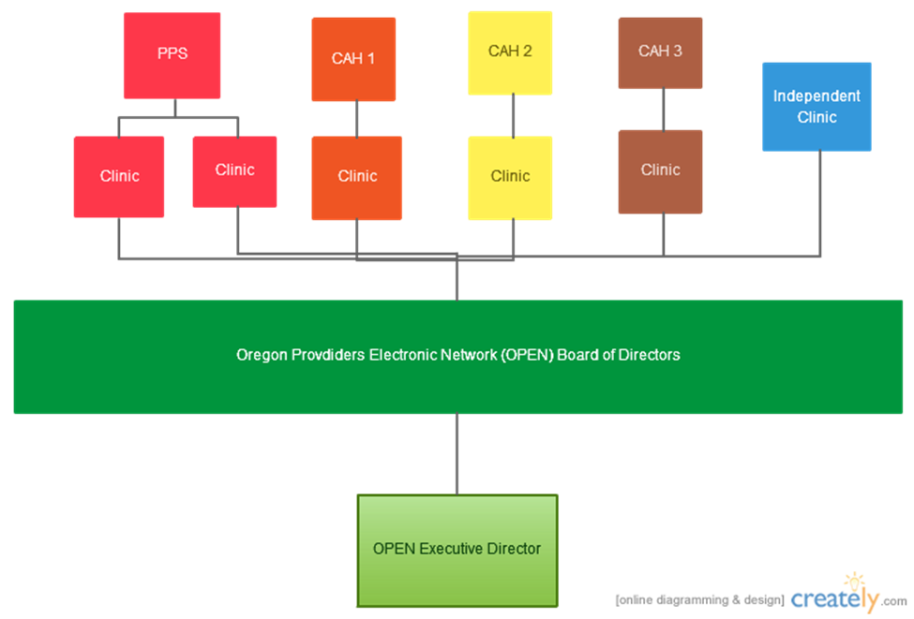

## OPEN Narrative: Network Description



In 2005, a group of providers and hospital administrators in rural Oregon met to discuss how they can work together to implement a conversion to a shared EHR platform. Although the group (4 hospitals and 6 clinics) had an existing affiliation through a regional health system, there was no continuity in the HIT systems or processes they were currently using. This lack of continuity challenged the efficiency of their existing (and often time overlapping) services, creating duplicative work for the providers, and wasted the time of the patients. If the group could find a shared platform that worked for all involved parties, they could; pool resources, share staff, and increase the operating efficiency of their existing services.

The group had history together, with each entity having a tie to Oregon Health Partners. 2 of the hospitals, both Critical Access, had strong system affiliation with OHP; shared specialists, established referral channels, and two Board seats occupied by OHP executives. The third CAH had an MOU for some visiting specialty services through OHP providers, and the fourth hospital was a wholly owned, regional PPS hospital with 100 licensed beds. Five of the six clinics had direct connections to the four hospitals (shared, employed physicians) and the sixth was located on the same campus as one of the CAHs, but didn’t have any OHP physicians currently employed at that facility.

After group agreed to move forward together, they became a loosely developed “network”, adopting the name, Oregon Providers Electronic Network, or OPEN for short. Each of the 10 entities that comprised OPEN had a representative in place to ensure that each entity had a say in the direction OPEN would take. Their first order of business was to draft a business plan that would identify how OPEN would move from a loosely affiliated handshake network, to a fully functional, standalone entity that provided a shared EHR platform and shared staffing model. The next step was for OPEN to hire an executive director, and begin the process of seeking granting dollars, and vetting EHR vendors. The OPEN ED was hired as a employee of the PPS hospital, and each of the others paid a portion of the employment expense.

During the next two year period, OPEN was able to:

* secure grant dollars to develop the “network”
* Chose a vendor through a lengthy RFP process
* Acquire a low interest loan from the USDA to purchase the EHR
* Develop articles of incorporation, by laws, and an operations plan
* Achieve 501c3 not for profit status.

In 2007, OPEN started doing business as a stand-alone entity providing a shared EHR platform and shared staffing model to its 10 members. It was not an easy task, and there were trials and tribulations along the way, but they were able to achieve their common goal of a becoming an HIT network providing a shared service to all members.  Their success was built upon a commitment to a common cause, a well-defined strategy map and business plan, and a present and engaged Board of Directors. The purpose of this training is to give you tips and tactics to develop and engage a Board of Directors that will help to lead your organization down the path of sustainability and success.

## OPEN CTM Financial Workbook

|  |  |  |  |
| --- | --- | --- | --- |
| Oregon Providers Electronic Network (OPEN) | | | |
| Contribution to Margin (as defined by revenues, less expenses per service line) | | | |
|  |  |  | |
| **Service** | **Actual** | **Budget** |
| Member Services | -50000 | -57500 |
| EHR-platform | 350000 | 355000 |
| Help Desk | 88000 | 79500 |
| Shared Staffing | 165000 | 148000 |
| HIT Consulting | 32000 | 45000 |
| Software | 40000 | 37000 |
| Hardware | 124000 | 123000 |

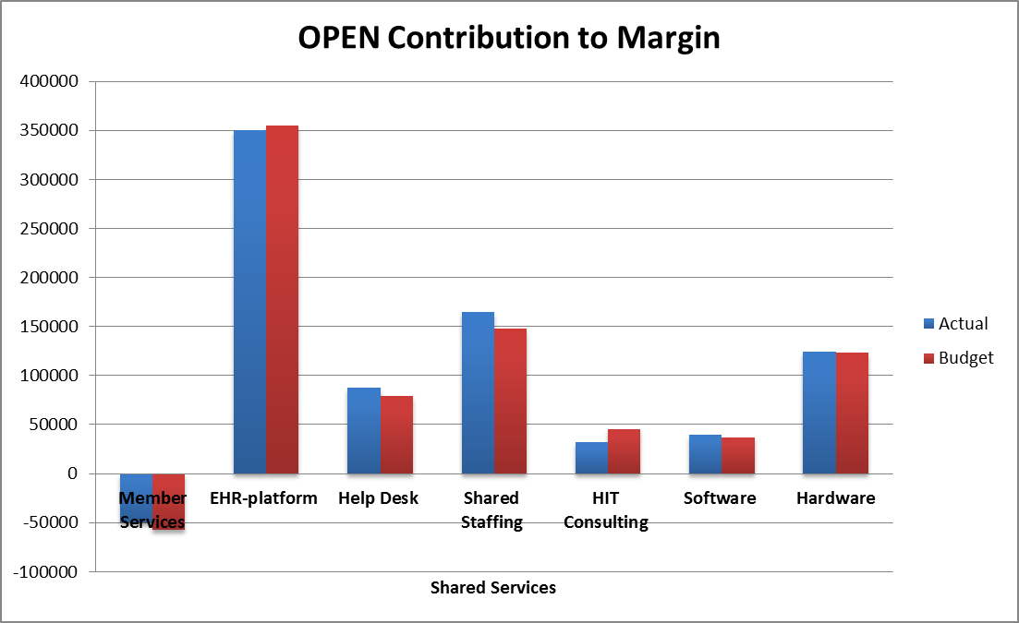

## OPEN Meeting Agenda



**Agenda for the OPEN Board of Directors**

**Friday September 6, 2013**

**10:00 a.m. to 12:00 noon with lunch to follow**

**Location:** Network Office & Training Center, City, State

**Participation:** When a Member’s designated Board Director cannot attend, **sending an** **Alternate Director is** **strongly encouraged**. Assuming primary Director Authorization, he/she will have full voting rights.

**Ground Rules:** Everyone Participates – **No One Person Domin**ates

An Individual’s **Silence Will be interpreted as Agreement**

Listen as an Ally -- **Work to Understand Before Evaluating**

Helps to **Assume Positive Intent** First When Things Go Wrong

Please **Minimize Side Conversations**

**10:00 am OPEN Board of Directors Call to Order** (Board President) ***Enclosure #1***

* **Check In** with Members who are participating from remote locations
* **Consent Calendar –** The below consent agenda includes items for approval as well as items received. A Member may request any time on the consent agenda to be removed for separate consideration; it will then be considered after the consent agenda is adopted.

**For Approval**

* **Board Agenda** (Members are encouraged to contact OPEN staff or the Board President to have a question or issue put on the agenda)
* **Minutes** of the last Board meeting (enclosed)
* **Financial Report** for the prior month (enclosed)

**Motion to approve Consent Agenda Requested** (after any items are removed from the consent agenda for separate consideration or discussion)

**10:05 am Member Discussion** (All)

**This agenda item is intended to be a brief “CEO Roundtable” – Everyone is encouraged to share ideas, successes, items of interest, questions, whatever with their colleagues.**

Please contact the Board President or Executive Director in advance if you have an issue you would like to have addressed, but you are not comfortable bringing it up individually.

**10:15 am Organization Liaison Reports** (ED, Managers, All) ***Enclosure #2***

**Q & A welcomed**

**10:30 am Update on OPEN Benchmarking Program** (OPEN Staff) Enclosure ***#3***

For over a year, some OPEN members have been participating in a voluntary benchmarking program administered by OPEN. The participating members submit specified data monthly, which is then compiled by OPEN staff, and then shared with the group. Data is provided to OPEN by the 20th of the month, and then returned to the group by the 20th of the following month. OPEN staff will discuss this program and answer questions.

*See the enclosed PPT and a copy of July’s report*

**Opportunity for Questions, Discussion, and Feedback**

**11:00 am Guest Speaker: A National View of Rural Health** *Enclosure #4*

[Speaker], is uniquely positioned to share their experiences, and prognostications, on health care reform and the impact on rural health. Topics will cover; value based purchasing, the role of the ACO, and how to actively position your organization for reform, while effectively managing the changes it will bring.

**Q & A welcomed**

**Noon Adjourn**

**12:15 pm Lunch**

# Job Descriptions

## Board Member Job Description

**Oregon Providers Electronic Network (OPEN)**

**POSITION DESCRIPTION**

**POSITION TITLE:** **BOARD MEMBER (DIRECTOR)**

**POSITION SUMMARY:**

Governance of the organization is assumed by the directors. The major roles of governance are to decide the appropriate action for the organization to take and to determine the extent to which the organization is effective in achieving that goal. Concern is with outcome and effectiveness. Governance policy and structure are defined by the charter and by-laws of the organization.

**RESPONSIBILITIES:**

*Community Trust:* The individual represents individual hospitals and communities as well as the total community served by OPEN and holds this position for the benefit of those institutions and people.

*Attendance:* It is from the primary duty of community trust that duties of the director flow. Attendance and participation at board meetings, committee meetings, and organizational functions are minimum requirements.

*Informed Decisions:*  In addition to attendance, it is the director's responsibility to exercise reasonable caution and skill. Familiarity with the issues is essential since each board member assumes full responsibility for any decisions made by the board which he did not oppose.

*Specific Duties:* Beyond the general responsibilities of the board members, the specific duties involve the preservation and further development of a coordinated system of rural health care EHR and the protection of the assets of the organization.

**FUNCTIONS:**

• Establish and maintain procedures for conducting the business of the board.

• Establish and update objectives and policies for OPEN.

• Develop and continuously update a long-range plan and ensure compliance.

• Monitor and evaluate plans and programs to ensure that they meet and are consistent with the vision, values, and mission of OPEN

• Ensure the organization's long-range financial stability.

• Appoint an executive director. Define the executive director's duties and responsibilities and evaluates performance of same.

• Ensure that the community served is well informed of the organization's goals and performance and ensure that the community needs are met.

**QUALIFICATIONS:**

• Commitment to the improvement and development of a rural health care system.

• Ability to be unbiased, open to necessary changes, and optimistic concerning the future.

• Disclosure of potential conflict of interest that could present accountability problems.

• Adequate time to serve.

• Demonstration of skills that are desirable in the performance of board functions.

• Cooperation, consideration, and tolerance for views of others.

• Willingness to learn more about the changing healthcare system and the role of the organization.

THIS POSITION DESCRIPTION DOES NOT CONSTITUTE A CONTRACT FOR EMPLOYMENT

## President Job Description

**Oregon Providers Electronic Network (OPEN)**

**POSITION DESCRIPTION**

**POSITION TITLE:** **BOARD MEMBER – PRESIDENT (CHAIR)**

**POSITION SUMMARY:**

The President shall preside at all meetings of the shareholders and Board of Directors, and shall carry out other duties as assigned by the Board of Directors. Governance of the organization is assumed by the directors. The major roles of governance are to decide the appropriate action for the organization to take and to determine the extent to which the organization is effective in achieving that goal.

**RESPONSIBILITIES:**

*Community Trust:* The individual represents individual hospitals and communities as well as the total community served by OPEN and holds this position for the benefit of those institutions and people.

*Attendance:* It is from the primary duty of community trust that duties of the director flow. Attendance and participation at board meetings, committee meetings, and organizational functions are minimum requirements.

*Informed Decisions:*  In addition to attendance, it is the director's responsibility to exercise reasonable caution and skill. Familiarity with the issues is essential since each board member assumes full responsibility for any decisions made by the board which he did not oppose.

*Specific Duties:* Beyond the general responsibilities of the board members, the specific duties involve the preservation and further development of a coordinated system of rural health care EHR and the protection of the assets of the organization.

**FUNCTIONS:**

• Establish and maintain procedures for conducting the business of the board.

• Establish and update objectives and policies for OPEN.

• Develop and continuously update a long-range plan and ensure compliance.

• Monitor and evaluate plans and programs to ensure that they meet and are consistent with the vision, values, and mission of OPEN

• Ensure the organization's long-range financial stability.

• Appoint an executive director. Define the executive director's duties and responsibilities and evaluates performance of same.

• Ensure that the community served is well informed of the organization's goals and performance and ensure that the community needs are met.

**QUALIFICATIONS:**

• Commitment to the improvement and development of a rural health care system.

• Ability to be unbiased, open to necessary changes, and optimistic concerning the future.

• Disclosure of potential conflict of interest that could present accountability problems.

• Adequate time to serve.

• Demonstration of skills that are desirable in the performance of board functions.

• Cooperation, consideration, and tolerance for views of others.

• Willingness to learn more about the changing healthcare system and the role of the organization.

THIS POSITION DESCRIPTION DOES NOT CONSTITUTE A CONTRACT FOR EMPLOYMENT

## Secretary/Treasurer Job Description

**Oregon Providers Electronic Network (OPEN)**

**POSITION DESCRIPTION**

**POSITION TITLE:** **BOARD MEMBER – SECRETARY/TREASURER**

**POSITION SUMMARY:**

The Secretary/Treasurer of the board shall: (a) keep regular minutes of all meetings of the members (note taking may be assigned to a designee during the meetings), the Board of Directors, and any committee meetings; (b) see that all notices are given in accordance with the provisions of the bylaws or as required by law; (c) be custodian of the corporate records of the network; (d) keep or arrange for the keeping of contact information for all members of the network; (e) have charge and custody or, and be responsible for all funds and securities of the network; (f) other duties as assigned by the Board of Directors.

**RESPONSIBILITIES:**

*Community Trust:* The individual represents individual hospitals and communities as well as the total community served by OPEN and holds this position for the benefit of those institutions and people.

*Attendance:* It is from the primary duty of community trust that duties of the director flow. Attendance and participation at board meetings, committee meetings, and organizational functions are minimum requirements.

*Informed Decisions:*  In addition to attendance, it is the director's responsibility to exercise reasonable caution and skill. Familiarity with the issues is essential since each board member assumes full responsibility for any decisions made by the board which he did not oppose.

*Specific Duties:* Beyond the general responsibilities of the board members, the specific duties involve the preservation and further development of a coordinated system of rural health care EHR and the protection of the assets of the organization.

**FUNCTIONS:**

• Establish and maintain procedures for conducting the business of the board.

• Establish and update objectives and policies for OPEN.

• Develop and continuously update a long-range plan and ensure compliance.

• Monitor and evaluate plans and programs to ensure that they meet and are consistent with the vision, values, and mission of OPEN

• Ensure the organization's long-range financial stability.

• Appoint an executive director. Define the executive director's duties and responsibilities and evaluates performance of same.

• Ensure that the community served is well informed of the organization's goals and performance and ensure that the community needs are met.

THIS POSITION DESCRIPTION DOES NOT CONSTITUTE A CONTRACT FOR EMPLOYMENT

## Past President Job Description

**Oregon Providers Electronic Network (OPEN)**

**POSITION DESCRIPTION**

**POSITION TITLE:** **BOARD MEMBER – PAST PRESIDENT**

**POSITION SUMMARY:**

The Past President shall serve in the capacity of the current President in the event he or she is not present and or able to serve. The Past President shall serve in this capacity until the current President is able to return, OR the Board of Directors elects or appoints a new President.

**RESPONSIBILITIES:**

*Community Trust:* The individual represents individual hospitals and communities as well as the total community served by OPEN and holds this position for the benefit of those institutions and people.

*Attendance:* It is from the primary duty of community trust that duties of the director flow. Attendance and participation at board meetings, committee meetings, and organizational functions are minimum requirements.

*Informed Decisions:*  In addition to attendance, it is the director's responsibility to exercise reasonable caution and skill. Familiarity with the issues is essential since each board member assumes full responsibility for any decisions made by the board which he did not oppose.

*Specific Duties:* Beyond the general responsibilities of the board members, the specific duties involve the preservation and further development of a coordinated system of rural health care EHR and the protection of the assets of the organization.

**FUNCTIONS:**

• Establish and maintain procedures for conducting the business of the board.

• Establish and update objectives and policies for OPEN.

• Develop and continuously update a long-range plan and ensure compliance.

• Monitor and evaluate plans and programs to ensure that they meet and are consistent with the vision, values, and mission of OPEN

• Ensure the organization's long-range financial stability.

• Appoint an executive director. Define the executive director's duties and responsibilities and evaluates performance of same.

• Ensure that the community served is well informed of the organization's goals and performance and ensure that the community needs are met.

**QUALIFICATIONS:**

• Commitment to the improvement and development of a rural health care system.

• Ability to be unbiased, open to changes that are necessary, and optimistic concerning the future.

• Disclosure of potential conflict of interest that could present accountability problems.

• Adequate time to serve.

• Demonstration of skills that are desirable in the performance of board functions.

• Cooperation, consideration, and tolerance for views of others.

• Willingness to learn more about the changing healthcare system and the role of the organization.

THIS POSITION DESCRIPTION DOES NOT CONSTITUTE A CONTRACT FOR EMPLOYMENT