Reporting Instructions and Data Dictionary for FY 2021 Flex Program PIMS

*FORHP Performance Improvement and Measurement System*

*Medicare Rural Hospital Flexibility Program*

*Program years FY 2019 – FY 2023 (9/1/2019 – 8/31/2024)*

Introduction

Flex awardees must complete an annual Performance Improvement and Measurement System (PIMS) report. This is a program requirement and listed on the Notice of Award (NOA). Awardees will access the PIMS report through the HRSA Electronic Handbooks (EHB), [grants.hrsa.gov](https://grants.hrsa.gov). For FY 2021, the reporting system will open September 1 and reports are due October 30, 2022. Please contact your project office with questions about PIMS reporting.

PIMS was revised starting with the FY 2015 reporting period. In PIMS awardees are asked to report **participation** and **improvement**, including sustained high performance, by Critical Access Hospitals (CAHs) in their state.

PIMS does not reflect everything that state Flex programs accomplish. This is a standardized, program-wide data collection tool to provide information about the Flex Program as a whole. Project officers also use progress reports, site visits, and individual updates to understand Flex activities in each state. We use the standardized data collected through PIMS for reports to HRSA, as part of the program justification measures in the yearly federal budget, and to inform Flex Program evaluations conducted by the Flex Monitoring Team. You can review the [HRSA Budget and Performance Report online](http://www.hrsa.gov/about/budget/).

PIMS Reporting Process – Overview

1. Log in to EHB, go to performance reports, and open PIMS
2. Select the applicable activities for your state’s Flex program
3. Record individual CAH participation and improvement in each selected activity category
4. Record your program spending in each activity category
5. Save each page and mark complete
6. Validate and submit your data
7. Your project officer will review your PIMS data and may ask for clarification or corrections

Detailed Instructions for FY 2021 Reporting

Accessing PIMS

The Performance Improvement and Measurement System is a module within the HRSA Electronic Handbooks. Access EHB using your usual username and password, then open the Grants drop-down. From this menu you can select Performance Report which take you to PIMS. The screenshots in Appendix B show this process.

Selecting Activities

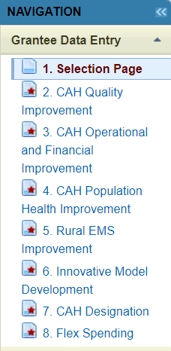The FY 2021 PIMS report has up to eight pages: a selection page, six pages that correspond to the six Flex program areas, and a spending page as shown in the screenshot to the right. Start with the selection page and use the check boxes to choose the specific Flex activity categories that were part of your state Flex program in the just-completed budget year (FY 2021). The PIMS category numbering matches the numbering in the [Flex Grant Guidance](https://www.ruralcenter.org/resource-library/flex-program-fiscal-year-2019-cooperative-agreement-guidance-and-supporting). The required activities (1.1 – 1.4 and 2.1) are selected by default.

Note that in the navigation sidebar the selection page is #1 and the program area pages are #2 through #7. **This doesn’t match their numbering in the guidance so follow the titles, not the numbers in the sidebar**. The numbering of the individual activity categories matches the guidance.

Once you have selected activity categories applicable to your program, click save on the bottom of the selection page. On the subsequent data entry pages you will only see the categories you selected. If you realize you missed a category you can always reopen the selection page, make changes, and save it again to update the activity categories available to report.

In PIMS you will report on the Flex activities that were carried out in the past year. This usually corresponds to the categories in your FY 2021 work plan, please use the comment box at the end of each page to explain any changes from your work plan activity categories. You will not report data for program areas and categories that are not part of your state Flex program.

Checking your CAH List

Select Quality Improvement from the navigation sidebar. The reporting page will open and show a list of the CAHs in your state by Medicare number (CCN) and name. The names come from Medicare provider files so they may be different from business names in some cases. Review this list and make sure that all CAHs in your state that were open during the reporting period are included. This could include CAHs that were open last September but have since closed as well as hospitals that converted to CAH status in the last few months. The same list will repeat in each activity category so make sure it is correct before you start entering data.

**Stop and contact your project officer to update the database if there are any missing CAHs, facilities that should not be on your state CAH list, or CAHs with incorrect names.**

Recording CAH Participation and Improvement

After confirming your CAH list, you can start entering data. Open the reporting page for activities in each program area using the navigation sidebar. Activities are grouped under Quality, Financial, Population Health/Emergency Medical Services (EMS), CAH Conversion, and Innovative Models. You will individually report CAH **participation** and **improvement** for activities in all five Flex program areas as applicable.

On the reporting page, each activity category (for example 1.1, 1.2, 1.3, 1.4) will have a list of the CAHs in your state followed by check boxes for indicating participation and improvement. See the Definitions for help in understanding these terms for PIMS.

Check the box following the name of each CAH that participated in this Flex activity category in the past budget year. After selecting the CAHs that participated, use the second column to indicate participating CAHs that improved on the outcome that was the goal of the project. Many Flex programs have defined multiple projects or sub-activities in a single Flex activity category. A CAH could meet the definition of participation in that category if they engaged in one of those projects or several.

We recognize that Flex Coordinators will not have information on whether some CAHs improved or not since their projects may have been recently completed and data collection for quality and financial measures takes time. A blank in the “improved” column does not mean that the CAH did not improve. It merely indicates that the state Flex Coordinator was not able to document improvement at the time of the PIMS report.

Historical Participation

The CAH Historical Participation column was a new feature for the FY 2016 PIMS report and it continues in the FY 2021 PIMS report. This column cannot be edited and it shows which CAHs the Flex Coordinator previously reported as participating in each activity category. For the FY 2021 PIMS report, historical participation will be checked for a CAH if you previously reported participation by that CAH in FY 2020.

Recording Flex Spending on Activities

The Flex Spending page has a section at the top of the page called Award Information. This section will help us report consistent data by checking total awarded and available funding against total spending reported for the program areas. You will use this section to record your FY 2021 award, approved carryover**, and estimated unspent funds. The page will calculate actual program spending for the reporting year. With this new section you do not need to record estimated unspent funds in the comment box.

The section will calculate Actual Program Spending as:

|  |
| --- |
| $Total award+*Carryover*-Unspent funds=Actual spending$ |

**Carryover = FY 2020 funds that were carried over into FY 2021**

The page will compare the calculated actual spending to the calculated Total Flex Funds Utilized at the bottom of the spending page and alert you of the error if these two sums don’t match.

See screenshots of this section in Appendix B and a list of FY 2021 award amounts in Appendix C.

The Flex spending page will only display program areas and activity categories that you selected on the selection page. If a category is missing you will need to update and save the selection page so that the spending page shows the additional category.

Report your utilization of Flex funds in each activity category. Only report Flex award funds; in-kind resources and money from other sources should not be included in the PIMS report. All types of spending that directly support an activity should be reported, including contracted services, staff salaries, travel, and direct sub-contracts to CAHs to support individual projects. We recognize that some Flex programs accomplish much of their work through in-house staff while others use consultants and contracts to carry out activities. This data is intended to capture all of the program investments that support a specific Flex activity, regardless of spending type.

We understand that this PIMS report will be completed before the final financial report for the budget year and so you may not have exact expenditure numbers in some cases. Estimate spending if necessary and explain in the comment box at the bottom of the page.

**Non-specific spending**: State Flex programs generally have some award spending that is unrelated to a specific activity. Examples of such non-activity-specific spending could include staff salaries for time spent on general program administration, expenses for travel to national meetings, and indirect costs charged to the award. Use the spending calculator in the [PIMS Data Collection Tool](https://www.ruralcenter.org/resource-library/pims-data-collection-tool) to allocate non-specific spending to your program activity categories for PIMS reporting. The spending calculator in the PIMS Data Collection Tool will allocate indirect costs and other non-specific spending for you. The total spending, including allocated indirect costs will be shown in the calculated Column E (the last column on the right). When you log in to PIMS to report total spending you will report the calculated totals in Column E, not the category-specific amounts you reported in Column B.

**Explanation**: The suggested [Flex work plan template](https://www.ruralcenter.org/resource-library/flex-program-fiscal-year-2022-funding-guidance-and-supporting-materials) includes proposed spending by activity category. We recognize that this budgeted amount is subject to change throughout the year as Flex programs adjust their projects and services based on changing needs and CAH feedback. Collecting information on actual spending for each activity in PIMS at the end of the budget year allows us to estimate the total Flex investments in each of the major areas of the Flex Program.

Sections with Different Data Entry Options

Most sections of the PIMS report ask you to select participating and improving CAHs using the CAH list and check boxes. However a few categories include different data entry methods.

* 2.1: No CAH selection, just record spending.
* 4.1: No entry, just record spending.
* 4.2: Number of EMS entities participating
* 4.3: Number of EMS entities participating
* 4.4: Number of EMS entities participating
* 5.1: Only CAH participation, number of reports/documents created
* 5.2: Only CAH participation, number of reports/document created
* 6.1: Number of hospitals requesting assistance in converting to CAH status, number of hospitals successfully converting to CAH status, number of hospitals requesting assistance but did not convert, listing of hospitals that did not convert.
* 6.2: Only CAH participation

Submitting Your Data

After entering data on each page, you must click *Save* so that your data will be recorded. **You should save each page at least every 20 minutes to ensure that your work session does not time out**. You can save the page, navigate away, and return multiple times as you enter data. Once you have entered all of the data for the page, change *Is this Form Complete?* to *Yes* and save a final time to mark the page as complete.

If you encounter any validation problems or error messages that you are not able to solve, please take a screenshot of the error and send it your project officer.

Sections that are completed will be indicated with a green checkmark in the left-side navigation sidebar. Once all of your applicable sections are completed with a green checkmark, select *Validate/Submit Report* from the sidebar. The system will confirm that data has been recorded on all of your sections and the report will be submitted to HRSA.

An important note!

* **The system timeout clock is now set to 20 minutes. Save your work frequently!**

Definitions for FY 2021 Reporting

**Budget year FY 2021** refers to Flex activities conducted from 9/1/2021 through 8/31/2022. See the award cycle timeline in Appendix A.

**Participation** answers the question, “Did this CAH engage in a Flex-funded activity intended to improve a specific outcome during the past budget year?”

To be considered participating in PIMS, CAHs must be engaged in a project or activity that meets the following criteria:

* Occurred between 9/1/2021 and 8/31/2022
* Used Flex funding
* Had a defined goal or improvement outcome
* Activities of the project were beyond normal Flex engagement

In most cases, you will only report participation for a subset of CAHs in your state. Some activity categories in the work plan may have no in-depth CAH engagements that meet the PIMS participation criteria.

You will report for all CAHs that were open during the budget year, even those that closed or converted during the reporting period.

You should not report a CAH as participating if it:

* Started an activity but quickly dropped out or failed to substantially engage in the activity.
* Is only participating in other performance improvement projects not supported by Flex resources (e.g., HIIN projects).

**Table of examples of activities that meet and do not meet the criteria for participation**

|  |  |
| --- | --- |
| **Meet PIMS participation criteria** | **Do NOT meet PIMS participation criteria** |
| Working towards a goal to improve MBQIP reporting | Reporting in MBQIP alone |
| Coordinating a chargemaster review | Projects that CAHs started but quickly ended or failed to engage in |
| Attending a two-day TeamSTEPPS training | Attending a state rural health conference |
| Joining a HCAHPS quality improvement cohort that meets bi-monthly via webinar | Participating in one webinar on a specific quality improvement topic |

**Improvement** answers the question, “Did the participating CAH improve the outcome that was the target of the activity?”

* Improvement is any change in the positive direction, including Sustained High Performance.
* You can only report improvement for CAHs that are also participating in the activity.
* CAHs listed in the Historical Participation column can be selected for improvement without selecting participation for the current year as long as the identified improvement occurred in or immediately after the current FY.
* If a CAH is participating in multiple projects within a PIMS activity, they need only show improvement in one of the target outcomes to qualify for improvement.
* If you have no information on improvement or the data is not yet available, leave the check box blank which indicates “no [identified] improvement”.

The [PIMS Data Collection Tool](https://www.ruralcenter.org/resource-library/pims-data-collection-tool) offers a format for Flex Coordinators to track CAHs throughout the year as they engage in Flex-funded improvement activities and identify individual improvement goals.

**Sustained high performance** only applies to quality improvement, Program Area 1. This concept recognizes that state Flex programs use considerable resources helping CAHs maintain a high level of performance after they initially reach that level. *This is a very high level of performance, and we expect few CAHs to meet the applicable benchmarks.* We added this reporting definition in FY 2016 in response to Flex Coordinator concerns that improvement, as defined for PIMS, excluded CAHs that consistently maintained excellent performance since most quality metrics have an upper limit.

* Applies to CAHs participating in one or more Flex-funded activities in categories 1.1 through 1.8.
* Only applies to CAHs that do not have reportable improvement activities in the applicable Flex activity category—sustained high performance requires that they were already performing at the top level at the beginning of the year.
* For this section, *high performance* refers to actual scores, e.g. percentage of EDTC cases with all data elements, while *measure reporting* refers to the reporting of data, or zero cases, regardless of scores.
* A CAH must achieve one of the following for the most recently available four quarters of MBQIP data (or year in the case of annual measures):
  + For all MBQIP measures except HCAHPS a CAH must maintain *high performance* at or above the 90th percentile for CAHs nationally on the applicable measure(s) every quarter.
  + For HCAHPS *high performance* a CAH must meet or exceed the CMS Value-Based Purchasing (VBP) Program performance benchmark for the performance period that most closely aligns with the CAH’s HCAHPS data. Note that payment periods are two years after the performance period so use the appropriate performance period, not the payment adjustment period. VBP benchmark scores are available from the [Quality Reporting Center Inpatient Resources page](https://www.qualityreportingcenter.com/inpatient/iqr/resources-and-tools/) (section called Domain Weighting in VBP Resources). The VBP performance standard defines a floor, a threshold, and a benchmark—the highest level, the benchmark, is based on the top decile of national performance.
  + For EDTC and HCAHPS, CAHs must meet the performance benchmarks for all sub-measures.
  + Sustained high performance in *measure reporting* requires the CAH to report qualifying data or zero cases for all four quarters for all core measures and sub-measures in the applicable MBQIP domain.
  + HCAHPS reporting is not eligible for sustained high performance for *measure reporting* since CAHs need less Flex program assistance with the process of HCAHPS reporting after establishing vendor contracts.
  + Annually reported measures are not eligible for sustained high performance for *measure reporting* since one data point cannot demonstrate a trend.
* Flex Coordinators that use the improvement box to indicate CAHs that demonstrated sustained high performance must list those CAHs in the comment box at the bottom of the quality improvement reporting page. Based on Flex Coordinator input, we expect that this will be a small number of CAHs, but the comments will show how often Flex Coordinators identify sustained high performance. The comment should include the following information:
  + Activity category (e.g. 1.3), CAH name and Medicare number (CCN), reason *(high performance* or *measure reporting*)
* CAHs must be participating in Flex funded activities in the applicable activity category to be reported for sustained high performance. A CAH that achieves sustained high performance without in-depth engagement(s) with the state Flex program should not be reported in PIMS which is limited to reporting on Flex-funded activities and interventions.
* We anticipate that consistent reporting of existing MBQIP measures will not be considered high performance in PIMS after the end of the current Flex Program performance period and sustained high performance will be limited to performance scores and reporting of new measures.

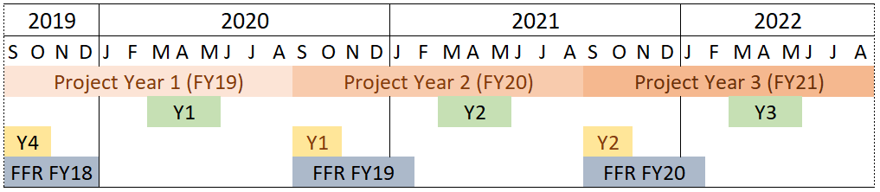Appendix A: Flex Award Cycle and Reporting Periods

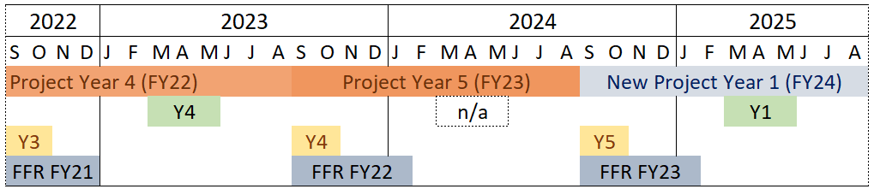

|  |
| --- |
| Non-Competing Continuation Progress Reports |
| Performance Improvement Measurement System Reports |
| Competing Continuation Applications |
| Federal Financial Reports |

# 

Appendix B: Flex PIMS Screenshots

PIMS User Tips

* Save your work frequently. EHB will time out after 20 minutes of inactivity.
* Saving a form resets your time-out clock.
* Viewing a different page resets your time-out clock.
* Entering data **does not reset** your time-out clock.
* Save pages before pausing or leaving to ensure you don’t lose any data.
* For the Flex Funds boxes you must enter only whole numbers. Do not use $ signs or commas or decimal places. Any of these will cause a validation error.
* Browser cache issues occasionally cause errors when attempting to open PIMS. Fix by logging out of EHB, clearing browser cache and memory, then logging back in to EHB.

Login to EHB at <https://grants.hrsa.gov>

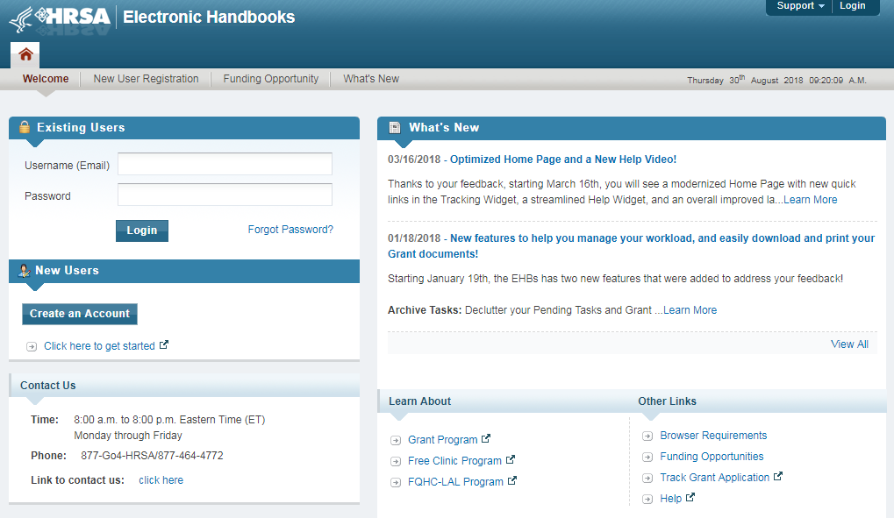

Go to Grants > Performance Report

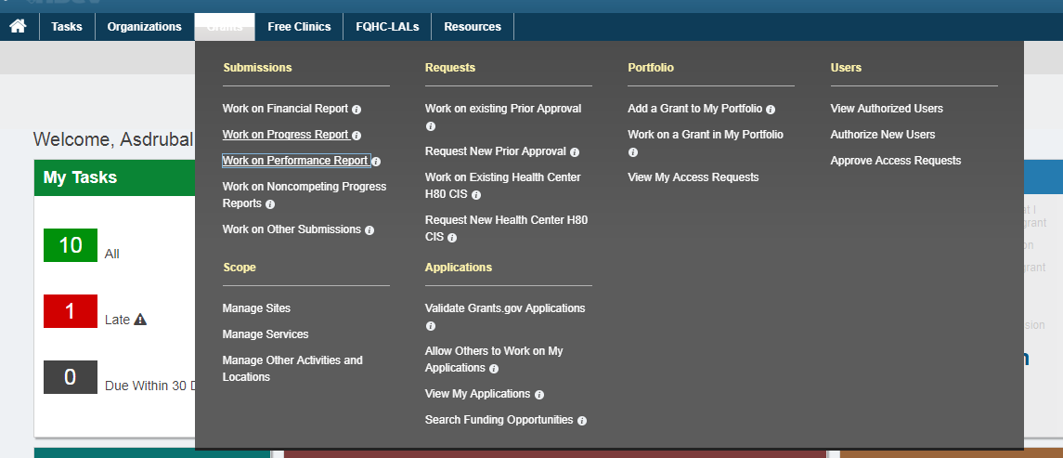

Select the performance report for your Flex award and select Start which will take you to the PIMS entry page.

On the entry page confirm that the state and reporting period are correct (this year should be 9/1/2021 – 8/31/2022), then select Continue.

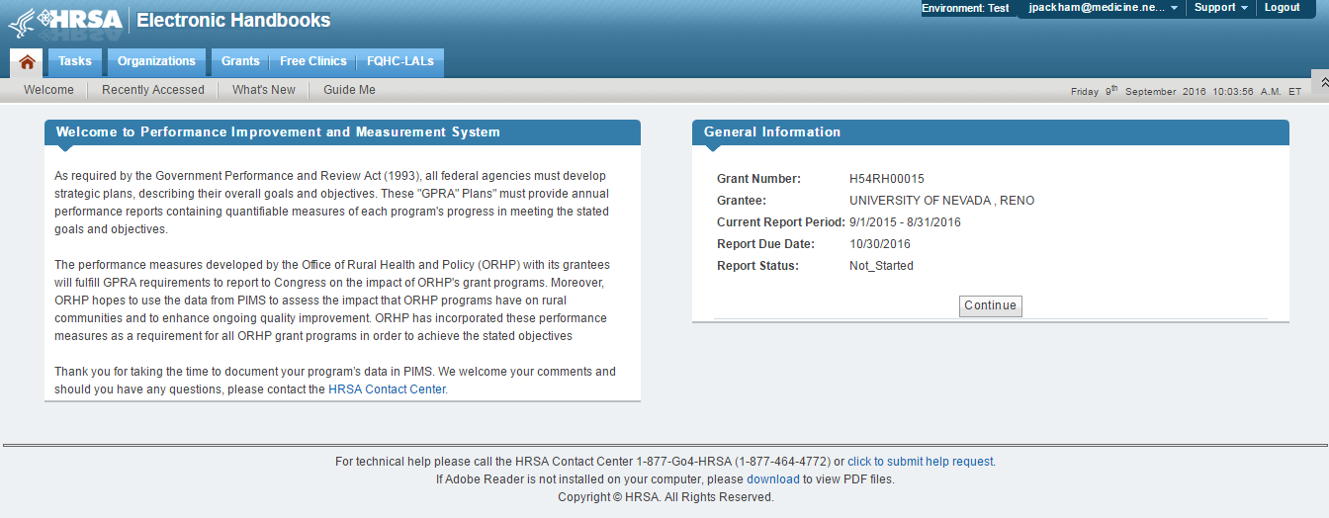

Using the left hand sidebar, navigate to the selection page.

There is a separate data entry page for activities in each program area, only the selected activities chosen on the selection page will appear on the data entry pages. Use the check boxes on the selection page to select the activity categories in your state Flex program.

After selecting the applicable activities for your program, use the save button to update the report so the correct pages are available to you for reporting.



The navigation side bar shows which pages are underway and which are marked as complete (green check mark). A red asterisk indicates a required page that is not started.

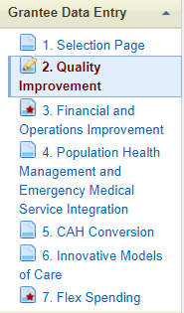 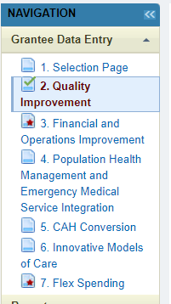

Here is a screenshot of the Quality page before any data has been entered for the current year. Make sure this list has the correct name and Medicare number (CCN) for all of the CAHs in your state. They are usually listed alphabetically by name.

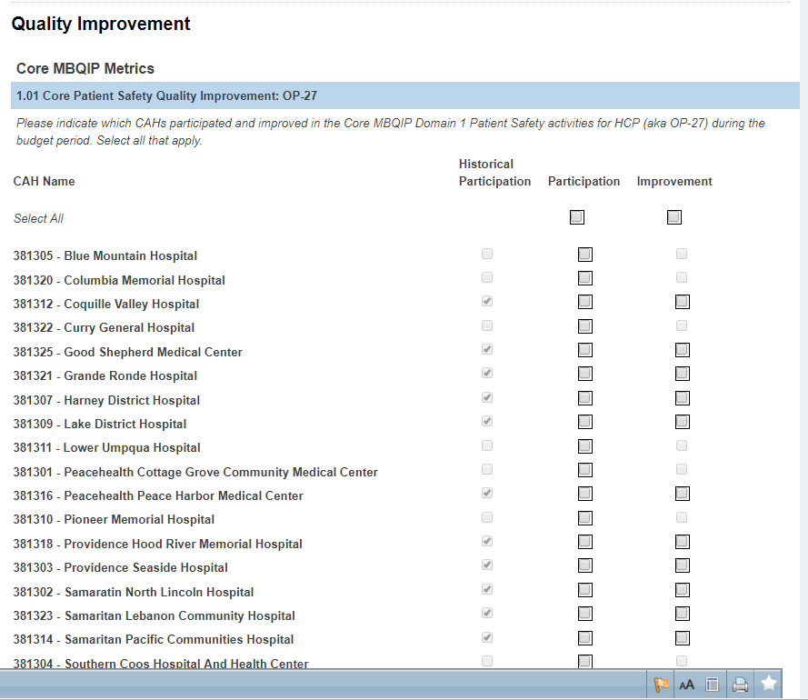

Only CAHs selected for Participation (in either the current year or previous years as indicated by Historical Participation) can be selected in the Improvement column as you can tell by the grayed-out check boxes. The form automatically totals the number of CAHs selected in each section.

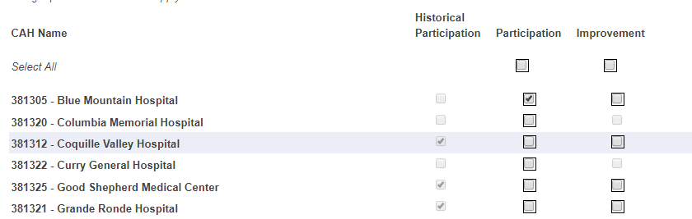

Selectable

Non-selectable

Selectable

The check box at the top of the column allows you to select all or unselect all.

Some pages have different data entry formats, for example CAH Conversion only asks about participation, not improvement. Your CAH list should include *all* CAHs that were open at any time during the reporting year, including newly designated CAHs so that newly-designated CAHs can be selected in the CAH Conversion page.

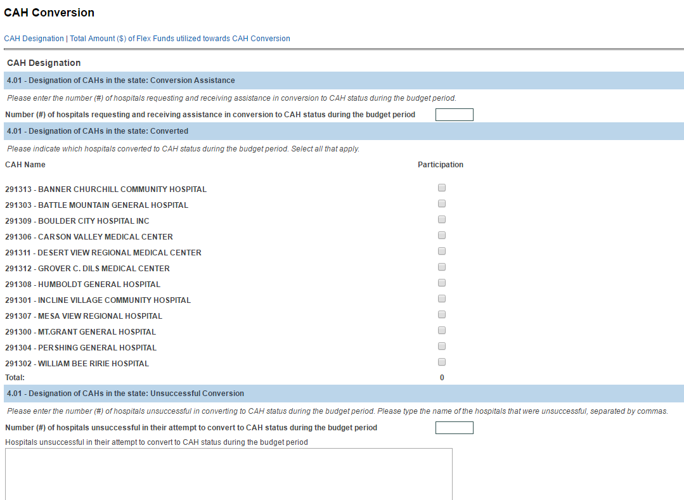

The Flex Spending page has a section at the top of the page called Award Information.

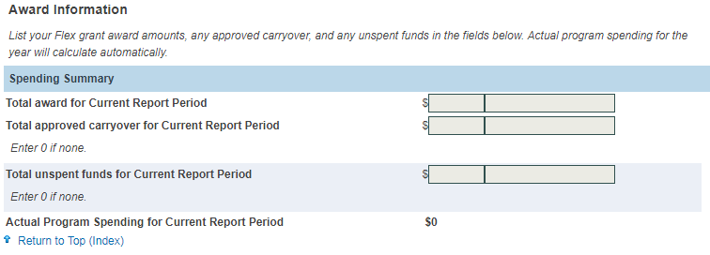

Use this section to record your FY 2021 award, approved FY 2020 carryover, and estimated unspent funds. Do not include FY 2021 Flex Supplements in your FY 2021 award amount.

The page will compare the calculated actual spending to the calculated Total Flex Funds Utilized at the bottom of the spending page and alert you of the error if these two sums don’t match.

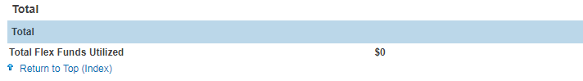

Here is the error message you will see after saving the page if the calculated total funds utilized does not equal actual spending calculated at the top of the page.



Each data entry page has a comment box, a Form Complete toggle, and a save button at the bottom.

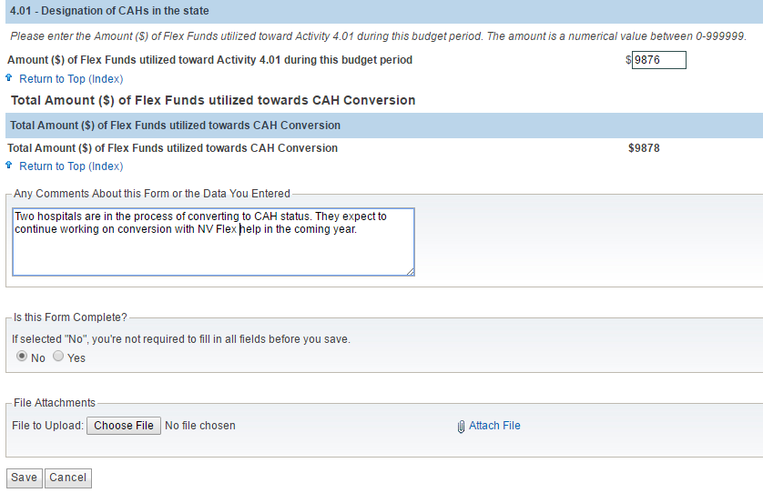

Complete each page, including the comment box if needed. Change the Form Complete button to Yes. Click the Save button at the bottom of the page. The navigation sidebar will change to a green check mark for that page.

Complete all of the pages corresponding to the selected program areas and categories on your Selection Page. Then select Validate/Submit Report. The system will check for errors and take you to the certification page. Check the box to certify your report and use the submit button to send to HRSA. You can view the report but you can’t make any changes after it is submitted. If necessary your project officer can return the report so you can make changes.

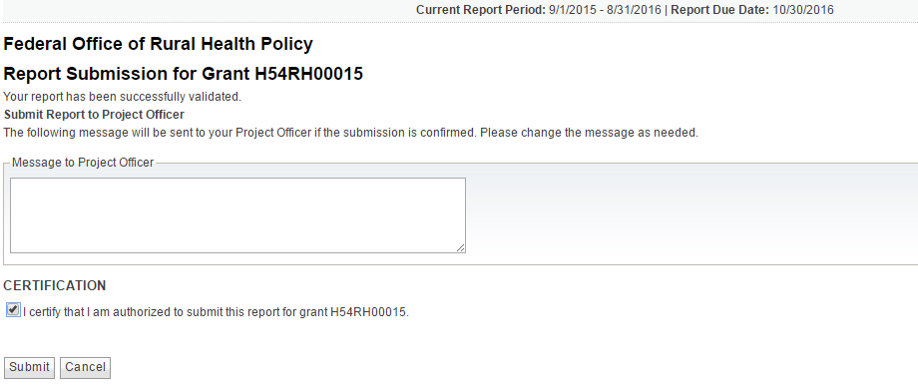

You can download a pdf report of the data you entered from the navigation sidebar. However this report may be poorly formatted compared to viewing your data on the data entry pages.

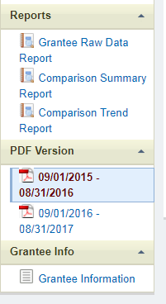

Please share any suggestions about what you would like to see on the downloadable pdf report with your project officer. We will continue to improve the PIMS reports for next year.

Appendix C: Flex FY 2021 Awards

|  |  |  |  |
| --- | --- | --- | --- |
| **State** | **Organization** | **Cooperative Agreement Number** | **Award Amount** |
| AK | HEALTH AND SOCIAL SERVICES, ALASKA DEPARTMENT OF | U2WRH33307 | $611,422 |
| AL | PUBLIC HEALTH, ALABAMA DEPARTMENT OF | U2WRH33293 | $364,358 |
| AR | ARKANSAS DEPARTMENT OF HEALTH | U2WRH33304 | $602,319 |
| AZ | University Of Arizona | U2WRH33311 | $551,961 |
| CA | Department of Health Care Services | U2WRH33322 | $542,359 |
| CO | COLORADO RURAL HEALTH CENTER | U2WRH33305 | $655,393 |
| FL | Health, Florida Department of | U2WRH33316 | $511,289 |
| GA | COMMUNITY HEALTH, GEORGIA DEPT OF | U2WRH33286 | $651,413 |
| HI | HEALTH, HAWAII DEPARTMENT OF | U2WRH33309 | $446,074 |
| IA | PUBLIC HEALTH, IOWA DEPARTMENT OF | U2WRH33302 | $757,191 |
| ID | HEALTH AND WELFARE, IDAHO DEPARTMENT OF | U2WRH33308 | $641,351 |
| IL | Public Health, Illinois Department Of | U2WRH33301 | $824,375 |
| IN | Indiana State Department Of Health | U2WRH33300 | $656,819 |
| KS | HEALTH AND ENVIRONMENT, KANSAS DEPARTMENT OF | U2WRH33306 | $968,815 |
| KY | University Of Kentucky | U2WRH33312 | $602,464 |
| LA | Health, Louisiana Department Of | U2WRH33310 | $563,812 |
| MA | PUBLIC HEALTH, MASSACHUSETTS DEPT OF | U2WRH33294 | $316,735 |
| ME | HEALTH AND HUMAN SERVICES, MAINE DEPARTMENT OF | U2WRH33288 | $437,911 |
| MI | Michigan Center For Rural Health | U2WRH33317 | $692,449 |
| MN | DEPARTMENT OF HEALTH MINNESOTA | U2WRH33314 | $911,531 |
| MO | HEALTH AND SENIOR SERVICES, MISSOURI DEPARTMENT OF | U2WRH33295 | $510,424 |
| MS | HEALTH, MISSISSIPPI STATE DEPARTMENT OF | U2WRH33290 | $488,194 |
| MT | PUBLIC HEALTH AND HUMAN SERVICES, MONTANA DEPARTMENT OF | U2WRH33320 | $806,474 |
| NC | Health & Human Services, North Carolina Department Of | U2WRH33287 | $626,231 |
| ND | University Of North Dakota | U2WRH33321 | $815,742 |
| NE | HEALTH AND HUMAN SERVICES, NEBRASKA DEPARTMENT OF | U2WRH33315 | $882,649 |
| NH | HEALTH AND HUMAN SERVICES, NEW HAMPSHIRE DEPT OF | U2WRH33289 | $431,566 |
| NM | HEALTH, NEW MEXICO DEPARTMENT OF | U2WRH33297 | $317,683 |
| NV | Nevada System of Higher Education | U2WRH33318 | $495,108 |
| NY | HEALTH RESEARCH, INC. | U2WRH33296 | $394,932 |
| OH | Health, Ohio Department of | U2WRH33298 | $688,294 |
| OK | OKLAHOMA STATE UNIVERSITY | U2WRH33319 | $673,496 |
| OR | Oregon Health & Science University | U2WRH33327 | $697,883 |
| PA | Pennsylvania State University, The | U2WRH33292 | $444,516 |
| SC | South Carolina Office of Rural Health | U2WRH33328 | $394,458 |
| SD | South Dakota Department of Health | U2WRH33329 | $673,740 |
| TN | Health, Tennessee Dept Of | U2WRH33325 | $498,448 |
| TX | AGRICULTURE, TEXAS DEPARTMENT OF | U2WRH33313 | $901,523 |
| UT | DEPARTMENT OF HEALTH UTAH | U2WRH33323 | $391,386 |
| VA | HEALTH, VIRGINIA DEPARTMENT OF | U2WRH33299 | $356,713 |
| VT | Human Services, Vermont Agency Of | U2WRH33291 | $320,206 |
| WA | HEALTH, WASHINGTON STATE DEPARTMENT OF | U2WRH33326 | $686,629 |
| WI | UNIVERSITY OF WISCONSIN SYSTEM | U2WRH33303 | $804,871 |
| WV | Health And Human Resources, West Virginia Department Of | U2WRH33324 | $551,220 |
| WY | WYOMING, DEPARTMENT OF HEALTH | U2WRH33330 | $497,399 |
| 45 | Totals |  | $26,659,826 |

This table shows the FY 2021 Flex funding levels.

We expect that the “Total award for Current Report Period” on the Flex Spending page will reflect these award amounts. Please use the comment box to explain any discrepancies.

Appendix D: Flex PIMS Frequently Asked Questions

Last updated for budget period: 9/1/2021 – 8/31/2022

**Questions about reporting participation**

1. *I don’t yet have information on whether the CAHs participating in this project improved or not. What do I report?*
   1. Use the check box to indicate CAHs with known improvement. If you don’t yet know if the CAH improved then leave it blank.
2. *Should all of my CAHs which reported quality data for MBQIP be listed as participating in Quality Improvement activities?* 
   1. Not necessarily. Reporting quality data alone is not a “Flex-funded activity intended to improve a specific outcome.” Reporting CAH participation in PIMS should be limited to quality improvement projects and other activities and interventions where the Flex program expects to help CAHs make changes and show improvements. See the definition of participation.
3. *One of our activities was to increase the number of CAHs reporting EDTC. Should I check participation in PIMS for all of the CAHs that started reporting EDTC in the last year?* 
   1. As the example vignettes in the [PIMS Data Collection Tool](https://www.ruralcenter.org/resource-library/pims-data-collection-tool) show, the first step in performance improvement is collecting data to know where you stand. If a CAH’s Flex-supported performance improvement project for this year is to start reporting a measure or measures then you would report the CAH as participating if they engaged with the Flex activities as planned and you would report them as improving if they successfully started the reporting which was their project goal.

*We changed this answer since the FY 2015 reporting FAQs.*

1. *Every year we produce individual financial status reports and distribute them to all of our CAHs as part of Activity 2.2, in-depth financial and operational assessments. Since all of our CAHs receive a report, should I list them all as participating?*
   1. It depends. There are two parts to 2.2 in PIMS, 1) which CAHs underwent individual assessments, and 2) which CAHs identified targets for improvement and showed improvement following the assessment. If the reports are part of activity category 2.2 in your work plan and you think they meet the criteria for in-depth CAH assessments, then you could list them all for part 1. Based on those reports (and possibly other TA and guidance) some of those CAHs may have identified specific targets for financial improvement and you’d report those in part 2. Other CAHs would not have specific improvement targets and projects so you would not list them in part 2.
2. *Should I report all of my CAHs that attended a topical conference (such as a patient safety conference) as participating in PIMS?* 
   1. It depends. Would you expect to see a CAH implementing changes in their operations based on attending the conference alone? Or would you only expect to see changes implemented at CAHs that attended the conference and participated in the other training and engagement efforts that were part of your larger improvement project? For PIMS participation we are trying to identify the CAHs that participate in Flex-funded improvement projects at a level that could realistically lead to changes. PIMS certainly won’t capture everything you do as a Flex program—a lot of your work is general information and “light-touch” activities that you don’t expect to lead to trackable changes. CAHs that are only attending these events wouldn’t be reported as participating for PIMS.
3. *Should I report all CAHs as participating on the Quality Improvement page that submitted MBQIP data and show up in the MBQIP report?* 
   1. No. FORHP has copies of the same MBQIP reports, and we can calculate which CAHs reported data over the past year. For PIMS you should report which CAHs participated in a Flex-funded improvement project and whether they improved on the outcome that was the target of the project. In the quality area those outcomes are going to be one or more MBQIP measures or optional measures, in the finance area they could be a range of outcomes depending on the specific project. For some activity categories you may report just a few CAHs as participating in improvement projects in PIMS, even though many CAHs are reporting MBQIP data or doing other work that doesn’t match the PIMS definition of participation. (Also see questions 15, 16, and 18 of these FAQs.)
4. *For the number of EMS entities participating in improvement projects (Activities 4.1, 4.2 and 4.3) should we include the number of EMS entities that participated in our EMS Assessment Survey which is not an improvement activity?* 
   1. No. The assessment is a valuable data-gathering activity for you, but you would not expect that completing the assessment alone would be associated with improvements in operations on the part of the EMS entities.
5. *The CAH assessments in Activities 2.2 and 3.3, the network participation question in 2.4, and the CAH conversion questions in 6.1 don’t have improvement associated with them. What does CAH participation mean for these questions since they aren’t intended to improve a specific outcome for the CAH?* 
   1. For these sections you should include all CAHs that were assessed or participated in the network as you define it. These assessments would not be improvement projects on their own. See sections with different data entry options for more detail on these categories.

**Questions about reporting spending**

1. *I am reporting spending in each program area of my Flex program. Should those numbers total my full Flex allocation? What if I don’t have final spending reports from my finance office yet?*
   1. Yes, the total on the Flex Spending page should match your full Flex award, minus any unspent funds / unobligated balance. If final spending reports aren’t available when completing PIMS, report your best estimate based on the data you have.
2. *Do the spending reports include all Flex projects and activities or just the improvement activities? Some of the tasks in our work plan are things such as giving out data reports which are helpful but aren’t improvement activities.* 
   1. The reported spending should include all of the Flex investments you made in that activity area, both ongoing work like distributing reports and the specifically improvement-directed work. We have two different sets of questions on each activity category—one part is the total Flex investment reported on the spending page and the other is the CAH participation specifically in improvement interventions.
3. *For some of the quality improvement activity categories my Flex program provided general information about reporting processes and deadlines to all of my CAHs through mailing lists, webinars, and other presentations. However, we did not fund any in-depth engagements or interventions in specific CAHs with the goal of improving this quality domain. Can I report my spending in this activity without reporting participation by specific CAHs?* 
   1. Yes, you should report all spending for the activity categories. For participation (and improvement) in each activity you should only report the CAHs which met the definition of an in-depth engagement as described in the reporting instructions. However, for the total funds spent in that activity you should include all Flex investments, both the spending for in-depth engagements and interventions and the spending for more general information sharing and basic TA. Be sure to avoid double counting when you are reporting general spending that supports multiple activities. Also see question #15 in these FAQs.
4. *Our Flex program didn’t spend any additional money (just staff time) on the statewide assessments such as 2.1 and 3.1. What should I report for spending in those activity categories?*
5. If you can estimate the cost of the Flex staff time that was used to complete the assessment, then you should report that as the spending for this activity category. If the assessment was completed by other staff not funded by the Flex award or if you can’t estimate the cost of Flex staff time then you should enter zero (0) for spending in this category in the spending calculator in the [PIMS Data Collection Tool](https://www.ruralcenter.org/resource-library/pims-data-collection-tool).

**Questions about selecting activity categories**

1. *Do I need to report on Activity 6.1 Designation of CAHs in the State if we didn’t have any new CAHs this year?*
2. Report on the activities actually conducted under your Flex award in the past year. For example, helping a rural hospital assess the financial feasibility of CAH conversion would be part of Activity 6.1 but the hospital might decide not to convert following that assessment. In that case you would report that you assisted one hospital and it did not convert to CAH status.
3. *I completed my statewide CAH financial needs assessment (Activity 2.1) before the FY 2019 budget year started because I used that assessment to write my Flex award application in 2019. What do I report for Activity 2.1 in PIMS?*
4. If you spent some time or money revisiting and updating that statewide assessment in preparation for the progress report last spring, then you might have some spending to report for 2.1. If no effort was spent for 2.1 in the past year you should report zero (0).

See question #16.

1. *Is it ok if I don’t check any CAHs as participating in a specific activity category?*
2. Yes. On the selection page you should include all activity categories that were part of your Flex work plan, however for the CAH lists on the program area pages you only report the CAHs that were involved in projects and interventions meeting the definition of participation. If an activity didn’t include CAH involvement meeting the definition of participation, then you should not check any CAHs for that section and you should leave the entire CAH list blank. You should still report your Flex program spending in that activity category.
3. *Our Flex program worked in an activity category that did not have any specific CAH improvement projects that meet the definition of participation. One example was our statewide population health needs assessment under Activity 3.1. Should we select that category on the Selection page and what do we report on the Population Health data page for this category?*
4. On the PIMS Selection page you should include all activities (organized by numbered category) that were part of your work plan for the past year. Yes, this does include categories such as Activity 3.1 that don’t have CAH participation in specific reportable improvement projects meeting the definition of participation for PIMS. Activity categories without qualifying CAH participation should still be checked on the selection page so that you can report the related program spending on the spending page.
5. *Should the activity categories I check on the Selection page match my work plan for the past year?*
6. Yes. The only exception to the Selection page matching the work plan is if some planned activities were not carried out. In PIMS you should only report activities that were actually done in the FY 2021 budget year.

**Other questions**

1. *How is the PIMS report different from the MBQIP report for the quality improvement activities?*
2. The hospital and state MBQIP reports produced by FMT include all of the CAHs that are reporting quality measures to the national quality data systems that are part of MBQIP. Only some of those CAHs will be engaged in Flex-funded improvement projects. The PIMS report reflects your Flex program’s information about which CAHs participated in Flex engagements and interventions and whether you were able to track improvement on the outcomes that were the target of those interventions.

Simply put, the MBQIP report reflects data from all reporting CAHs while PIMS tracks only improvements associated with participation in Flex-funded activities.

1. *In PIMS there is a place to upload documents. Should we be submitting reports or other files?* 
   1. No. That’s a default feature in PIMS that we don’t use for Flex reports. Refer to the reporting instructions and FAQs. The documents walk through everything you need to report.
2. *I have CAHs with names changes and a new CAH that’s not listed in PIMS. How can I correct my CAH list?* 
   1. Send your project officer a list of the CAHs with name changes. Please include old name, new name, and Medicare CCN on the list. If you have a new CAH send your project officer the CAH’s name, new Medicare CCN, and street address. See *Checking your CAH List*.