Building Trust in Collaborative Partnerships

Worksheet

February 2018

[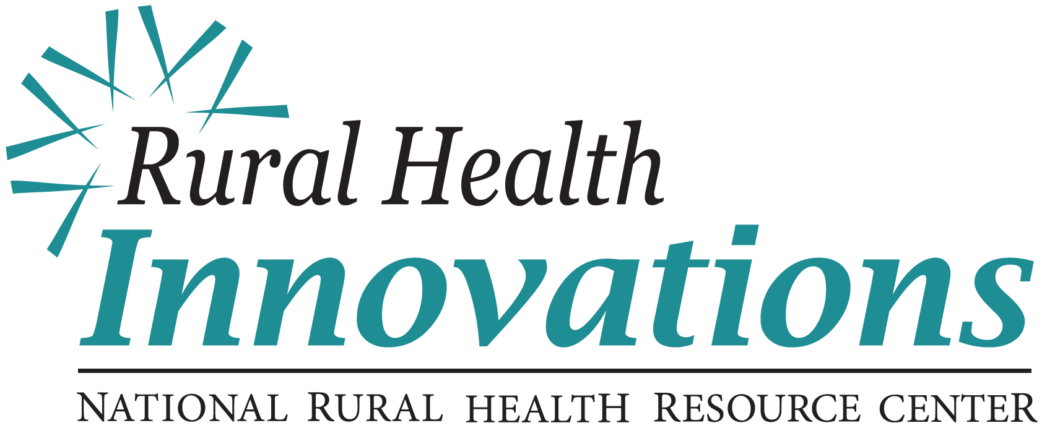](http://www.ruralcenter.org)

525 South Lake Avenue, Suite 320 │ Duluth, Minnesota 55802   
(218) 727-9390 │ info@ruralcenter.org  
Get to know us better: [www.ruralcenter.org/rhi](http://www.ruralcenter.org/rhi)

[Facebook icon](https://www.facebook.com/NationalRuralHealthResourceCenter)cid:image002.png@01CF4CF0.D46F4E00[Blog icon](http://oncenterblog.weebly.com/)cid:image002.png@01CF4CF0.D46F4E00[Twitter icon](https://twitter.com/RHRC)cid:image002.png@01CF4CF0.D46F4E00[LinkedIn Icon](http://www.linkedin.com/company/national-rural-health-resource-center)

Table of Contents

Background and Purpose 3

Lesson 1: We Are Better Together 4

Lesson 2: Degrees of Collaboration 5

Lesson 3: Building Credibility 6

Lesson 4: High Trust and Low Trust 8

Lesson 5: Building Trust in Your Relationships 9

Next Steps: Individual Trust Action Plan 10

Resources 12

# Background and Purpose

Rural Health Innovations (RHI), LLC, is a subsidiary of the National Rural Health Resource Center (The Center), a non-profit organization. Together, RHI and The Center are the nation’s leading technical assistance and knowledge centers in rural health. In partnership with The Center, RHI enhances the health of rural communities by providing products and services with a focus on excellence and innovation. RHI is providing technical assistance (TA) to grantees of the Rural Health Network Development Planning Grant Program through a contract with the Federal Office of Rural Health Policy.

Collaboration is one of the keys to sustainability in our changing health care environment. Rural health networks provide value to their members and contribute to the health and wellness of their communities with effective collaboration. This worksheet and the accompanying webinar are designed for rural health network leaders to improve skills and build capacity for meaningful and impactful collaborations.

*Building Trust in Collaborative Partnerships* will help network directors enhance and improve trust in all relationships—at the individual, team, and network levels. When demonstrated and modeled by network directors, trustworthiness sets a behavioral precedent and helps to create a culture of collaboration.

# Lesson 1: We are Better together

There are many different types of collaboration, from large-scale to small-scale and everywhere in between. In their text *Collaboration: What Makes It Work*, researchers at the Wilder Foundation provide a working definition of the term “collaboration” in the context of inter-organizational collaborative groups such as rural health networks:

*“Collaboration is a mutually beneficial and well-defined relationship entered into by two or more organizations to achieve common goals.”*

## Cartoon illustration of three mice faced with a maze. After discussing it together, the mice stand on each other's shoulders so that the mouse on top can see the full maze and take notes.

## 

## Activity 1.1: Identify Collaboration Opportunities

* What current needs of your network or your members would benefit from collaboration?
* Select one of these situations and briefly describe the collaboration opportunity. Include a list of the potential stakeholders.

# Lesson 2: Degrees of Collaboration

**Cooperation**Requires the lowest level of effort and complexity. Examples include sharing information, sharing space, sharing transportation services, sharing equipment or sharing lab resources.

**Coordination**Requires more commitment and may involve a moderate degree of integration. Examples include sharing administrative services (e.g., payroll), sharing staff, subcontracting, sharing training programs, EHRs or joint programming.

**Partnership**While all the examples discussed so far are collaborations at some level, full-scale collaboration requires substantial effort and complexity in partnering. Examples include formal partnership agreements, mergers, affiliations and management contracts.

## Activity 2.1: Determine the Degree of Collaboration Needed

Referring to the collaborative opportunity you identified in Activity 1.1, place that opportunity in the Degree of Collaboration Grid below next to the most appropriate collaboration type: Cooperation, Coordination or Partnership.

| **Degree of Collaboration** | **Description** | **Examples** | **Your Opportunity** |
| --- | --- | --- | --- |
| **Cooperation** | Low effort  Low complexity  Little integration | Informal networking  Resource sharing |  |
| **Coordination** | Moderate effort  Moderate complexity  Moderate integration | Administrative coalition  Joint programming  Joint service offerings |  |
| **Partnership** | High effort  High complexity  High integration | Formal Partnerships  Affiliations  Mgmt Service Orgs |  |

Adapted from LaPiana, Stanford Social Innovation, 2010, and Arthur Himmelman. Creating Collaborative Advantage. London: Sage Publishers.

# Lesson 3: Building Credibility

## A Balance of Expertise and Trust

Credibility is made up of two components: expertise and trust.

**Expertise**Expertise consists of your industry knowledge, your knowledge of the business, and your technical knowledge and skills. Building your expertise is gained through formal education, training and experience.

Note that expertise does not equal experience. Some people gain the equivalent of five years of experience with only one year on the job; other people get one year’s worth of experience in five years on the job.

**Trust**Trust is the other key component of credibility. Trust consists of following through with commitments, behaving in an ethical manner, and making sound decisions based on data and proof. Building trust includes being sensitive to both what the situation calls for and the needs of stakeholders.

In their book *Credibility:* *How Leaders Gain and Lose It, Why People Demand It*, James Kouzes and Barry Posner describe their research that found credibility is directly linked to both expertise and trust. Leaders who demonstrated high levels of both were deemed credible by research subjects.

*“Leaders know that while their position may give them authority, their behavior earns them respect. Leaders go first. They set an example and build commitment through simple, daily acts that create progress and momentum.”*

*— Kouzes and Posner*

## Credibility Matrix

## A graph with four quadrants. "Expertise" is on the x-axis, and "Trust" is on the y-axis. The four quadrants are "low trust and low expertise," "high trust and and low expertise," "low trust and high expertise," and "high trust and high expertise."

**Low trust/Low expertise:** Never on time or prepared. A lot of “fluffy talk” without too much to back it up. Being in this quadrant will not even win you an audience with someone.

**Low trust/High expertise:** Smart but sneaky or overly competitive. While you will be respected for being bright and intelligent, your motives might not be trusted. People will seek you out for information but won’t be as willing to give information to you.

**High trust/Low expertise:** Well-liked and comfortable to be with but not competent. People may want to work with you if you are enthusiastic or have growth potential, but they won’t be as eager to follow you.

**High trust/High expertise:** Responsive, calm and able to understand and explain themselves. This quadrant is where leaders are sought and are most effective.

# Lesson 4: High Trust and Low Trust

Stephen M. R. Covey, son of the late Stephen R. Covey, explains in his book *The Speed of Trust* that having high levels of trust makes execution easier and improves results for organizations or collaborations. Conversely, having low levels of trust hinders execution and can cause results to suffer.

| **High-Trust Environments**  **Lead To:** | **Low-Trust Environments**  **Lead To:** |
| --- | --- |
| Growth | Disengagement |
| Innovation | Redundancy |
| Loyalty | Turnover |
| Team-Oriented Focus | Defensiveness |

## Activity 4.1: High-Trust and Low-Trust Relationships

Think about a person within your network with whom you have a high-trust relationship. What are your conversations like? What are the results of your work together?

Now think about a person within your network with whom you have a low-trust relationship. What are your conversations like? What are the results of your work together?

What differences do you notice between the high-trust relationship and the low-trust relationship?

# Lesson 5: Building Trust in Your Relationships

## Behaviors that Build Trust

Stephen M. R. Covey identified 13 behaviors individuals can exhibit to increase trust in their relationships.

1. **Talk Straight:** Be honest and tell the truth.
2. **Demonstrate Respect:** Respect the dignity of every person and every role.
3. **Create Transparency:** State your intent and admit your mistakes.
4. **Right Wrongs:** Apologize and seek restitution.
5. **Show Loyalty:** Share credit and speak about others as if they were in the room.
6. **Deliver Results:** Establish a track record of doing what you are hired to do.
7. **Get Better:** Seek professional improvement and listen to feedback.
8. **Confront Reality:** Address tough issues directly and early.
9. **Clarify Expectations:** State and restate expectations; don't assume they are known.
10. **Practice Accountability:** Hold yourself, others and the team responsible.
11. **Listen First:** Demonstrate understanding of others before you speak.
12. **Keep Commitments:** Say what you will do and do what you will say.
13. **Extend Trust:** Share authority and show people you trust them.

## Activity 5.1: Personal Behavior Trust Inventory

Which trust-strengthening behaviors do you currently practice?

Which trust-strengthening behaviors do you know you could practice more of to build trust within your network relationships?

# Next Steps: Individual Trust Action Plan

## Part 1: Assessment

**Instructions:** Identify one individual in your network with whom you would like to have greater sense of trust. Consider the stakeholders involved in the collaboration opportunity you identified in Activity 1.1. Then complete the following questions, keeping in mind the concepts reviewed throughout this worksheet.

**Assess the situation:**

What is my credibility with this individual? Does this person see me the same way I see myself? Have I had an opportunity to show this person who I am?

What does this person know/think about what I do (and how I do it)? Are there trustworthy behaviors of mine that this person does not yet know about? How can he or she learn of my commitment, honesty, loyalty or accountability?

**Plan for action:**

What is one thing I can do to understand this person better?

What is one thing I can do that would help this person understand me better?

What is one commitment I can make to this person that would showcase my reliability and consideration of his or her needs?

Which trust-building behaviors can I better demonstrate to this person?

## Part 2: Action Plan Chart

Using your responses to the previous questions, develop an action plan to achieve your trust-building goals. A chart may be a useful format. Review your action plan periodically to track your progress and document outcomes. Repeat the process for everyone with whom you’d like to build or strengthen a high-trust relationship. Keep your responses to the Assessment questions as part of your plan documentation.

**Individual Trust Action Plan for: ­__________________________**

**Date Created: _______________**

| **Objective** | **Action** | **Timeline** | **Progress** |
| --- | --- | --- | --- |
| *Example: Build mutual understanding with B.G.* | *Attend an in-person training session together* | *September or November* | *Researched upcoming events; need to invite B.G.* |
| *Example: Demonstrate commitment and accountability* | *Volunteer to co-manage a project that will benefit B.G.* | *4th quarter* | *Discuss at next committee meeting* |
|  |  |  |  |
|  |  |  |  |
|  |  |  |  |
|  |  |  |  |

# Resources

For further research and discussion on building trust and improving collaboration within networks, we encourage you to explore the materials and tools listed below.

Building Commitment through Group Decision Making (recorded presentation and handout), National Rural Health Resource Center https://www.ruralcenter.org/‌rural-hit-network-development/resources/building-commitment-through-group-decision-making

*Collaboration: What Makes It Work*, by Paul W. Mattessich, Marta Murray-Close, and Barbara R. Monsey, of the Wilder Research Center. Fieldstone Alliance, 2001.

*Creating Collaborative Advantage* edited by Chris Huxham. London: Sage Publishers, 1996.

*Credibility: How Leaders Gain and Lose It, Why People Demand It* by James M. Kouzes and Barry Z Posner. San Francisco: Jossey-Bass Publishers, 1993.

Engaging Stakeholders During Times of Change and Transition (recorded presentation), National Rural Health Resource Center https://www.ruralcenter.org/‌rural-hit-network-development/resources/engaging-stakeholders-during-times-change-and-transition

PARTNER: a Social Network Analysis Tool to Collect, Analyze, & Interpret Data to Improve Collaboration within Community Networks http://partnertool.net/

*The Speed of Trust: The One Thing that Changes Everything* by Stephen M. R. Covey and Rebecca R. Merrill. Simon and Schuster, 2006.

Wilder Collaboration Factors Inventory: A Free Online Collaboration Assessment, Amherst H. Wilder Foundation http://wilderresearch.org/tools/cfi/index.php

*This publication lists non-federal resources in order to provide additional information to consumers. The views and content in these resources have not been formally approved by the U.S. Department of Health and Human Services (HHS) or the Health Resources and Services Administration (HRSA). Listing these resources is not an endorsement by HHS or HRSA.*