Project Strategic Plan Guide

Rural Health Network Development Grantees Program Technical Assistance

October, 2017

[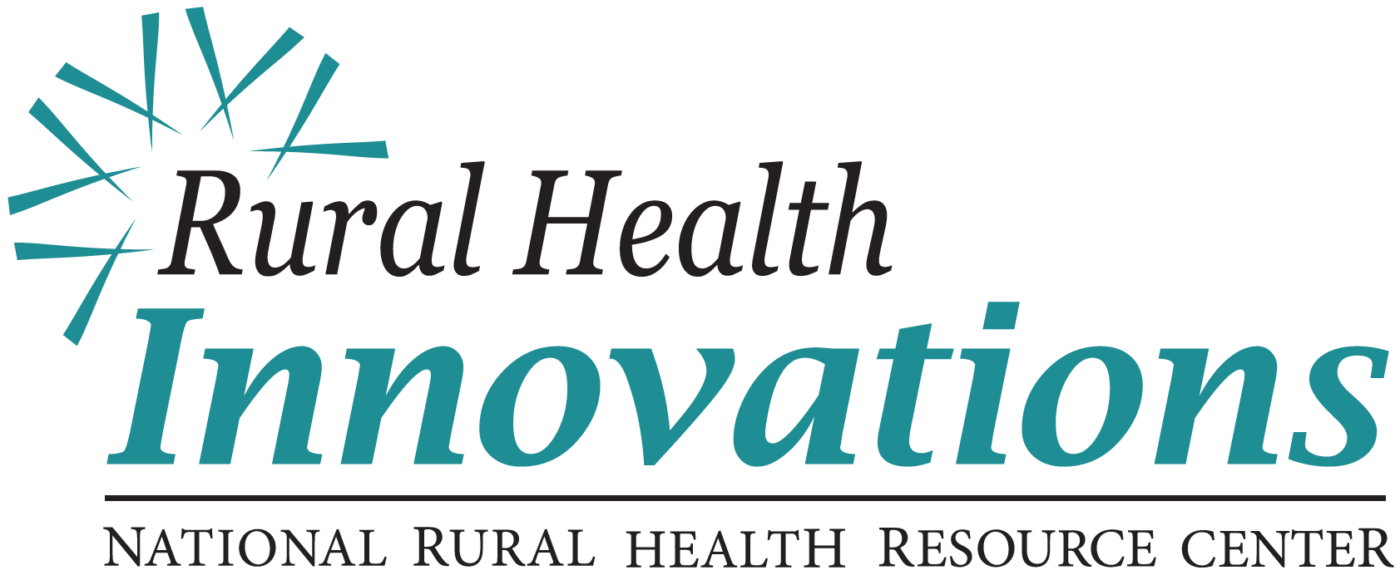](http://www.ruralcenter.org)

525 South Lake Avenue, Suite 320 │ Duluth, Minnesota 55802   
(218) 727-9390 │ info@ruralcenter.org  
Get to know us better: [www.ruralcenter.org/rhi](https://www.ruralcenter.org/rhi)

[Facebook icon](https://www.facebook.com/NationalRuralHealthResourceCenter)cid:image002.png@01CF4CF0.D46F4E00[Blog icon](http://oncenterblog.weebly.com/)cid:image002.png@01CF4CF0.D46F4E00[Twitter icon](https://twitter.com/RHRC)cid:image002.png@01CF4CF0.D46F4E00[LinkedIn Icon](http://www.linkedin.com/company/national-rural-health-resource-center)

RHI Disclaimer

Table of Contents

Background and Purpose 2

Glossary 3

Getting Started With Strategic Planning 4

Strategic Plan Components 9

Network Purpose, Shared Vision and Project Goals 10

Environmental Scan and Analysis 11

Strategic Objectives 13

Communication Plan for Strategic Planning 15

Next Steps 16

Facilitation Guide For Strategic Planning 169

1. Strategic Planning Agenda: Single-Day Event 20

2. Strategic Planning Agenda: Multiple-Day Sessions 21

3. Vision and Project Goal Check-In and Commitment 22

4. Environmental Scan and Analysis 23

5. Strategic Objectives Workshop 24

6. Strategic Objectives Check – In Discussion 25

7. Strategic Objectives Cross-walk with Levers and Blocks Chart 26

8. Alignment with Vision and Mission 27

9. Communication and Measurement Exploration 28

10. Planning Event Conclusion and Closing 29

Strategic Planning Resources 30

# Background and Purpose

Rural Health Innovations (RHI), LLC, is a subsidiary of the National Rural Health Resource Center (The Center), a non-profit organization. Together, RHI and The Center are the nation’s leading technical assistance and knowledge center in rural health. In partnership with The Center, RHI enhances the health of rural communities by providing products and services with a focus on excellence and innovation. RHI is providing technical assistance (TA) to the Rural Health Network Development grantees through a contract with the Federal Office of Rural Health Policy (FORHP).

The aim of strategic planning effort is to identify deliberate paths for effective change that will move an organization from today’s environment toward its vision. The purpose of this *Project Strategic Plan Guide* is to support Rural Health Network Development grantees in understanding:

* Commitment to a shared vision as a key to effective strategic planning
* The dynamic and iterative nature of the strategic planning cycle
* Four key components of a strategic plan for a network’s grant project
* Specific tools for developing an effective strategic plan

The outcome of using this guide will be a completed strategic plan for a network that includes documentation of a shared vision, an environmental analysis of blocks and levers, a projects strategic objectives and communication plan.

The audience of this *Project* *Strategic Plan Guide* for Rural Health Network Development Programsgranteesincludes the network leaders of rural health networks. This guide is designed as part of a toolkit that also includes a template and sample documents.

# Glossary

The following are terms you will find throughout the strategic plan materials, which are based on the Baldrige Performance Excellence Framework. (National Institute of Standards and Technology, Baldrige Performance Excellence: http://www.nist.gov/baldrige).

**Alignment:** A state of consistency among plans, processes, information, resources decisions, workforce capability and capacity, actions, results and analyses that support key organization-wide goals.

**Approach:** The methods your organization uses to carry out its processes.

**Goals:** Future conditions or performance levels that your organization intends or desires to attain.

**Governance:** The systems of management and controls exercised in the stewardship of your organization.

**Effective:** How well a process, or a measure, addresses its intended purpose.

**Key:** Major or most important; critical to achieving your intended outcome.

**Mission:** Your organization’s overall function.

**Partners:** Key organizations or individuals who are working in concert with your organization to achieve a common goal or improve performance.

**Results:** Outputs and outcomes achieved by your organization.

**Stakeholders:** All groups that are or might be affected by your organization’s actions and success.

**Strategic objectives:** The aims or responses that your organization articulates to address major changes or improvement, competitiveness or social issues and service advantages.

**Vision:** Your organization’s desired future state.

# Getting Started With Strategic Planning

The work of strategic planning provides a means for building stakeholder consensus on the vision of the network and the objectives that will drive change. Following are questions to consider as preparation for developing and writing a strategic plan.

### What are the benefits of writing a Strategic Plan?

A strategic plan is the end result of an intentional planning effort. Peter Drucker, a management thinker from the ‘50s and ‘60s, said, “The best way to predict your future is to create it.” The goal of strategic planning is to articulate the paths that will create the desired future. Strategic planning provides a focus for a network and a process of determining the key areas to work on that will move a network toward its vision and fulfill its purpose. The strategic planning process will create a road map for completion of the grant project leading toward success.

There are new stakeholders at the table that were not a part of developing the grant goals and strategies. Going through a strategic planning process will engage their support and participation. Doing strategic planning will validate the goals and strategies developed during the grant application process. Another aspect to consider is the situation or environment may have changed since writing the grant application. A strategic planning process will allow the opportunity to make needed adjustments.

Strategic plans serve a purpose for both internal and external audiences.

* Internal readers will use the strategic plan as a reference for decision making and a guide or roadmap for meeting challenging changes.
* External readers will use the strategic plan to gain a better understanding of the network’s focus, direction and strategies to make decisions such as funding or membership.

### Which planning framework, traditional strategic planning or logic model, is appropriate for my network?

There are different approaches to or frameworks for strategic planning. Each has its strengths and best applications. Each person, or network, may have their favorite approach. The framework selection is based on the preference of the network leadership. We find the Traditional Strategic Planning framework tends to fit the network environment better. This guide includes language based on the Traditional Strategic Planning framework.

The descriptive language and terms may vary between frameworks or approaches. Whichever planning framework is selected, be consistent with the language throughout the planning and documentation process. No matter what methodology you use, look at the definitions put forth in this guide and find the terminology in your method that applies. For example, if you use the logic model your “impact” translates nicely to what the traditional approach calls goals, the “outcomes” translates to objectives and “outputs and activities” translate to initiatives in the traditional approach. Feel free to use terms like impact, outcomes, outputs and activities. It does not matter what you call it, just so you are consistent throughout your work.

### Who should be involved?

The Center and RHI have developed resources describing the importance of collaboration in transforming health care. During this time of rapid change within the health care landscape and the movement toward population health, rural health networks have a unique and critical opportunity to bring stakeholders together from both health-care-based organizations and community-based organizations.

The list of stakeholders invited to participate in the strategic planning process will vary depending on the network’s unique characteristics. Consider carefully the stakeholders who can bring information and understanding of the environment and who can help strategically consider changes to move from the current reality toward the vision. 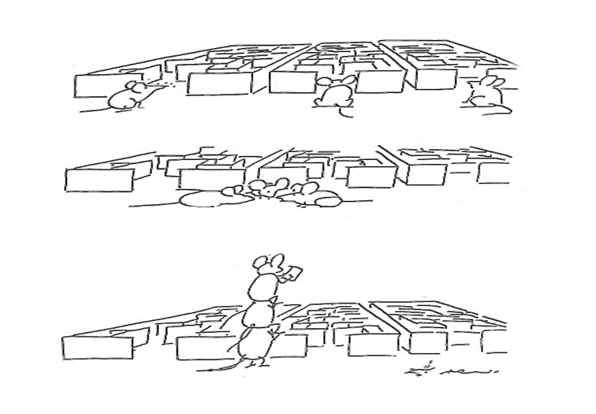

**Collaboration: We are better together.**

### What are the benefits of a shared vision?

When developing an effective strategic plan, commitment to a shared vision is the first, critical step. A vision identifies the “achievements” of the network’s aspirations and therefore acts as a beacon for the network.

Peter Senge, of the MIT Sloan School of Management and author of the organizational development book The Fifth Discipline, views organizations as dynamical systems in a state of continuous adaptation and improvement. This thinking identifies that having a shared vision pulls a network toward its vision. The ongoing operations, when guided by strategic objectives, constantly adjust and work to realize the achievements identified by the vision.

In other words, strategic planning is effective when it has a destination to aim for, which is the shared vision of the network’s achievements and aspirations.

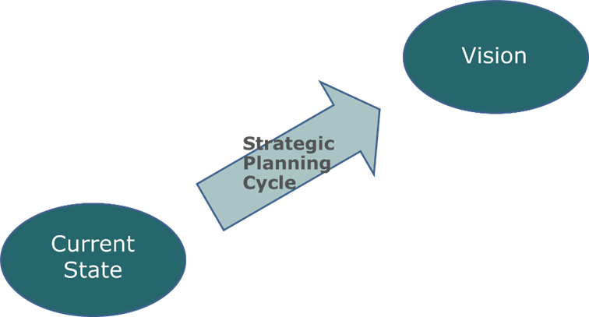

### What is the Strategic Planning Cycle?

The dynamic and iterative environment of planning, communicating, operationalizing and adapting describes a strategic planning cycle.

Robert Kaplan and David Norton, business management writers and thinkers of the 1980’s, studied organizations to figure out why some succeeded while others did not. They discovered that successful organizations approached planning in a holistic way. Based on their study and their discovery, they devised a planning methodology called the Balanced Scorecard. One of the key aspects of the Balanced Scorecard planning methodology is the strategic planning cycle: Analyze & Plan, Document and Communicate, Execute the Plan and Monitor & Adjust.

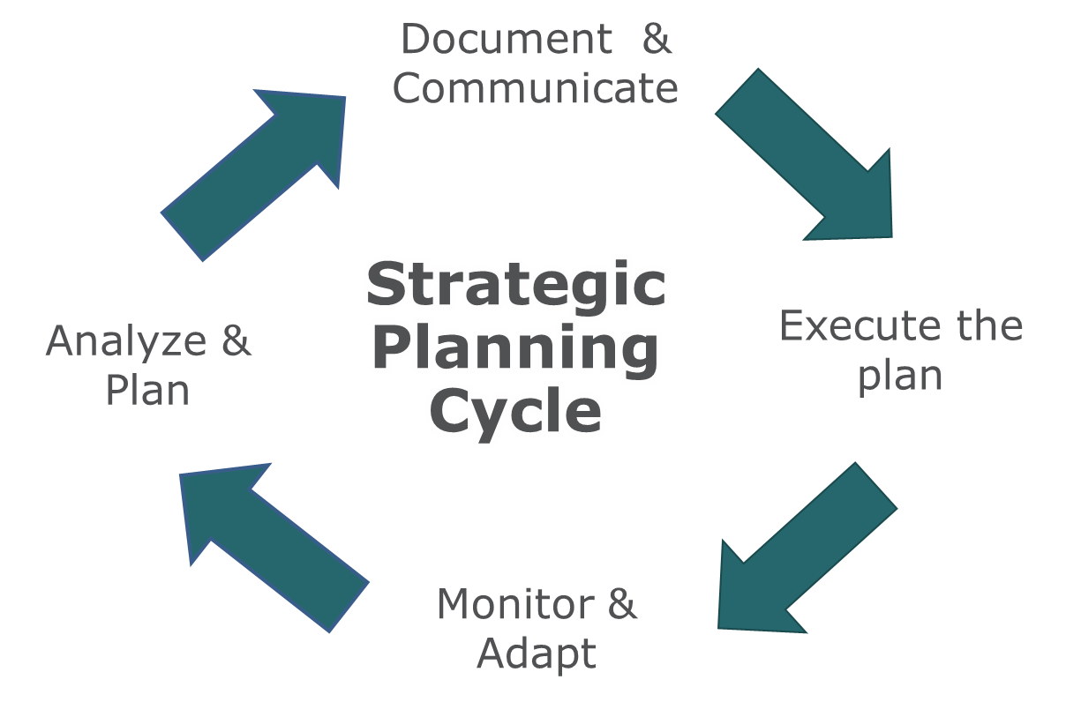

Walking through the basics of strategic planning, we’ll use a baseball team as an analogy to help better understand the terminology.

Before a team even begins to analyze or plan, some basic aspects of existing as an organization need to be in place: their mission, values and vision.

**Mission** = What do we do? For our analogy, we are playing baseball.

**Values** = How do we want to behave? Our baseball team wants to play fair and play competitively.

**Vision** = What do we want to achieve or become as a network? Our baseball team has agreed they all want to win the biggest trophy while rallying the most devoted and enthusiastic fans in the league.

In this strategic planning guide, we are jumping into the strategic planning cycle at the Analyze & Plan phase, where strategies are developed using information from the environment. The intention is for the strategies to leverage what is going well and address those aspects of the environment that are blocking progress toward the vision. For our baseball team, a *game plan* is established using strategies such as: increase ticket sales, utilization of effective training programs, entertain the fans with our athleticism and showmanship, effective implementation of game strategies and foster a positive culture.

In continuing the strategic planning cycle with our baseball team to be successful, there is more strategic efforts to be completed. The next phase is *communicating* the mission, values, vision and strategiesto the players and staff as well as with all the stakeholders involved in the team’s effort to achieve its vision. The goal of the communication phase is to engage all involved so that everyone understands: 1) what the network is aiming to achieve and 2) the agreed upon paths for getting there.

A critical phase for the team’s success is to operationalize the strategies by *creating and executing key initiatives*, such as improved processes for ticket sales, ensuring the stadium infrastructure is functioning and meeting expectations of the players, coaches and fans. Lastly, to address an ever-shifting environment, the team must *both monitor progress toward the strategic objectives and key initiatives* to be able to adjust to the challenges of change while advancing towards their vision of winning the biggest trophy while rallying the most devoted and enthusiastic fans in the league.

### Why is it important to engage in the complete cycle?

We recommend starting at the Analyze & Plan phase where the strategic objectives are identified and agreed upon. The next step is to communicate the strategic objectives throughout the network and to its partners. Identify the key initiatives that set your network’s strategies into motion and execute work plans. Monitoring progress quarterly and adjusting annually starts the cycle over again. Completing this cycle annually is a best practice of a healthy network.

Each time through the strategic cycle, the network is not at the same place as it was in the previous cycle. If one pictures a Slinky®, it is a circle, but the top of the circle is at two different points. As a network goes through the strategic planning cycle it learns, grows, makes changes and leaves the cycle at a new place of experience, capacity and maturity. Engaging the strategic planning cycle allows the network to adapt to the ever-changing environment and best stays on course to achieve the shared vision, the desired future of the network.

# Strategic Plan Components

### Rural Health Network Development Grant Projects

This guide provides support to networks in developing a project strategic plan based on the following four components:

1. **Network Purpose, Shared Vision and Project Goals**

This section provides a high-level overview of the network’s history, members and mission, and states the shared vision and primary grant project goals.

1. **Environmental Scan and Analysis**

This section reviews significant characteristics of the network’s internal and external environment in terms of key blocks and strengths of the network, particularly associated with the grant project goals.

1. **Strategic Objectives**

This section identifies the two-to-three year strategic objectives that will move the network toward its project goals.

1. **Communication Plan**

This section details how the strategic objectives are communicated throughout the network and partner organizations.

## Network Purpose, Shared Vision and Project Goals

This section provides a high-level overview of the network’s history, members and mission, and states the shared vision and primary grant goals. It sets the context for the strategic planning efforts. When writing your strategic plan, a narrative of the following elements are typical for this section:

**History:** The information in this section provides the reader with context for the network’s activities and infrastructure. A brief overview of the main points and significant achievements is an appropriate level of detail for the strategic plan.

**Members:** Listing the key partners participating in the network will help illustrate collaborative achievements, demonstrate the level of community commitment and convey the scope of the project. Also, consider including the location or service area of each partner, type of organization and network role.

**Mission:** A mission statement articulates your network’s purpose for being and the network’s values. The mission will describe how the network will achieve its vision in relation to specific objectives and customer needs.

**Shared Vision:** A vision statement, or list of vision “achievements”, expresses your network’s aspirations. It outlines where your network aims to be in the next two-to-three years, acting as a beacon for your grant goals. (If your network does not have a vision, please contact RHI for tools to assist in developing a vision.)

**Goals:** List your primary grant goals. These are the future conditions, or performance levels, that your network intends or desires to attain through the life of the grant; these can be found in the grant application. These goals act as your beacon for identifying project strategic objectives.

*It is critical for the network’s project goals to have full commitment from leadership, staff and stakeholders in the early steps of planning. See the* ***Facilitation Guide for Project Strategic Planning*** *(Page 18) for assistance in conducting a project goals check-in discussion.*

## Environmental Scan and Analysis

This section reviews significant characteristics of the network’s internal and external environment in terms of key blocks and strengths of the network.

It is important within the Analyze and Plan phase of the strategic planning cycle to take the time to study the environment in which the network is functioning. It is in this effort, and analysis, that the network can identify the aspects of its environment that will assist in reaching the vision of the network and those issues that are the blocks to achieving the shared vision.

When writing your strategic plan, a summary of the environmental data and findings from the environmental analysis is included. This may be done in narrative format, with a visual or a combination of both.

### Environmental Scan

Below is a checklist of suggested environmental scan information to gather in preparation for rural health network strategic planning. This is not an exhaustive or required list but rather meant to prompt thinking in preparation for strategic planning.

### Suggested Environmental Scan Data:

|  |
| --- |
| **Structure and Governance** |
| * Mission and values * List of board members and/or network leadership, including name, job title, employer and length of service * Network governance and policies * List of partner organizations and brief description of collaboration history * Results from member needs assessment or collaboration assessment |
| **Resource Development** |
| * Network positions and FTE allocation * Summary of financial environment and primary revenue streams * Financial forecast for the next two-to-three years * Inventory of resources owned by the network or shared by network partners |

|  |
| --- |
| **Market Analysis** |
| * Geographic setting of the network * Demographic information for the service areas of the members (i.e. age, gender, ethnicity, income) * Health indicators of the service area population * List of local and regional service providers * Member, customer and/or patient satisfaction survey results * New regulations or significant industry changes |
| **Significant Initiative Progress** |
| * Grant project work plan update and progress report * Network evaluation plan update * Communication plan tracking |

Environmental Analysis Findings

There are many approaches for designing and completing an environmental scan analysis for effective strategic planning. The key is to use a participative process that provides all stakeholders with an opportunity to consider the environmental information and seek the underlying barriers and opportunities that will inform their strategic thinking.

*See the Environmental Scan Analysis section in the* ***Facilitation Guide for Project Strategic Planning*** *(Page 23) for one approach to using a consensus-based method that gathers many ideas and highlights the key environmental levers and blocks to consider for developing strategic objectives.*

## Strategic Objectives

This section identifies the two-to-three year strategic objectives that will move the project toward its goals. At this point, two paths that can be taken:

* Use the goals and objectives in the grant application and do a “check in” on them to make sure they are still applicable
* Start the planning process with a ‘blank slate’ for the primary benefit of enlisting support from the new stakeholders at the table that were not a part of developing the grant goals and strategies. This approach also is a way to check-in to make sure the goals and objectives in the grant application are still on target given your changing environment.

Whichever path you chose to follow, listing and communicating the agreed-upon strategic objectives is the primary purpose of the strategic plan. The strategic plan will also show how the objectives relate to and are aligned with the shared vision of the network and project goals. Therefore, it is important to make it easy for both the internal and external reader to see the alignment of the strategic objectives with the goals of the project and the vision of the network. The *Project* *Strategic Plan Template* for Rural Health Network Developmentgranteesand the *Project* *Strategic Plan Samples* for Rural Health Network Development Grantees gives you examples of how to do this.

Strategic Objectives: The paths for moving a network toward the project goals.

* A best practice of strategic planning is utilizing the environmental scan and analysis to prepare the planning participants for strategic thinking.
* A participative process is a key to building consensus among stakeholders and identifying meaningful strategic objectives. This is significant for networks while it furthers relationships and builds trust and understanding among the network partners.
* Strategic objectives focus on achieving the vision and grant goals of the network while addressing the identified blocks and taking advantage of the identified strengths.
* Typically, strategic objectives look out two-to-three years toward the vision.
* It is helpful for the strategies to be written following the SMART acronym: Specific, Measurable, Attainable, Realistic, and Timely.
* Depending on a network’s governance structure, the strategic objectives are finalized when approved by the network’s governing body.
* There are many approaches to identifying and prioritizing strategic objectives. The path you chose, either doing a check-in on the applications goals and objectives or starting with a ‘blank slate’, sends you in a different direction.
  + If you chose to start with a ‘blank slate’ see the **Facilitation Guide for Strategic Planning** (Page 24) for the Strategic Objectives Facilitation Guide - a workshop that uses a consensus-based method to gather many ideas and group those ideas into similar strategic objectives.
  + If you chose to use the application goals and objectives it is important to do a check in with all the stake holders. See the **Facilitation Guide for Strategic Planning** (Page 25) for the Strategic Objectives Check-In Facilitation Guide.

### Alignment

It is important, both for the internal and external readers, to see that the project objectives are in alignment with the mission and vision of the network. That the work of this project does indeed fit with the work of the network. See the **Facilitation Guide for Strategic Planning** (Page 27) for the Alignment with Vision and Mission Facilitation Guide.

## Communication Plan for Strategic Planning

The communication plan section details how the mission, vision and strategic objectives are communicated throughout the network and partner organizations. This communication plan, within the Strategic Plan, is only for the plan and analyze a portion of the cycle. (The communication plan’s scope in the evaluation plan will be for the entire strategic planning cycle.) It is a plan for intentionally and purposefully communicating the network shared vision and purpose, the environmental analysis and approved strategic objectives to partners and stakeholders. This is a key step for building commitment and accountability in achieving the strategic objectives. Consider the audience, channel, timeline and parties responsible for each message within the plan. In the *Project* *Strategic Plan Template* for Rural Health Network Developmentgrantees*,* you will find a chart that may be helpful. If you do use narrative, limit the narrative in this section to no more than one page.

### Communication Plan Components:

* **What:** Identify key information of the strategic plan, i.e. mission, vision and key strategies
* **Audience:** Identify specific audience, i.e. program staff, board members, member organization staff, potential partners, funders, community members, etc.
* **How:** Identify specific mode(s) of delivering information, i.e. in-person, network board meetings, email, website, SharePoint, phone, formal reports, discussion, planning retreats, social media, etc.
* **When:** Identify frequency for providing information, i.e. ad hoc, monthly, quarterly, in-person only, as requested, etc.
* **Who:** Identify the person(s) responsible for communication accuracy, timeliness, frequency, etc.

It’s often valuable to create visual representations of the objectives and progress for use in your communications, including tools such as a Strategic Objective Map (page 7 of the *Project Strategic Plan Template*). This is something Kaplan and Norton recommend in their Balance Score Card work. We are including an optional template for use in the *Project* *Strategic Plan Template* for Rural Health Network Developmentgrantees.

## Next Steps

Taking a second look at the strategic planning cycle, you will see three elements of the Analyze and Plan phase have been completed. Part of the initial planning is determining what is going to be measured to show progress toward your project goals and how that is going to be done, known as your evaluation plan. There will be a communication element and monitoring component to your evaluation plan as well.

**Plans in the Strategic Planning Cycle**

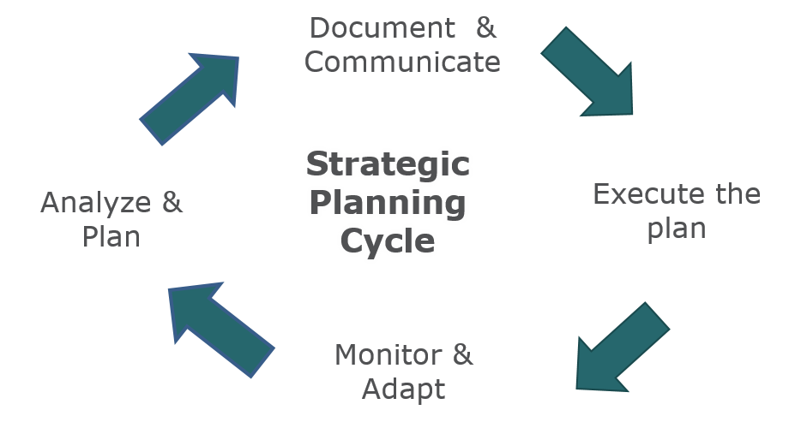

**Analyze and Plan**

* Network purpose and shared vision
* Environmental scan and analysis
* Strategic objectives
* *Evaluation measures and plan to adjust and monitor (Evaluation Plan)*

***Communicate***

* *Communication Plan for the entire life of the cycle (Strategic, Evaluation and Marketing Plan)*

***Operationalize***

* *Operationalizing the strategic objectives with key initiatives (Work Plan)*

***Monitor and Adjust***

* *Monitoring and adjusting (based on the work in Evaluation Plan)*

As project implementation moves forward you will continuously be going around this cycle. Make sure to consider how you will do a thorough look at and possibly revision of your strategic plan during year three. This will carry the network into year four and five.

# Facilitation Guide for Strategic Planning

# Facilitation Guide For Strategic Planning

The following materials are intended to provide support in designing and leading strategic planning events that include discussions and workshops with network stakeholders. The facilitation conversations and workshops are based on the Technology of Participation Focus Conversation and Workshop methods. These methods center on participative values and group decision-making facilitation principles. The goal of the following tools is to provide network leaders with ways to engage stakeholders through meaningful discussion and problem solving for effective strategic planning. This guide contains the following 10 facilitation tools:

### Strategic Planning Design and Agendas

1. The first agenda illustrates a single event designed for five-to-seven hours of presentation, discussion and planning.
2. The second agenda breaks the planning elements down into five one-to-two hour sessions.

### Shared Vision and Project Goal Check-In

1. Your network has an established vision. It is important to revisit the vision through an intentional check-in and commitment discussion before moving forward with strategic planning. The same is true of your project goals.
   * Reaching agreement on and commitment to the network vision and project goals is a critical component in creating meaningful strategic objects.
   * The participants will gain an understanding of and comfort with the network vision.

### Environmental Scan Analysis Workshop

1. After the environmental scan data has been presented, the planning participants will engage in a discussion to analyze the data. Through this conversation, participants will identify the key levers and blocks the network is facing as it works to achieve the network vision.
   * Find key levers and blocks, both internal and external, which will be incorporated into the development of strategic objectives.
   * Feel confident that the key leverage points and underlying blocks have been identified to consider strategic options.

### Strategic Objectives Workshop

Participants will gain consensus on the strategic directions that will provide pathways for the network work to move toward its vision.

* + Reach group consensus on strategic objectives that address levers and blocks and that will move the network toward its vision.
  + Agree that the identified strategic objectives are doable and will provide guidance to the organization over the coming two-to-three years

Chose one of the following facilitations.

1. Strategic Objectives Facilitation Guide – full 120-minute workshop – for starting with a blank slate to gain commitment of entire group to move forward together.
2. Strategic Objectives Check-In Facilitation Guide – 60-minute workshop to be used for a check-in on the objectives in the grant application.
3. A chart to help facilitate the conversation in the Strategic Objectives Check-In conversation.

### Alignment with Vision and Mission Discussion

1. After reaching consensus on strategic objectives, participants will engage in a discussion to ensure alignment of the objectives with the vision and mission of the network.
   * Confirm alignment of new strategic objectives with network vision and mission
   * Gain understanding of and comfort with the new network strategic objectives relative to the network’s vision and mission

### Communication and Measurement Exploration

1. Before leaving the event, it is helpful for participants to know what the next steps are and what the information just generated will be used for. This 45-minute conversation includes elements to be used for the communication plan in this document and the beginning steps of the evaluation plan.
   * What does success look like?
   * How are we going to communicate the strategic planning work to stakeholders?

### Closing

1. It is always helpful to wrap up the events work and to bring the group to conclusion. This 10-minute facilitation will help draw the workshop to a close.

## Strategic Planning Agenda: Single-Day Event

**[Rural Health Network]**

**Strategic Planning Event**

[Date and Time]

[Location City, State]

**9:00 – 10:00 a.m.**

* Welcome, Introductions and Agenda – 30 min
  + Network Director
  + Planning Facilitator
* Strategic Planning Overview and Methodology (*presentation available from RHI*) – 30 min

**10:00 – 12:30 p.m.**

* Strategic Planning – Part I
  + *Vision and Project Goal Check-In and Commitment –30 min*
  + Environmental Scan (presentation – see pages 12-13 of this guide) – 30 min
  + *Environmental Analysis to Prioritize Levers and Blocks*– 90 min

**12:30 – 1:15 p.m.**

* Lunch

**1:15 – 3:45 p.m.**

* Strategic Planning – Part II
  + *Strategic Objectives* *Workshop* – 120 min **or***Strategic Objectives Check – In Discussion* - 60 min
    - *Strategic Objectives Crosswalk with Levers and Blocks chart*
  + *Alignment of Strategic Objectives with Mission and Vision* – 30 min

**3:45 – 4:30 p.m.**

* *Communication and Measurement Exploration* – 35 min
  + What does success look like?
  + How are we going to communicate today’s work?
  + Board/Advisor Approval Process for next board meeting
* *Planning Event Conclusion and Closing* – 10 min

## Strategic Planning Agenda: Multiple-Day Sessions

[Rural Health Network]

**Strategic Planning Event**

[Date and Time]

[Location City, State]

**Session 1: (45-60 min)**

* Agenda and Introduction – 15 min
* Strategic Planning Overview and Methodology (*presentation available from RHI*) – 30 min

**Session 2: (60 min)**

* Review Results of Session I – 15 min
* *Vision and Project Goals Check-In and Commitment– 30 min*

**Session 3: (120- 150 min)**

* Review Results of Sessions I-II – 30 min
* Environmental Scan (presentation – see pages 12-13 of this guide) – 30 min
* *Environmental Analysis to Prioritization of Levers and Blocks* – 90 min

**Session 4: (120 min)**

* Review Results of Sessions I-III – 20 min
* *Strategic Objectives* *Workshop* – 120 min **or***Strategic Objectives Check – In Discussion* - 60 min
  + - *Strategic Objectives Crosswalk with Levers and Blocks chart*

**Session 5: (90 min)**

* Review Results of Sessions I-IV – 15 min
* *Alignment of Strategic Objectives with Mission and Vision* – 30 min
* *Communication and Measurement Exploration* – 35 min
  + What does success look like?
  + How are we going to communicate today’s work?
  + Board/Advisor Approval Process for next board meeting
* *Planning Event Conclusion and Closing* – 10 min

## Vision and Project Goal Check-In and Commitment

**Facilitation Guide: 30 – 40 Minute Discussion**

|  |  |
| --- | --- |
| **Rational Objective**: Reach agreement on and commitment to the network vision and project goals as a critical component in creating meaningful strategic objectives. | **Experiential Objective**: Gain understanding of and comfort with the network vision and project goals. |
| **Setup and Materials**: Prominently display or provide the network vision and project goals from grant application. | |
| **Pre-requisite:** An existing shared vision in place for the network. | |
| **Opening: (5 min)** Review the purpose and description of a shared vision. Read through the network vision. (This may be the highest-level grant goals.) Our network vision has already been approved by the governing board [if applicable]. Due to the importance of having a shared vision during the planning process as a beacon to aim for our planning for the coming two-to-three years. We will also review our projects goals as submitted in our grant application. Let’s spend about 20-30 minutes talking about what this vision means to us and our network and how the grant goals align with our work. | |
| **Focused Conversation: (20 min)**   * Read vision * What specific word in this vision catches your attention? (Have every participant answer this question.) * What about this vision resonates with you? How does it hold your attention? * How does this vision describe what we want to become as a network in this region and for our members? * Read grant goals * What specific goal catches your attention? (Have every participant answer this question.) * What about these goals resonates with you? How do they hold your attention? * What might be the impact on our communities as the network strives to become what is stated in our vision and accomplishes these goals? * Is this vision one we are all comfortable with and do we feel these goals are in alignment with the vision so we can use them as a beacon for our strategic planning?   + If not: What can we adjust to make it right for us today? | |
| **Consensus Building: (5 min)**   * Make sure all participants are ready to move forward with the vision and project goals for strategic planning. Use a method of gaining commitment to the vision: thumbs-up (agree), flat (can live with), or thumbs-down (can’t live with and need additional discussion). * Do not proceed with planning until all participants are in consensus that the vision is a worthy target for strategic planning. * Note: If the vision and goals are close but the discussion identifies that revisions and further input is needed, consider getting group consensus that it is close enough for the strategic planning process and that a vision review will take place in the near future. Set a timeline and ask an individual to take the lead on next steps. | |

## Environmental Scan and Analysis

**Facilitation Guide: 90-Minute Workshop**

|  |  |  |  |  |
| --- | --- | --- | --- | --- |
| **Rational Objective**: Find key levers and blocks, both internal and external, which will be incorporated into the development of strategic objectives. | | | **Experiential Objective**: Feel confident that the key leverage points and underlying blocks have been identified in-order-to consider strategic options. | |
| **Setup and Materials:** Sticky wall or blank wall for displaying notes, writing markers, two-four flip chart-sized papers. Label two papers, one as “Levers” and another as “Blocks”. | | | | |
| **Pre-requisites:** Presentation of environmental scan data and commitment to a shared vision. | | | | |
| **FOCUS QUESTION: “*What are the levers and blocks that we will either leverage or work around in moving toward our vision and project goals?****”* | | | | |
| **Opening:** Review the purpose and description of an environmental analysis; identifying key levers and blocks. *Given the information provided in the environmental scan presentation, we will be considering our focus question. In this discussion, we will begin by first brainstorming events and happenings that will help our network move towards its vision (levers) as well as those that will get in our way (blocks). We will share our ideas and discuss together to gain insight on what we can leverage and the underlying issues that we need to be aware of as we plan the paths we will take toward our vision.* | | | | |
| **Brainstorm:** (**10 min)**  Individually brainstorm the events and happenings going on in health care, your community and your organization that are:   * **Leveraging:** Helping the network move toward its vision * **Blocking:** Getting in the way of the network from moving towards its vision * Working individually, make a list of >10 ideas. * Review your individual list and star four-five of your best ideas | **Small Group Discussion:** **(15 min)**  First for levers and then for blocks:  Working in pairs:   * Between both individual lists, select the top best five-six ideas. (Note: need 30-35 total data pieces, assumes six pairs) * Ask small groups to be ready to share with the larger group, one idea at a time. | **Report Out:** (**30 min)**  Synthesize the data to identify key leverage points and key blocks. Sharing from small groups, one group at a time, until all levers and blocks are shared. The intent is to identify those underlying levers and blocks. Ask deeper questions if there is a “lack of” description, and seek the cause of the issue.   * Ask: *What are the clearest or most straightforward ideas?* (Record onto flip chart, moving to next group following a response.) * Ask: *What are different ideas or complex ideas?* * Continue around the small groups until all levers and then blocks have been shared. | | **Identify Keys: (20 min)**  The intent of this section is to prioritize underlying levers and blocks while transitioning to the strategic planning effort.  Working together as a large group:   * *Of these levers and blocks* (address separately)*, which ones are important for us to highlight and be sure to bring forward in our planning and problem solving?* (Underline identified levers and blocks). * [IF TIME] Ask participants to put a mark to have the group prioritize: “*What are top three levers and top three blocks that are critical in moving the network toward its vision/or mission*”? * Allow 15 min for this voting work. |
| **Transition to development of strategic objectives**: **(5 min)**  Next Step: Getting started with strategic thinking and planning: Looking for key paths that will take us from our current reality to our desired future state.   1. Have a participant read the network’s vision, another person the grant goals and another person read through the titles of levers and blocks. 2. *Are there any surprises in these? Did we get to the underlying issue or the cause?* 3. *Of the top three levers, which will be easiest to leverage and take advantage of? Which one will be more difficult? Of the top three blocks, which one will be the easiest to deal with or work around? Which one the hardest?* | | | | |

## Strategic Objectives Workshop

**Facilitation Guide: 120 Minute Workshop**

|  |  |  |  |  |
| --- | --- | --- | --- | --- |
| **Rational Objective**: Reach group consensus on strategic objectives that address levers and blocks and that will move the network toward its vision. | | | **Experiential Objective**: Agree that the identified strategic objectives are doable and will provide guidance to the organization over the coming two-to-three years. | |
| **Setup and Materials:** Sticky wall or blank wall for displaying notes and writing markers. 50 half-sheets of paper, 10 blue full sheets of paper, six-eight full yellow sheets of paper. Writing utensils. Painter’s tape if needed. | | | | |
| **Pre-Requisite:** Completed environmental analysis with established priorities of underlying Levers and Blocks. | | | | |
| **Opening:** *Together, we will be considering,* ***“What are the key strategic objectives that will guide this organization from today’s reality toward tomorrow’s vision?”*** *We have agreed on our network vision and identified the key levers and blocks of our current reality. In this discussion, we will begin brainstorming actions and activities that will move us toward our vision and then spend time identifying key strategies that our ideas describe. We’ll then seek consensus on the strategic goals or objectives that will provide guidance to our network over the coming two-to-three years.* | | | | |
| **Brainstorm:** (**10 min)**  Individuallybrainstorm:   * *What are the ideas, initiatives, tasks, or to-do’s that will address the issues impacting the network that we identified in the environmental analysis?* * Have each person compile a list of >10 ideas. * After giving time for brainstorming, have each person review his/her list and star the four-five best ideas. | **Data:** (**15 min)**  Working in pairs:   * Compare both lists and select the top five-six ideas. (Note: Need 30-35 total data pieces, assumes six pairs) * Describe each idea using three-five words. Write one idea per half-sheet of paper and post on wall, or use flip chart to record ideas. | **Organize:** (**40 min)**  Working together as a large group, synthesize the data to identify key leverage points and key blocks. Another way to think of this is seeking consensus on strategic directions or objectives.   * Cluster data into similar ideas. *What is the common thread or strategic path being described by this data that moves the network from today’s reality to tomorrow’s vision?* * Seek consensus on the key strategic directions or objectives by naming the clusters. For each cluster, ask, *“In this cluster, what is the title that best describes the strategic idea?*” * Titles should be descriptive and action oriented, three-five words: **verb + adjective + noun**. Examples: Improve Operating Efficiency, Provide Outstanding Customer Service, and Deliver Timely and Effective Care. * Write a strategic objective title on a full sheet of green paper and place at the top of the cluster. | | **Name:** (**30 min**)  The intent of this section is to prioritize the strategic objectives and set commitment (strategic objectives = titles agreed upon in the Organize step).   * Read the titles across and refer to the overall planning question: *(TITLEs) are our key strategic objectives that will guide this network toward its vision.*   Ask participants:   * *How do these strategic objectives align with our network’s mission?* * *Which of these strategic objectives are critical to our network’s sustained success?* * *Which will take more focus and dedication of us as members?* * *How will we as network leaders be involved in promoting and communicating these strategic objectives?* |
| **Begin to review the strategic objectives:**  Next Step: Double check for SMART objectives and revise as needed. Begin considering the key initiatives that the network can undertake for each strategic objective. Transition to assessing the objectives’ alignment with the vision and mission. | | | | |

## Strategic Objectives Check – In Discussion

**Facilitation Guide: 60 Minute Discussion**

|  |  |
| --- | --- |
| **Rational Objective**: Reach group consensus on strategic objectives that address levers and blocks and that will move the network toward its vision and project goals. | **Experiential Objective**: Agree that the identified strategic objectives are doable and will provide guidance to the organization over the coming two-to-three years. |
| **Setup and Materials:** Prominently display a re-creation of the “Strategic Objectives Check-In Chart” and/or provide a personal copy. | |
| **Pre-Requisite:** Completed environmental analysis with established priorities of underlying levers and blocks. | |
| **Opening:** *Together, we will be considering,* ***“What are the key strategic objectives that will guide this organization from today’s reality toward tomorrow’s vision and meet the grant goals?”*** *We have agreed on our network vision and grant goals. We have identified the key levers and blocks of our current reality. In this discussion,* we will review our projects objectives as submitted in our grant application. Let’s spend about 20-30 minutes talking about how these objects will meet our grant goals based on the environment we are working in. | |
| **Strategic Objectives –Check-In Chart Preparation: (15 min)**  *You see the grant application objectives written across the top row. Place the top three blocks that we determined in the rows below the word blocks and the top levers below the word lever. Spend a few minutes individually marking ‘x’ in the row of the block or lever in the objective column – if the objective directly addresses the block or lever. Proceed as a group.*  **Focused Conversation: (40 min)**   * For each objective ask the group which of the different blocks and levers it addresses OR have each of the participants come up and put “dots” on the chart * Tally up the “x’s” or “dots” in each column * What catches your attention? What stands out as you look at this chart? * Are there any objectives that need changes?   + *Let’s look specifically at the objectives which have three or fewer “x’s”*. Have someone read those.   + *What can we adjust to make it right moving forward with more detailed planning*?   + Document those changes | |
| **Consensus Building: (5 min)**   * Make sure all participants are ready to move forward with the strategic objectives. Use a method of gaining commitment to the vision: thumbs-up (agree), flat (can live with), or thumbs-down (can’t live with and need additional discussion). * Do not proceed until all participants are in consensus that the strategic objectives on target for addressing blocks and levers while meeting grant goals. * Note: If the objectives are close but the discussion identifies that revisions and further input is needed, consider getting group consensus that it is close enough for the strategic planning process and that a strategic objective review will take place in the near future. Set a timeline and ask an individual to take the lead on next steps. | |

## Strategic Objectives Cross-walk with Levers and Blocks Chart

To be used with “Strategic Objectives Check-In Discussion”

** Prepopulate the objective row with the objectives from grant application. You may wish to use brief shorthand descriptions.

|  |  |  |  |  |  |  |  |  |  |
| --- | --- | --- | --- | --- | --- | --- | --- | --- | --- |
| Grant Application Objectives | Objective |  |  |  |  |  |  |  |  |
| Blocks |  |  |  |  |  |  |  |  |  |
|  |  |  |  |  |  |  |  |  |  |
|  |  |  |  |  |  |  |  |  |  |
|  |  |  |  |  |  |  |  |  |  |
| Levers |  |  |  |  |  |  |  |  |  |
|  |  |  |  |  |  |  |  |  |  |
|  |  |  |  |  |  |  |  |  |  |
|  |  |  |  |  |  |  |  |  |  |
| TOTAL |  |  |  |  |  |  |  |  |  |
| **Steps:**  1 – brief descriptions of grant objectives in row one  2 – write the three top Blocks and Levers in column one  3 – place an “x” in the row if the objective in the column directly addresses the Block or Lever  4 – total the number of “x’s” in each column  5 – highlight those columns with a total of three or less | | | | | | | | | |

## Alignment with Vision and Mission

**Facilitation Guide: 30 Minute Discussion**

|  |  |
| --- | --- |
| **Rational Objective**: Confirm alignment of new strategic objectives with network vision and mission. | **Experiential Objective**: Gain understanding of and comfort with the new network strategic objectives relative to the organization’s vision and mission. |
| **Setup and Materials:** Prominently display or provide the network’s vision and mission. | |
| **Pre-requisites:** Development of strategic objectives based on identified Levers and Blocks. | |
| **Opening:** *Throughout our strategic planning efforts, we have worked to aim our thinking and our strategies toward our network vision while recognizing that it is our shared vision pulling our network forward.* [Read through a vision that is displayed nearby for everyone to see. It is nice to have the vision posted to the left of the strategic objectives in as a “target.”] *Let’s spend the next 15 minutes or so checking our new strategic objectives back to our vision to double check that we are indeed aiming for it.* | |
| **Focused Conversation: (10-15 min)**  Have someone read through each of the newly agreed-upon strategic objectives.  Then ask:   * *Which of these objectives are an ’aha!’ or surprises? Any that really “hit the nail on the head”?* * *How do these strategic objectives move us toward our vision?* * *How do these strategic objectives follow the guidance of our mission?* * *Are there any themes running through the objectives?*    + If objectives are identified as “similar” in strategy, rearrange the information to group those objectives next to each other and consider adding a larger title to capture the common idea. * *Which of these objectives are going to be more difficult to operationalize or will need careful monitoring?*    + Place a star by the identified objectives to highlight them. This is a good place to emphasize the role of the board or advisory group to monitor progress toward the strategic objective and the network leadership’s role to operationalize the objectives into actions and initiatives. * *What might be the impact on our communities as our network uses these objectives to guide our work?* * *What is our commitment to these strategic objectives to guide our work toward our vision?*    + Check-in with everyone to gain consensus with a thumbs-up (agree), flat (can live with), or thumbs-down (can’t live with and need additional discussion).   + Do not complete the planning without full consensus (thumbs-up or flat). If there are any thumbs-down, then more discussion is needed. | |
| **Next stages of strategic planning:**  Seek formal acceptance of the strategic objectives by the board/or advisory group. | |

## Communication and Measurement Exploration

**Facilitation Guide: 35 Minute Discussion**

|  |  |
| --- | --- |
| **Rational Objective**: Following commitment to strategic objectives, explore communication options and identify initial measures that will be part of evaluation planning. | **Experiential Objective**: Celebrate the achievement of agreeing on strategic objectives by and begin to imagine what success may look like. |
| **Setup and Materials:** Have each of those objectives written on a flip chart. (If you are in a small enough group, one could write two on a piece.) Have markers for recording participant’s comments. Have a few blank pieces of flip chart paper. You may also use a colored half or whole sheet next to each objective on the sticky wall. One color for measures and one for communication ideas. | |
| **Pre-requisites:** Alignment of objectives checked with vison, mission and goals. | |
| **Opening:** *We have determined strategic objectives that are in alignment with our networks vision and project goals. How do we know we are successful or moving toward those goals? Another word – what does success look like? We also need to communicate the strategic planning work we have been doing. Let’s spend the next 20 minutes or so visioning what success would look. Then we will spend about 10 minutes talking about how we are going to communicate this good work.* | |
| **Focused Conversation “what does success look like?”: (20 min)**  Have someone read through each of the newly agreed-upon strategic objectives or groupings - if rearranged/or grouping in the previous alignment discussion.  Then ask:   * *We found some themes running through the objectives in the previous session – are there types of success running through these objectives?*    + If objectives are identified as having “similar” success measures, rearrange the information to group those objectives next to each other and consider adding a larger title to capture the common idea. * *Which of these objectives are going to be more difficult to measure success?*    + Place a star by the identified objectives to highlight them. This is a good place to emphasize the role of the board or advisory group to monitor progress toward the strategic objective and the network leadership’s role to operationalize the objectives into actions and initiatives. * *What does success look like?*    + Have participants shout out what success could look like for each of the objectives and write those ideas below each on the flip chart or on the colored sheet of paper next to it. * These ideas will be used in developing our evaluation plan.   **Focused Conversation on Communication (10 min)**   * Ask: “How can we communicate our strategic planning work to our program staff, board members, member organization staff, potential partners, funders and community members.”   + Record the participants answers on half sheet next to objectives or flip charts.   + If time allows begin to identify who oversees the communication and when. | |
| **Next steps to planning:**  This information will be helpful in completing communication plans and writing the evaluation plan. | |

## Planning Event Conclusion and Closing

**Facilitation Guide: 10 Minute Discussion**

|  |  |
| --- | --- |
| **Rational Objective**: Close the workshop. Review takeaway. | **Experiential Objective**: Relaxed atmosphere, participants paying attention |
| **Setup and Materials:** Chose one question or you may use both questions within each type. | |
| **Pre-requisites:** Participated in workshops | |
| **Opening:** *As we wrap up our time together today I would like to take 10 minutes to reflect on our day.* | |
| **Focused Conversation**  **O**   * What is something from the day that you stood out for you or resonated with you? (Go around the room.) * What was one thing that was a highlight, new discovery or a ‘WOW’ for you as we did this? (Go around the room.)   **R**   * What about the data up on the sticky walls make the most sense – which parts are most clear? * Where were you really engaged in the process? Where did you find yourself hanging back or disinterested? * What feelings or emotions came up for you?   **I**   * Anything that is a question for you or feels confusing or undone? * What is the significance of the work we have just completed?   **D**   * Where are you the most excited or ‘can’t wait to get started?   Thank them for coming and talk about the next formal steps, such as board approval or when the next meeting will be. | |

# Strategic Planning Resources

For further research and guidance on the strategic planning process, we encourage you to explore these additional resources:

**Aim for Impact and Sustainability, Rural Health Innovations** https://www.ruralcenter.org/rhi/network-ta/aim-for-impact

**Baldrige Performance Excellence Program: Health Care** http://www.nist.gov/baldrige/publications/hc_criteria.cfm

**Business Model Canvas, Business Model Generation** http://www.businessmodelgeneration.com/canvas/bmc

**Integrating the Strategic Plan, Logic Model, and Work Plan, Evaluation Research** **Team**   
http://www.cdc.gov/healthyyouth/evaluation/pdf/brief5.pdf

**Program Evaluation Planning and Tools: Allied Health Workforce, Rural Health Innovations**https://www.ruralcenter.org/resources/allied-health-program-evaluation-planning-and-tools

**So Many Plans, So Little Time: Aligning and streamlining your planning efforts for long-term success**  
http://oncenterblog.weebly.com/on-center-blog/-so-many-plans-so-little-time?utm_source=Network+TA%3A+April+Newsletter+2017&utm_campaign=Network+TA+April+2017&utm_medium=email

**Strategic Planning Basics, Balanced Scorecard Institute** http://balancedscorecard.org/Resources/Strategic-Planning-Basics

**Strategic Planning Process Outline, Center for Rural Health, University of North Dakota School of Medicine and Health Sciences** https://www.ruralcenter.org/tasc/resources/strategic-planning

**Strategic Planning That Leaves You Smiling, Studer Group (webinar recorded 10/13/2014)**   
https://www.studergroup.com/resources/news-media/articles/studer-group-to-host-national-rural-health

**Strategic Planning That Works: Integrating Strategy with Performance, American College of Healthcare Executives (webinar series ACHE members: $530, Non-members: $605)** <http://www.ache.org/seminars/online_detail.cfm?PC=ONLSTPLAN>