Critical Access Hospital Recognition: FY2018

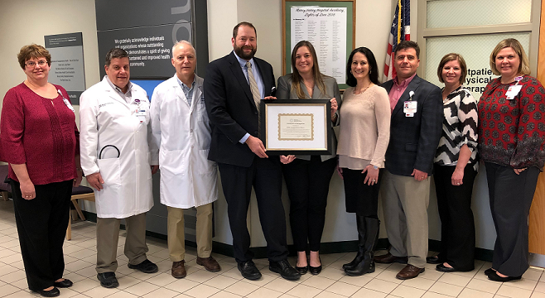
innovative telehealth initiatives Impacting population health

UPMC Susquehanna Muncy

Muncy, Pennsylvania
UPMC Susquehanna Muncy is recognized for the development of innovative telehealth services, including stroke.

Positive Outcomes
Executives and staff of UPMC Susquehanna Muncy accept CAH Recognition Certificate from the Pennsylvania Flex Program.
- Telehealth has proven to be effective in providing onsite, high quality, and timely health care services for patients
- Emergency department and medical/surgical staff significantly increased their skills and understanding of:
  - Specific community health needs
  - Time-critical diagnoses
  - Best practices in standards of care
- Maximized capacity and performance of emergency medical services

Top Accomplishments
Having the ability to treat complex patients via telehealth at UPMC Susquehanna Muncy decreases the need to transport patients to and from remote locations, lowers overall costs to the health system, and improves financial and operational outcomes. Additionally, their Hospital Consumer Assessment of Healthcare Providers and Systems (HCAHPS) (patient satisfaction) scores have increased across multiple measures.
“We’re proud to receive this certificate in recognition of our efforts to provide affordable, high quality health care to residents of eastern Lycoming County.”
– Matt McLaughlin, president, UPMC Susquehanna Muncy

