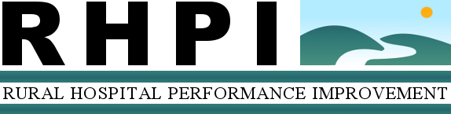

(Name) Hospital
Pre-/Post-Project Outcomes Work Sheet
CEO:
County/State:
Project: Revenue Cycle Management PI Project
Consultant:
Completion Date:

Anticipated Outcomes and Project Measures*
Anticipated Outcome  Submitted in Scope of Work | Measure | Pre-Project Values  Values obtained from either the Consultant report or RHPI data request | Post-Project Values  To be completed concurrent to RAP interview, which will be scheduled 9 – 12 months post-project
- Improved Revenue Cycle Processes to improve collections and increase revenue | - Cash collected and cash percentage of net revenue  - Gross accounts receivable  - Gross accounts receivable days  - Net accounts receivable  - Net accounts receivable days  - In-house and discharged not-final-billed receivables  - Third party aging over 90 days  - Cost to collect  - Bad debt and charity as a percent of gross charges  - Denials as a fraction of gross charges  - Point of service (POS) collections as a fraction of gross charges
*Data will be used to determine project progress and outcomes, and impact of the program on the hospital.

