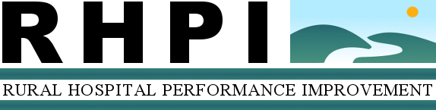

(Name) Hospital
Pre-/Post-Project Outcomes Work Sheet
CEO:
County/State:
Project: Readmission Prevention PI Project
Consultant:
Completion Date:

Anticipated Outcomes and Project Measures*
Anticipated Outcome  Submitted in Scope of Work | Measure | Pre-Project Values  Values obtained from either the Consultant report or RHPI data request | Post-Project Values  To be completed concurrent to RAP interview, which will be scheduled 9 – 12 months post-project
Pneumonia and COPD readmission rates will be within average to lower than State and National average as reported at the time closest to the RHPI review | Readmission rate % for PN 3b and PN 6
Decrease or remove the Hospitals’ liability for that extra financial loss. (i.e. Increase revenues back to pre-penalty phase and reduce CMS financial penalty/payback) | Net Patient Revenue  CMS penalty / payback  Medicare Readmission Penalties by Hospital (September 2012) reported DCGH with a penalty of 1% less Medicare revenue due to Pneumonia readmission rates
•Pneumonia Core Measures rate (PN 3b, PN 6) will be maintained at or higher than the National average | Pneumonia Core Measures rate (PN 3b and PN 6)  1. Pneumonia patients whose initial emergency room blood culture was performed prior to the administration of the first hospital dose of antibiotics  2. Pneumonia patients given the most appropriate initial antibiotic(s)
HCAHPS survey questions regarding discharge planning within average to higher than State average for rural hospitals | HCAHPS survey composites:  - RN Communication  - Medication Communication  - Discharge
*Data will be used to determine project progress and outcomes, and impact of the program on the hospital.

RHPI Standardized Data Request for All Projects**
Key Financial Indicator | Pre-Project Values  Reported by hospital on Nov 2013. Based on FY12 Financials | Post-Project Values  To be completed concurrent to RAP interview, which will be scheduled 9 – 12 months post-project  FY13
Operating Revenue
Net Patient Revenue
Total Operating Expenses
Days in Net Accounts Receivable
Days in Gross Accounts Receivable
Days Cash on Hand
Total Margin
Operating Margin
**Data will be aggregated with other participating hospitals for the RHPI program evaluation, which is a return on community investment (ROCI) analysis. The objective will be to determine program effectiveness. Individual hospital data will not be released.

